chapter
4

Unconventional Gas
Projects

Unconventional resource plays in South Australia are described in Chapter 2. The regulation of unconventional gas projects is covered in detail in Chapter 5. This
chapter describes publicly available details of unconventional gas projects in South Australia, and Figure 4.1 shows the petroleum infrastructure to give a context for these projects. Included are descriptions of the following projects:
• Santos operated Cooper Basin JV Unconventional Gas Project (Cooper Basin). Deep coal, shale gas and basin- centred gas targets.

• Beach Energy Nappamerri Trough Project (Cooper Basin). Shale gas and basin-centred gas targets.

• Senex Energy Unconventional Gas Project (Cooper Basin). Deep coal, shale gas and basin-centred gas targets.

• Strike Energy Southern Cooper Coal Seam Gas Project (Cooper Basin). Deep and shallow coal seam gas and shale gas targets.

• Somerton Energy Otway Basin Project.
Shale gas and tight gas targets.

• Altona Energy and CNOOC Arckaringa
Coal-to-Liquids and Power Project.

• Sapex Ltd (Linc Energy Ltd) Walloway Basin Underground Coal Gasification Project.

• Hybrid Energy (Strike Energy) Kingston Coal Project for the production of synthesis gas as feedstock for the manufacture of alternative products including but not limited to: fertiliser, methanol, and synthetic transport fuel.
4.1 Unconventional Gas Projects, Cooper and Otway Basins

4.1.1 Cooper Basin JV Unconventional
Gas Project
Licences And Licence Holders
PPLs 7, 8, 9, 11, 101, 102, 113
Santos Ltd (66.6%)*
Delhi Petroleum Pty Ltd (20.21%) Origin Energy Resources Ltd (13.19%)
*Denotes operator

Location
Cooper Basin, South Australia (Figure 4.2)

Project Summary
Santos, as operator of the Cooper Basin JV, commenced Australia’s first shale gas assessment project in 2006, acquiring a 9.4 m Roseneath Shale core in the Moomba 175 gas development well. Since that time shale cores have been acquired in two other gas development wells (Moomba 185, Bob’s Well
2) for shale gas assessment purposes. Santos has stated that results from the Moomba 185 shale core analyses are commensurate with US producing shale gas basins.

Assessment of the deep coal seam gas potential of the basin commenced with desorption analysis of a 4m Patchawarra coal seam cored in the Dorodillo 2 gas appraisal well in1998.

Further assessment of deep coal seam gas was suspended until 2007, when Santos flowed gas to surface at 100,000 scf/day from a fracture stimulated Patchawarra

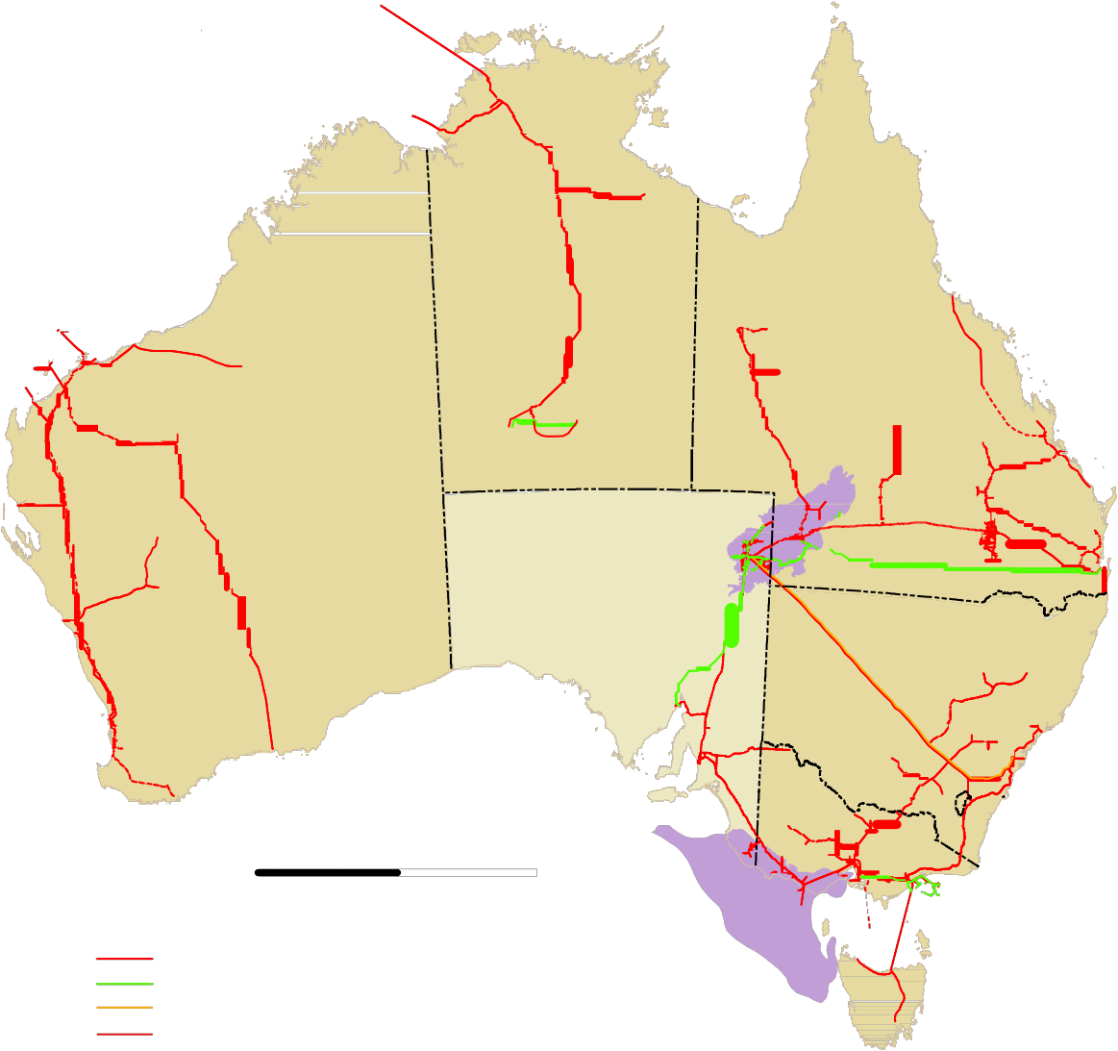Gove

Timor Sea
Papua New Guinea

")
Darwin

Northwest
Shelf

Port Hedland
") ")
Dampier
Broome ")

") Telfer

NORTHERN TERRITORY

Alice Springs

Mt Isa
")

QUEENSLAND

") Townsville

CH4

") Newman
# # ")
Rockhampton
")

Mereenie
Palm Valley
")Gladstone

Geraldton ")

Beharra Springs

WESTERN AUSTRALIA

") Kalgoorlie
Amadeus

Cooper
Eromanga

Moomba

SOUTH AUSTRALIA

Olympic Dam ")

Eromanga
ð

Ballera
#
Jackson

R^om#a ")
#

#
Moonie

ð
") Brisbane
ð

Perth ")

Bunbury ")

Esperance ")")

Port Bonython ^
Port August#a
NEW SOUTH WALES

ð

")
Newcastle

")
Albany
ADELAIDE ")

ACT ")
")
Sydney
ð

Katnook
ð
VICTORIA
")
Albury
Canberra

0 500 1000 km
Melbourne
Mount Gambier Iona )
#

Otway ")
Orbost

Gas pipeline, existing Oil–liquids pipeline Ethane pipeline
Equidistant Conic

ð Refinery
^ LPG plant
# Gas and oil treatment plant
Warrnambool

Minerva
(Otway)
Longford

Gippsland
Bass Strait

TASMANIA

Gas pipeline, proposed
Gas treatment plant
") Hobart

204218-0112

Figure 4.1 Map of Australia showing oil and gas infrastructure and Cooper and Otway basins.

Formation coal in the Moomba 77 gas development well. Since then additional deep coal seam gas assessment work has been carried out in seven gas development wells in the South Australian part of the Cooper Basin.

In December 2011, Santos drilled the first dedicated vertical shale gas well (Moomba 191), acquiring core from three shale intervals. A three stage fracture stimulation of the Moomba 191 Roseneath- Epsilon-Murteree (REM) section resulted
in a stabilised flow rate of 2.6 mmscf/d dry gas during the two week flow-back period. Moomba 191 was completed and connected to the Moomba processing facilities in October 2012. This brought the first shale gas production to eastern Australian gas markets.
Santos is accelerating unconventional gas
exploration in 2012-2013, with six vertical
wells planned to test the Nappamerri Trough basin-centred gas play (Figures 4.4 and 4.5), a vertical well to test the deep coal seam gas play at Moomba, and a horizontal well to assess the REM shale play at Moomba North (Figures 4.3 and 4.5).

At end 2010 Santos has booked a total 2C (contingent, probable, recoverable, Santos share) unconventional gas resource of 2,345
PJ, independently certified by DeGolyer and MacNaughton (approximately 3,500 PJ for the Cooper Basin JV). Santos has a 2015 2C target of 4,800 PJ (approximately 7,200 PJ
for the Cooper Basin JV). Santos estimate a potential range for recoverable raw gas from its licences in the Cooper Basin between a

139°30'E
26°0'S

QUEENSLAND
4
141°0'E
26°0'S

Wangkangurru/Yarluyandi Petroleum Conjunctive Indigenous Land Use Agreement (SI2011/023)

SC97/3
The Wangkangurru/Yarluyandi
Native Title Claim

SC98/1
Yandruwandha/Yawarrawarrka
Native Title Claim

PL20

Cooper Basin
27°0'S
27°0'S
Permian Edge

Coongie Lakes (NP)

Cooper
Innamincka (RR)
Innamincka (RR)

PPL 102

PPL 101
PL5
PL18

PPL 7
28°0'S

"
Moomba

PPL 113

PPL 9

PL17
28°0'S

PPL 8 PPL 11

PL15

SC97/4
Dieri Native Title Claim

PL9

Strzelecki (RR)
Basin

Yandruwandha/Yawarrawarrka Petroleum Conjunctive Indigenous Land Use Agreement (SI2006/008)
29°0'S
29°0'S

PLs7,8

SC99/1
Adnyamathanha No.1
SC08/2
Dieri No 2 Native Title Claim
139°30'E

PL2

PL1
0 10 20 30 40 km

MGA Zone 54
NEW SOUTH WALES
Strzelecki (RR)
141°0'E
REG 204218-017

Petroleum Production Licence (PPL)
Targeted areas of interest for
Indigenous Land Use
Agreement (ILUA)
* Satellite station
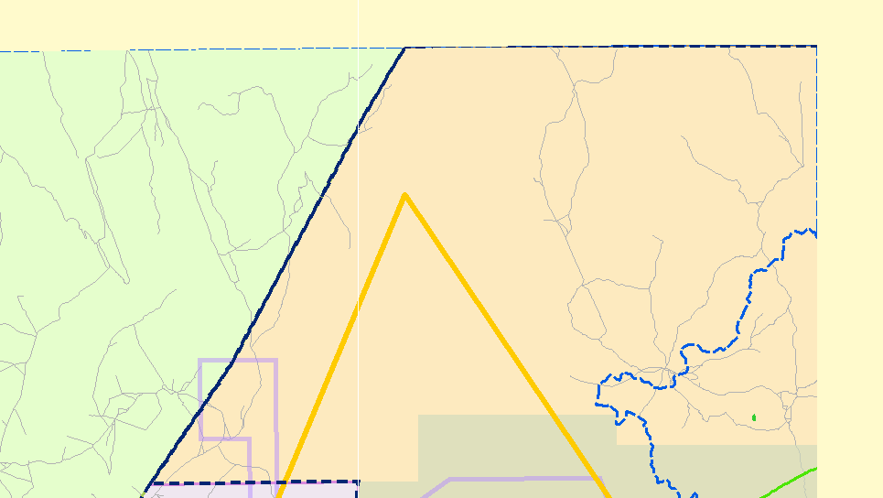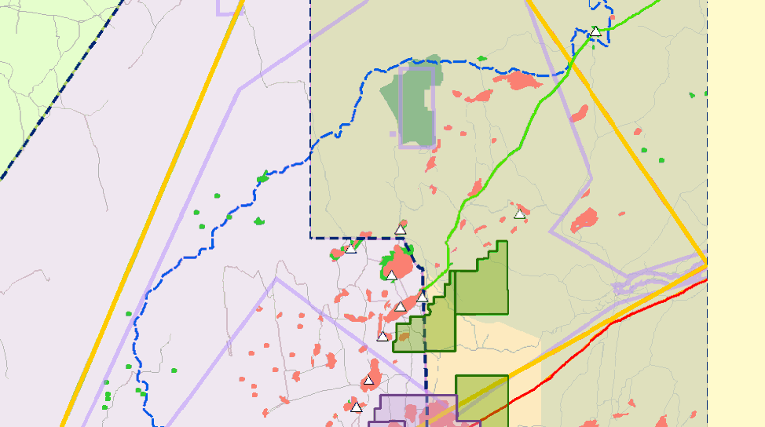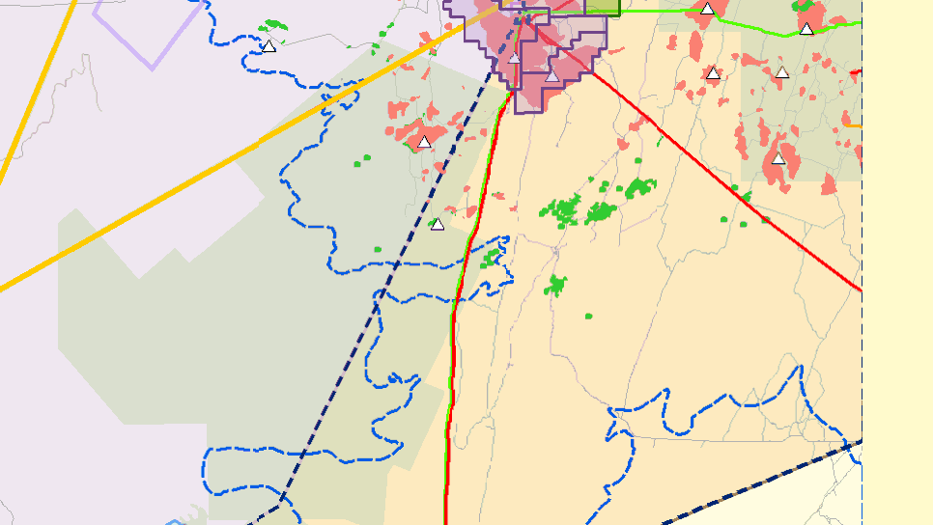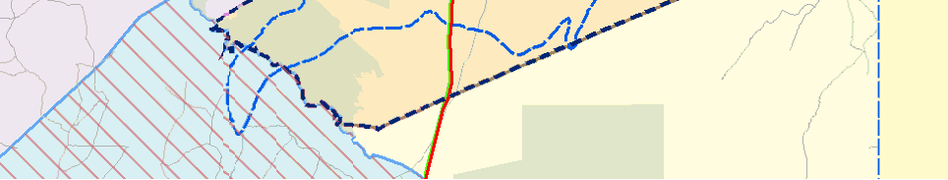" Processing plant

deep coal and shale
Targeted areas of interest for basin centred gas

Restricted areas
Coongie Ramsar site
National Estate area
Native Title Claims and Determinations
SC97/3:
The Wangkangurru/Yarluyandi
Native Title Claim
SC97/4:
Dieri Native Title Claim
SC98/1:
Liquids
Gas field
Oil field
Pipeline Licence (PL)
Gas
Gas and liquids

Parks with no petroleum exploration access
Yandruwandha/Yawarrawarrka Native Title Claim

Parks with petroleum exploration access
SC99/1:
Adnyamathanha No.1
SC08/2:
Dieri No 2 Native Title Claim
Roads

Figure 4.2 Project licences, land access and Native Title, Cooper Basin.

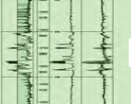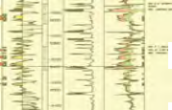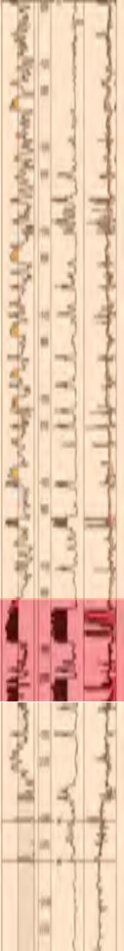 Moomba-Big Lake Typical Unconventional Section

TOOL DARA

TOOL DARA

ROSE EPSI MTRE

ROSE EPSI MTRE

PATC
Gross gas column >600m

PATC
low of 15 tcf to a high of 125 tcf (raw gas)1. The high-side estimate corresponds to a gross total of more than 200 tcf raw recoverable unconventional gas.

Unconventional Hydrocarbon Resource
Targeted
• Shale Gas (continuous gas accumulation), PPLs 7,8,9,11

• Basin-centred Gas (continuous gas
accumulation), PPLs 101, 102, 113

• Deep Coal Seam Gas (continuous gas accumulation), PPLs 7,8,9,11

Target Formations
• Toolachee Formation (deep CSG and

GRANITE

Figure 4.3 Moomba-Big Lake typical unconventional section
1 Santos’ equity in the Cooper Basin production licences is 66.6% in South Australia and 60.1% in Queensland. Hence, Santos of estimate of the potential range for recoverable raw gas from its licences in the Cooper Basin is, in gross terms, at least 22 tcf to a high
of more than 200 tcf (raw gas). Santos’ November
2012 estimates of its unconventional resources in the Cooper Basin can be accessed from: www.santos.com/ library/121112_EABU_Cooper_Basin_Unconventional_ Gas_Opportunities_and_Commercialisation.pdf

Nappamerri Trough Structural
Cross-section

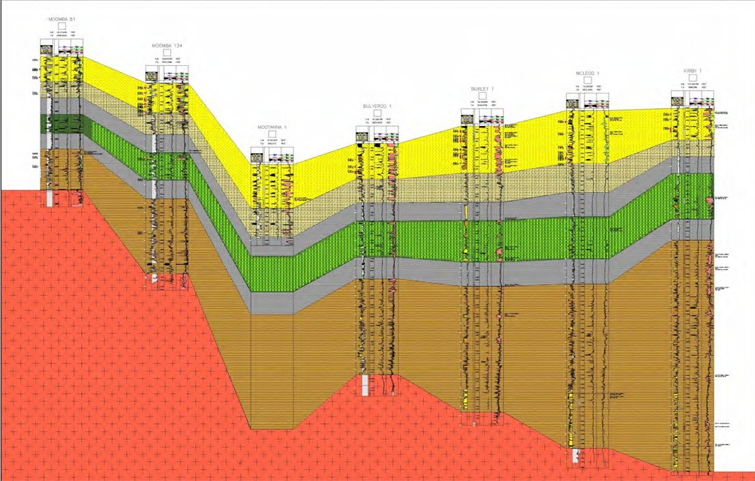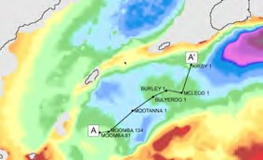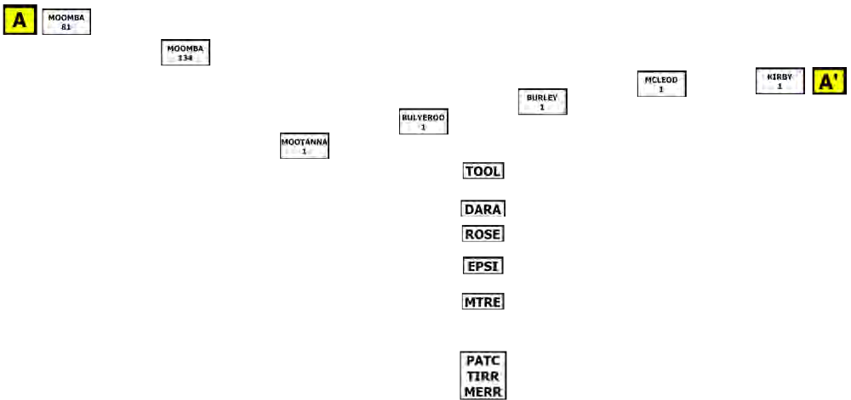Figure 4.4 Nappamerri Trough structural cross-section.

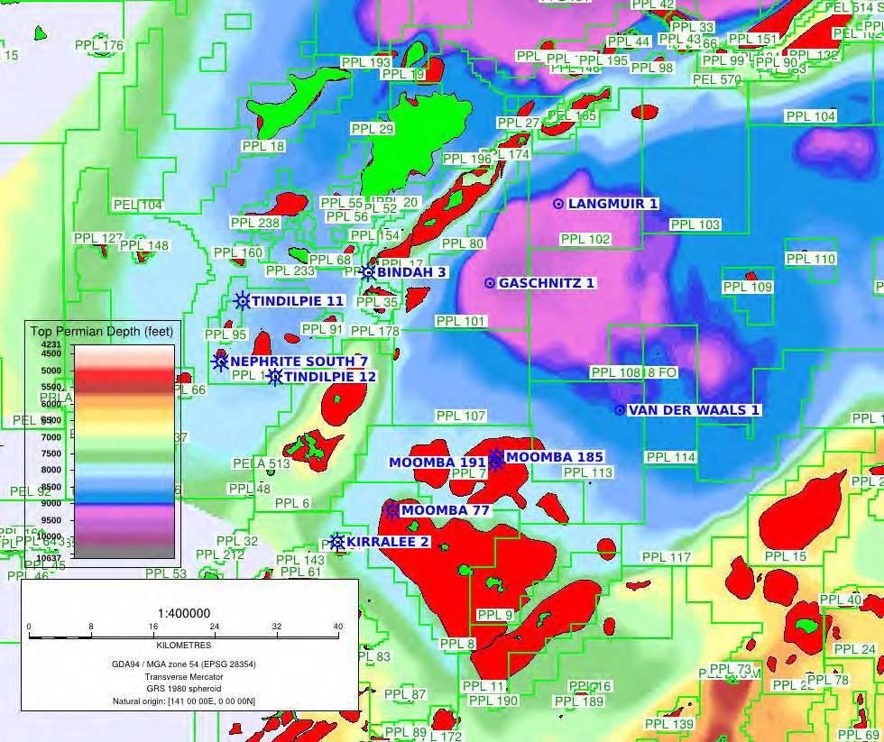4

Figure 4.5 Cooper Basin JV Unconventional Gas Project, planned wells for 2012. Langmuir 1, Gaschnitz 1 and Van der Waals 1 are planned vertical wells to test the basin-centred gas play in the Nappamerri Trough. A horizontal well to test the shale gas play at Moomba North, and a vertical well to assess the deep coal seam gas play at Moomba is also planned.

basin-centred gas)
• Roseneath Shale (shale gas)
• Epsilon Formation (shale and basin-
centred gas)
• Murteree Shale (shale gas)
• Patchawarra Formation (deep CSG and
basin-centred gas)

Target Depths
• Toolachee coals: 2450-3350 m

• REM: 2200-2700 m

• Patchawarra Formation: 2750-3950 m

• Patchawarra Formation coals:
2850-3500 m

Target Thickness
• Toolachee coals: Up to 25 m
• REM: 120 m - >180 m
• Patchawarra Formation: 300 m
• Patchawarra Formation coals: Up to 37 m
Exploration Results To End October 2012
• Moomba 185 shale core analyses are commensurate with US producing shale gas basins.

• Flowed gas to surface at 100,000 scf/ day from a fracture stimulated deep Patchawarra Formation coal (2745 m) in Moomba 77.

• A 3 stage fracture stimulation of the Moomba 191 Roseneath-Epsilon- Murteree (REM) section resulted in a stabilised flow rate of 2.6 mmscf/d dry gas. The well has been connected to
the Moomba processing facilities. Santos
estimate 3-6 bcf recoverable gas per

vertical well.

2C Resource Estimate (Pj, End 2010)
• REM shale: ~ 1026 (Santos share 684)

• Tight sands and mixed lithology: ~ 1613 (Santos share 1075)

• Deep Coal: ~ 879 (Santos share 586)

• TOTAL: ~ 3518 (Santos share 2345)

Environment And Land Access
Grant of a petroleum licence does not enable (approve) regulated activities within those tenements. Approval for an activity (e.g. geophysical surveys or
drilling) is a separate process that is subject to a separate, rigorous assessment and consultation process, so that operations
are planned and regulated to be sound, safe and meet community expectations for outcomes. An Environmental Impact Report (EIR) must be prepared, in consultation with stakeholders and relevant government agencies, addressing potential threats
and risks to the environment, and the extent to which these threats are likely and manageable. A Statement of Environmental Objectives (SEO), developed through an open, consultative process and based
on information in the EIR, must then be approved for compliance before a regulated activity can proceed. Please see Chapter 5 for further details of the approval process.

Copies of EIRs and SEOs prepared by licensees for regulated activities, and Environmental Significance Assessments prepared by the Energy Resources Division can be downloaded via the following link: www.pir.sa.gov.au/petroleum/environment/ register/seo,_eir_and_esa_reports

Forward Plan
2012-2013: (See Figure 4.5)
• 6 x vertical exploration wells to test the basin-centred gas play in the Nappamerri Trough

• 1 x dedicated shale horizontal drilling trial at Moomba North

• 1 x vertical well at Moomba to assess the
deep coal seam gas play

• Extensive fracturing trials beyond levels currently tested in the Cooper

2013+:
• Multiple horizontal and vertical appraisal wells

• Targeting initial shale reserve bookings in 2013 and initial production in 2015. Production now brought forward with connection of moomba 191 to the Moomba processing facilities and first production to sales expected in october
2012.

Contact Details
Name: Colin Cruikshank – General Manager – Development and Technical Services
Phone: +61 8 8116 5000
Website: www.santos.com

4.1.2 Nappamerri Trough Project
Licence And Licence Holders
PEL 218
Beach Energy (90%)*
Adelaide Energy (10%), subsidiary of Beach
Energy
*Denotes operator

Location
Cooper Basin, South Australia (Figure 4.6).

Project Summary
Beach Energy drilled the first purpose drilled vertical shale gas evaluation wells in PEL 218 the Cooper Basin, South Australia (Figure 4.6). Encounter 1 (2010) and Holdfast 1 (2011)
were specifically located off structure, and both wells encountered evidence of extensive gas saturation through the Permian section (see figures 4.7 and 4.8).

Holdfast 1 flowed gas at up to 2 mmscf/d after a seven stage fracture stimulation of the Early Permian succession. Encounter 1 was fracture stimulated on the Patchawarra interval in April 2012, flowing up to 0.75 mmscf/d, and on the REM package (5 stages) in June 2012, flowing 1.3 mmscf/d. Beach has stated that gas desorption from

139°30'E
26°0'S

QUEENSLAND
4
141°0'E
26°0'S

Wangkangurru/Yarluyandi Petroleum Conjunctive Indigenous Land Use Agreement (SI2011/023)

SC97/3
The Wangkangurru/Yarluyandi
Native Title Claim

SC98/1
Yandruwandha/Yawarrawarrka
Native Title Claim

PL20

Cooper Basin
27°0'S
27°0'S
Permian Edge

Coongie Lakes (NP)

Cooper
Innamincka (RR)

PEL 218
PL5
PL18

Moomba "
28°0'S
28°0'S
PL17

PL15

SC97/4
Dieri Native Title Claim

PL9

Strzelecki (RR)
Basin

Yandruwandha/Yawarrawarrka Petroleum Conjunctive Indigenous Land Use Agreement (SI2006/008)
29°0'S
29°0'S

PLs7,8

SC99/1
Adnyamathanha No.1
SC08/2
Dieri No 2 Native Title Claim
139°30'E

PL2

PL1
0 10 20 30 40 km

MGA Zone 54
NEW SOUTH WALES
Strzelecki (RR)
141°0'E
REG 204218-009

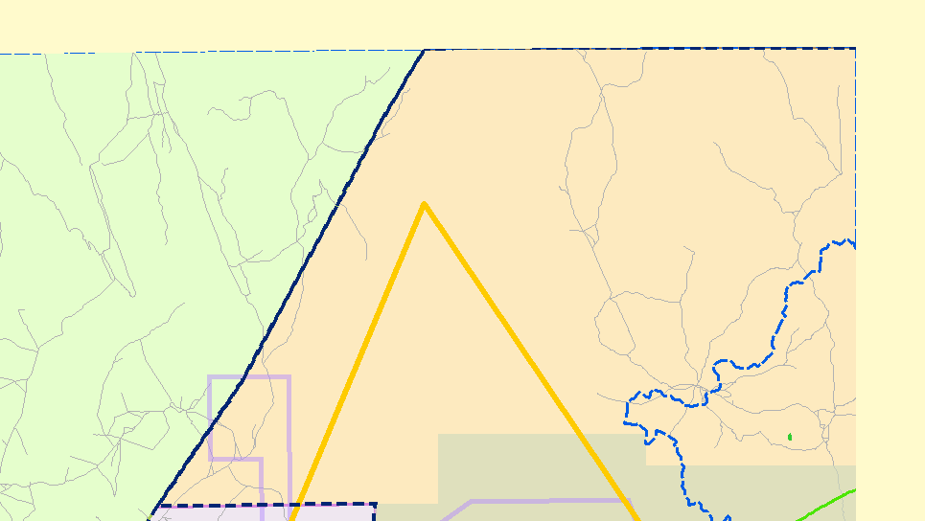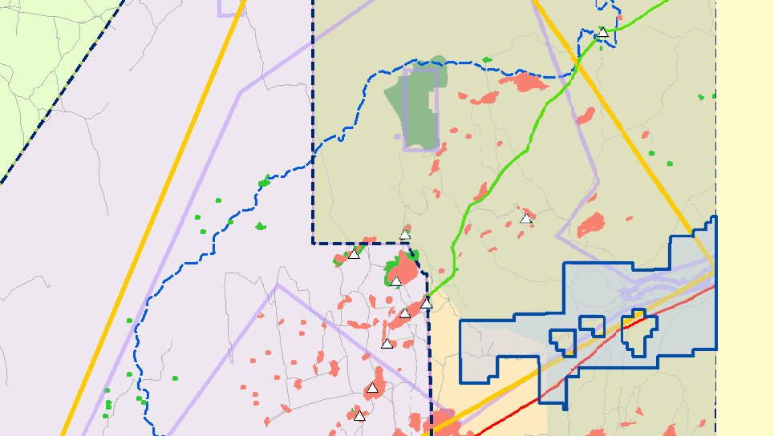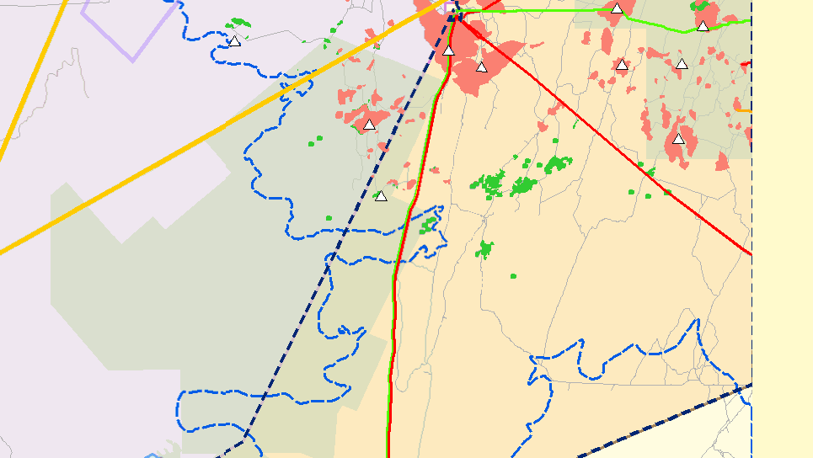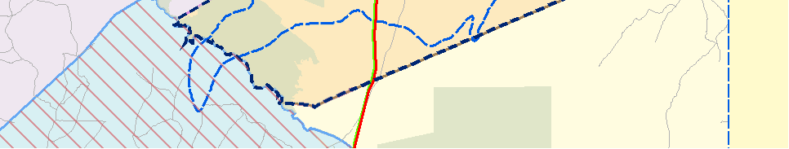Selected Petroleum tenements
Petroleum Exploration
Indigenous Land Use
Agreement (ILUA)
* Satellite station
" Processing plant

Licence 218
Restricted areas
Coongie Ramsar site
National Estate area
Parks with no petroleum exploration access
Native Title Claims and Determinations
SC97/3:
The Wangkangurru/Yarluyandi
Native Title Claim
SC97/4:
Dieri Native Title Claim
SC98/1:
Gas field
Oil field
Pipeline Licence (PL)
Gas
Gas and liquids

Parks with petroleum exploration access
Yandruwandha/Yawarrawarrka
Native Title Claim
Liquids

SC99/1:
Adnyamathanha No.1
SC08/2:
Dieri No 2 Native Title Claim
Roads

Figure. 4.6 PEL 218 location, land access and Native Title.

Triassic sediments Non-prospective No aquifers

Toolachee Formation

Daralingie Formation

Roseneath Shale
Gas Target Zone

Epsilon Formation Murteree Shale

Patchawarra Formation

700 m Gas
Saturated

Potential
600 m Gas
wells. However Beach has since adopted the new SPE Petroleum Resources Management System guidelines for booking unconventional resource volumes. The new
2C resource estimate for PEL 218 is 1.3 tcf (based on Holdfast 1 and Encounter 1 only, comprising 28 km2 around each well for sandstones and 41 km2 around each well for shales).

Unconventional Hydrocarbon Resource
Targeted
Shale Gas (continuous gas accumulation)
• Basin-centred Gas (continuous gas
accumulation)

• Discrete Tight Gas (within closure)

Tirrawarra Sandstone

Sandstone Shale Coal

Figure 4.7 Gas target zone, Nappamerri Trough.

the shales cored in the two wells suggests almost 100 tcf of shale gas in place in
PEL 218.

Cooper Basin
The presence of a basin-centred gas accumulation (BCGA) in the Nappamerri Trough has been suspected for over two decades. Beach has stated that the Encounter and Holdfast wells confirm the presence of gas in sands outside of structural closure and estimate that gas in place potentially exceeds 200 tcf in sands across PEL 218. Beach is accelerating exploration
in PEL 218. Recent wells Moonta 1 and Streaky 1 encountered gas saturation in the target Permian section and fracture stimulations commenced in October 2012.
These wells are the first two of between 5 and
8 vertical wells planned for PEL 218 in 2012-
2013 (Figure 4.9). The first horizontal well in South Australia is expected to be Holdfast 2, currently planned for Q4 2012.

Beach booked an initial gross contingent resource of 2 tcf of sales gas constrained
to a 10 x 10 km area around the Encounter
1 and Holdfast 1 shale gas evaluation
Target Formations
• Toolachee Formation (sand)

• Daralingie Formation (sand)

• Roseneath Shale (shale)1

• Epsilon Formation (sand and shale) 2

• Murteree Shale (shale)1

• Patchawarra Formation (sand)1

Target Depths
2600 – 4000 m

Target Thickness
1400 m

Exploration Results To End October 2012
• Encounter 1 drilled late 2010

• Holdfast 1 drilled early 2011

• Fracture stimulated Holdfast 1 with
7 stages (Patchawarra x 1 stage, Murteree x 1 stage, Epsilon x 3 stages and Roseneath x 2 stages)

• Flow tested Holdfast 1 with maximum rates of 2 mmscf/d

• Gas in place in PEL 218 estimated at up to 300 tcf, comprising almost 100 tcf gas in shales (estimated from gas desorption analyses of shales cored in Encounter 1 and Holdfast 1) and in excess of 200 tcf gas in sands.

2 Fracture stimulated and flow tested in Holdfast-1 and
Encounter 1.

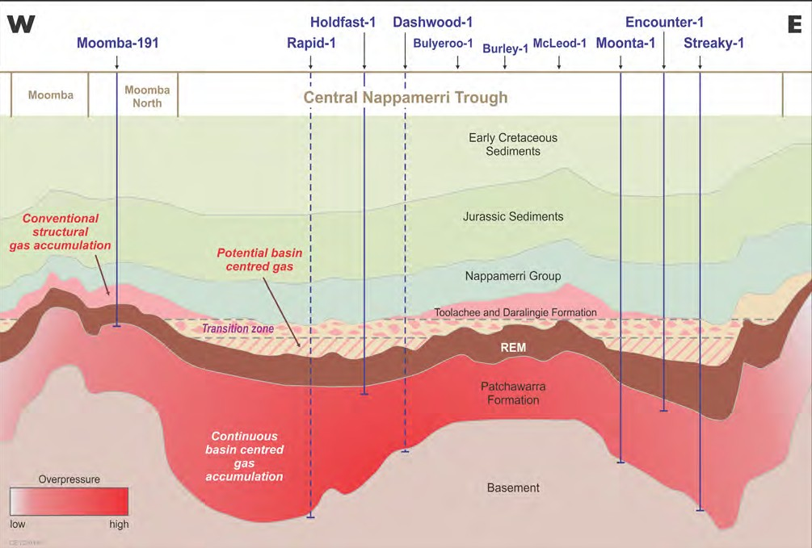4

Figure 4.8 Schematic section through the Nappamerri Trough showing the extent of the unconventional gas plays and
planned (dashed) and drilled (solid line) unconventional wells.

• Moonta 1 encountered gas saturation over more than 1,000m of the Permian target zone (Toolachee Formation to base of the Patchawarra Formation).

• Fracture stimulation of Moonta 1, focusing primarily on the Patchawarra Formation, has commenced (Patchawarra Formation – nine stages, Murteree Shale – one stage)

Upside Potential
The Encounter 1 and Holdfast 1 wells were terminated in the upper Patchawarra Formation. Potential for a further 400-600m of gas saturation in the Patchawarra Formation is being tested with the current drilling programme.

2C Resource Estimate (August 2012)
Beach has adopted the new SPE Petroleum Resources Management System guidelines for booking unconventional resource volumes. The new 2C resource estimate for PEL 218 is 1.3 tcf (based on Holdfast 1 and Encounter 1 only, comprising 28 km2 around
each well for sandstones and 41 km2 around each well for shales).

The gas-in-place estimate is unchanged at
300+ tcf for PEL 218.

Environment And Land Access
Grant of a petroleum licence does not enable (approve) regulated activities within those tenements. Approval for an activity (e.g. geophysical surveys or
drilling) is a separate process that is subject to a separate, rigorous assessment and consultation process, so that operations
are planned and regulated to be sound, safe and meet community expectations for outcomes. An Environmental Impact Report (EIR) must be prepared, in
consultation with stakeholders and relevant government agencies, addressing potential threats and risks to the environment, and
the extent to which these threats are likely and manageable. A Statement of Environmental Objectives (SEO), developed

Figure 4.9 PEL 218, Nappamerri Trough, South Australia: Existing vertical shale gas evaluation wells are Encounter-1 (2010), Holdfast-1 (2011), Moonta 1 and Streaky 1. Horizontal wells at Encounter and Holdfast are planned to assess gas deliverability from shales.

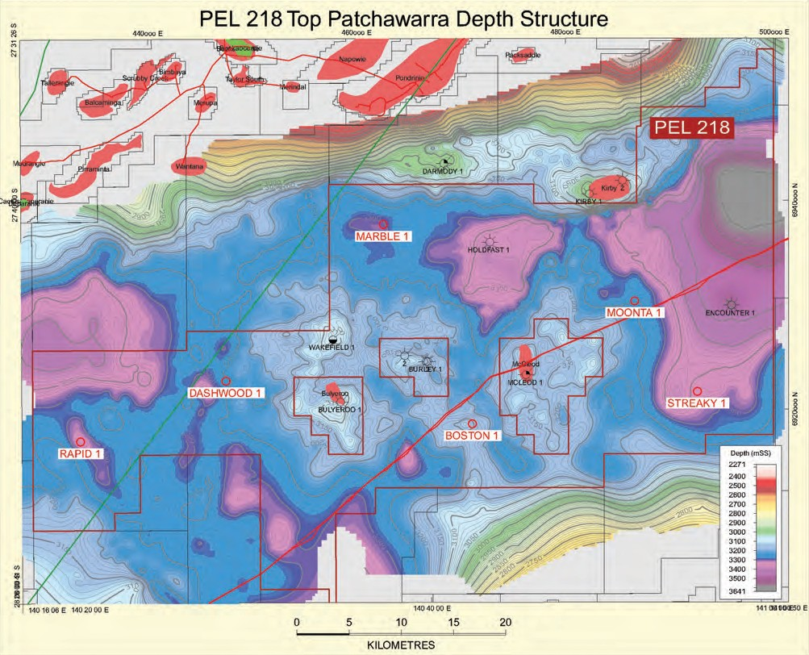through an open, consultative process and based on information in the EIR, must then be approved for compliance before a regulated activity can proceed. See
Chapter 5 for further details of the approval process.

Copies of EIRs and SEOs prepared by licensees for regulated activities, and Environmental Significance Assessments prepared by the Energy Resources Division can be downloaded via the following link: www.pir.sa.gov.au/petroleum/environment/ register/seo,_eir_and_esa_reports

The Land Access Agreement for PEL 218, pursuant to section 31 of the Native Title
Act 1993 (Cth) can be downloaded via the following link: www.petroleum.dmitre.sa.gov. au/environment/native_title,_aboriginal_ lands,_iluas/current_native_title_agreements
Forward Plan
2012 – Delineate basin-centred gas and tight gas concept in PEL 218 with vertical well drilling, stimulation and flow test program. Commence horizontal well program to estimate deliverability from shales.

2013 – Continue vertical and horizontal well drilling, fracture stimulation and flow testing. Drill appraisal wells to test deliverability potential ‘production pilot concept’.

2014 – Continue appraisal of production potential through drilling, stimulation and flow testing of production pilot wells.

Contact Details
Name: Mike Dodd – Exploration and
Development Manager
Phone: +61 8 8338 2833
Website: www.beachenergy.com.au

4.1.3 Senex Energy Southern Cooper
Basin Unconventional Gas Project
Licence and Licence Holders
PEL 516
Senex Energy Limited (100%)* PEL 115
Senex Energy Limited (55%)* Orca Energy Limited (20%) Others (25%)

Location
Cooper Basin, South Australia (Figure 4.10).

Project Summary
Senex Energy Limited acquired PEL 516 (Figure 4.10) following the acquisition of Stuart Petroleum in 2011. Assessment of unconventional gas plays in the licence commenced shortly after with the coring of Toolachee Formation coals and Roseneath and Murteree shales in the Vintage Crop
oil discovery well. Senex reported that the Toolachee Formation coals and REM (Roseneath – Epsilon- Murteree) shale formations exhibited continuous gas shows, as well as the presence of liquids and heavy gases.

A nine metre core in the Toolachee Formation and two nine metre cores in each of the Roseneath and Murteree shales were cut in Vintage Crop 1 for gas desorption analysis and other tests. Senex has reported that preliminary results confirm the presence of liquids rich gas, favourable mineralogy for fracture stimulation, and properties similar to successful North American shale plays.

Senex has accelered unconventional gas exploration in PEL 516 in 2012 drilling three vertical wells to end October, with results as follows:
• A multi-zone fracture stimulation of Patchawarra Formation tight sands and the Roseneath and Murteree shales in Sasanof 1 was completed in May 2012. The well produced fracture stimulation fluid and liquids rich gas at a peak rate of >200,000 scf/day.

• High gas readings with evidence of condensate and heavy gases were
recorded in the Permian section in 4
Talaq 1.

• Wireline logs and mud logs from Skipton
1 have confirmed material quantities of hydrocarbons outside of structural closure. Skipton 1 intersected more than 75 metres of interpreted net gas pay in the Patchawarra Formation and
164 metres of gas charged Roseneath and Murteree shales.

Senex commenced drilling its fourth operated unconventional gas exploration well, Kingston Rule 1 (PEL 115) in October
2012. A large scale hydraulic fracture stimulation program at Skipton 1, Talaq 1 and Kingston Rule 1 to test gas quality and deliverability is planned to commence in December 2012.

Senex has completed a $155 million equity raising to fund the planned FY2012-2013+ work program. The work includes 10+ vertical
wells targeting unconventional gas in Senex’s southern Cooper Basin permits (primarily PEL
516), following the early success at Sasanof 1, Talaq 1 and Skipton 1.

MHA Petroleum Consultants has estimated
potential gas-in-place in PEL 516 of over
100 tcf.

Unconventional Hydrocarbon Resource
Targeted
• Shale Oil

• Shale Gas (continuous gas accumulation)

• Basin-centred Gas (continuous gas
accumulation)

• Deep Coal Seam Gas (continuous gas accumulation)

Target Formations (Figures 4.11 and 4.12)
• Toolachee Formation (deep CSG)

• Roseneath Shale (shale)

• Epsilon Formation (shale)

• Murteree Shale (shale)

• Patchawarra Formation (basin centred gas)

139°30'E
26°0'S

QUEENSLAND
141°0'E

Wangkangurru/Yarluyandi Petroleum Conjunctive Indigenous Land Use Agreement (SI2011/023)
26°0'S

SC97/3
The Wangkangurru/Yarluyandi
Native Title Claim

SC98/1
Yandruwandha/Yawarrawarrka
Native Title Claim

PL20

Cooper Basin
27°0'S
27°0'S
Permian Edge

Coongie Lakes (NP)

Keleary

Cooper
Innamincka (RR)

Basin
PL5
PL18

PEL 516
Flax East 1

Innamincka (RR)
28°0'S
28°0'S

Moomba "
PL17

SC97/4
Dieri Native Title Claim

Strzelecki (RR)

PEL 516

PEL 115
PL15

PL9

PLs7,8

Dullingari
Moomba South
TaonoCtlaencnnhtareael Daralingie g Lake
Bi

Yandruwandha/Yawarrawarrka Petroleum Conjunctive Indigenous Land Use Agreement (SI2006/008)
29°0'S
29°0'S

SC99/1
Adnyamathanha No.1
SC08/2
Dieri No 2 Native Title Claim
139°30'E

PL2

PL1
0 10 20 30 40 km

MGA Zone 54
NEW SOUTH WALES
Strzelecki (RR)
141°0'E
REG 204218-010

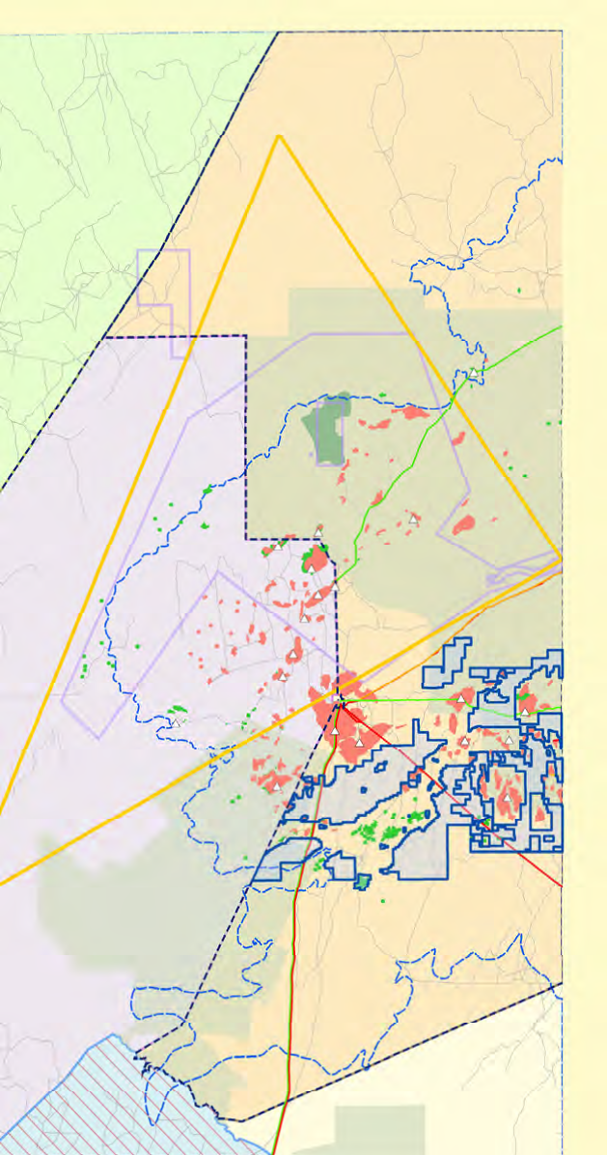Selected Petroleum tenements
Indigenous Land Use
* Satellite station

Petroleum Exploration Agreement (ILUA)
" Processing plant

Licences 115 and 516
Restricted areas
Coongie Ramsar site
National Estate area
Parks with no petroleum exploration access
Native Title Claims and Determinations
SC97/3:
The Wangkangurru/Yarluyandi
Native Title Claim
SC97/4:
Dieri Native Title Claim
SC98/1:
Gas field
Oil field
Pipeline Licence (PL)
Gas
Gas and liquids

Parks with petroleum exploration access
Yandruwandha/Yawarrawarrka
Native Title Claim
Liquids

SC99/1:
Adnyamathanha No.1
SC08/2:
Dieri No 2 Native Title Claim
Roads

Figure 4.10 PELs 115 and 516 location, land access and Native Title, Cooper Basin.

Teritiary

Cretaceous
-2000 m

Jurassic

Sasanof-1
shales in Sasanof 1 was completed in 4
May 2012. The well has produced fracture
stimulation fluid and liquids rich gas at
a peak rate of >200,000 scf/day. Talaq
1 encountered high gas readings with evidence of condensate and heavy gases in the Permian section and Skipton

Eromanga Aquifer

Triassic

Toolachee Formation

Daralingie Formation
Gas Target Zone
Permian

Roseneath Shale Epsilon Formation Murtaree Shale
-900 m

Patchawarra Formation

Tirrawarra Sandstone

Sandstone Shale Coal
Figure 4.11 Gas target zone for PEL 516.

Target Depths
2800-3200 m

Target Thickness
600-900m (Permian succession)

Exploration Results To End October 2012
Vintage Crop 1 cut a nine metre core in the
Toolachee Fm and two nine metre cores in each of the Roseneath and Murteree shales. Wet gas shows were encountered through the coring interval. Senex reported that preliminary results indicate the potential resource in PEL 516 is in the wet gas window, containing liquids and heavy gases with a low carbon dioxide content.

Assessment of the unconventional gas potential of PELs 516 and 115 is progressing with the drilling of the Sasanof 1, Talaq 1 and Skipton 1 vertical wells, and the Kingston
Rule 1 well in progress at end October
2012 (Figure 4.13) . A multi-zone fracture stimulation of Patchawarra Formation tight sands and the Roseneath and Murteree
1 intersected more than 75 metres of interpreted net gas pay in the Patchawarra Formation and 164 metres of gas charged Roseneath and Murteree shales.

Resource Potential
>100 tcf gas-in-place

Environment And Land Access
Grant of a petroleum licence does not enable (approve) regulated activities within those tenements. Approval for an activity (e.g. geophysical surveys or
drilling) is a separate process that is subject to a separate, rigorous assessment and consultation process, so that operations
are planned and regulated to be sound, safe and meet community expectations for outcomes. An Environmental Impact Report (EIR) must be prepared, in consultation with stakeholders and relevant government agencies, addressing potential threats
and risks to the environment, and the extent to which these threats are likely and manageable. A Statement of Environmental Objectives (SEO), developed through an open, consultative process and based
on information in the EIR, must then be approved for compliance before a regulated activity can proceed. Please see Chapter 5 for further details of the approval process.

Copies of EIRs and SEOs prepared by licensees for regulated activities, and Environmental Significance Assessments prepared by the Energy Resources Division can be downloaded via the following link: www.pir.sa.gov.au/petroleum/environment/ register/seo,_eir_and_esa_reports

The land access agreements for PELs 516 and
115, pursuant to section 31 of the Native Title Act 1993 (Cth), can be downloaded via the following link: www.petroleum.dmitre.sa.gov. au/environment/native_title,_aboriginal_ lands,_iluas/current_native_title_agreements

Forward Plan
2012-2013+:
• Fracture stimulation of Talaq 1, Skipton 1 and Kingston Rule 1 to test deliverability and gas composition.
• Book material contingent resource

• 10+ vertical wells targeting unconventional gas in Senex’s southern Cooper Basin permits (primarily PEL 516)

• Focus on flow testing (limited coring)

• Pilot program to follow a successful appraisal program

Contact Details
Name: Ian Davies – Managing Director
Phone: +61 7 3837 9900
Website: www.senexenergy.com.au

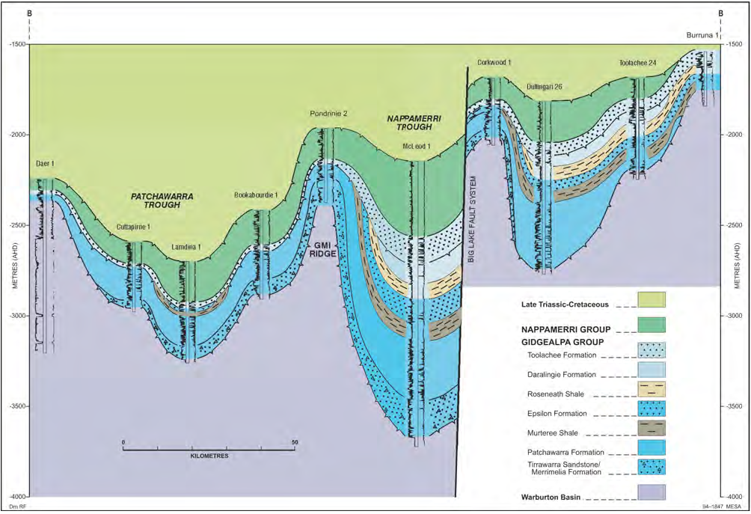

Figure 4.12 Regional N-S log correlation across the Cooper Basin, South Australia, highlighting the shallower occurrence of the prospective Permian succession in the Tenappera Trough/Mettika Embayment compared with the Nappamerri Trough. Senex’s planned Skipton-1 and Talaq-1 unconventional wells will test the Mettika Embayment. The relatively shallow depths mean lower temperatures are encountered, and there is no need for specialised casing or drilling materials.

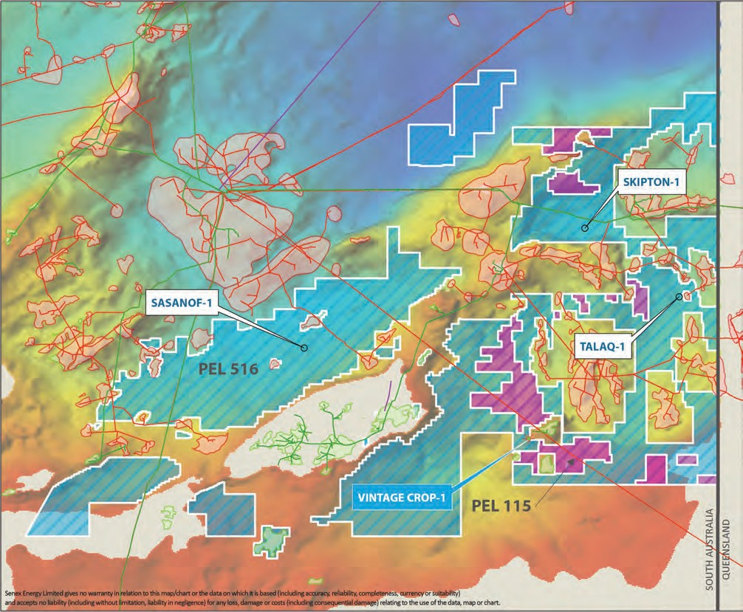4

Figure 4.13 Senex Energy Limited Unconventional Gas Project, planned wells for 2012.

4.1.4 Beach Energy JV Coal Seam Gas and Shale Gas Project Licence and Licence Holders:
PEL 94
Beach Energy Limited (50%)* Strike Energy Limited (35%) Senex Energy Limited (15%) PEL 95
Beach Energy Limited (50%)*) Strike Energy Limited (50%)
*Denotes operator

Location
Cooper Basin, South Australia (Figure 4.14)

Project Summary
PELs 94 and 95 were originally granted to Beach Petroleum NL (50%) and Magellan Petroleum (NT) Pty Ltd (50%) in 2001
(Figure 4.14). Beach Energy has retained a
50% interest in the licences and is operator of both licences.

Marsden 1 was drilled in the deepest part of Battunga Trough approximately 6 km southeast of the Battunga 1 well (Santos
Ltd, 1987) in 2012. A 20 m Patchawarra coal seam with mud gas readings up to 1835 units was intersected in Battunga 1. A 20 m Toolachee coal seam was also intersected
in Battunga 1. However the coal is less thermally mature peaking at around 20 units in the main seam and up to 500 units in thin overlying coal seams.

Marsden 1 (2012) was drilled specifically to test the coal seam gas potential of the Permian coals and the shale gas potential

139°30'E
26°0'S
26°0'S

QUEENSLAND
141°0'E

Wangkangurru/Yarluyandi Petroleum Conjunctive Indigenous Land Use Agreement (SI2011/023)
Yandruwandha/Yawarrawarrka Petroleum Conjunctive Indigenous Land Use Agreement (SI2006/008)

SC97/3
The Wangkangurru/Yarluyandi
Native Title Claim

SC98/1
Yandruwandha/Yawarrawarrka
Native Title Claim

PL20

Cooper Basin
27°0'S
27°0'S
Permian Edge

Coongie Lakes (NP)

Keleary

Cooper
Innamincka (RR)

Basin
PL5
PL18

Flax East 1

Innamincka (RR)
28°0'S
28°0'S

Moomba "
PL17

SC97/4
Dieri Native Title Claim
PL15

PL9

Dullingari
Moomba South
TaonoCtlaencnnhtareael Daralingie g Lake
Bi

Strzelecki (RR)

PEL 94
29°0'S
29°0'S

PEL 95

PLs7,8

SC99/1
Adnyamathanha No.1
SC08/2
Dieri No 2 Native Title Claim
139°30'E

PL2

PL1
0 10 20 30 40 km

MGA Zone 54
NEW SOUTH WALES
Strzelecki (RR)
141°0'E
REG 204218-036

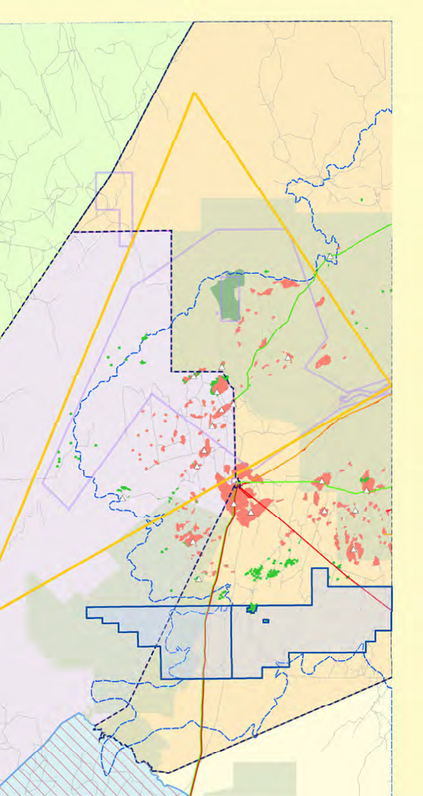Selected Petroleum tenements

Indigenous Land Use
* Satellite station

Petroleum Exploration Agreement (ILUA)
" Processing plant

Licences 94 and 95

Restricted areas
Coongie Ramsar site
National Estate area
Native Title Claims and Determinations
SC97/3:
The Wangkangurru/Yarluyandi
Native Title Claim
SC97/4:

Gas field
Oil field
Pipeline Licence (PL)

Parks with no petroleum
Dieri Native Title Claim Gas

exploration access
Parks with petroleum exploration access
SC98/1: Yandruwandha/Yawarrawarrka Native Title Claim
SC99/1: Adnyamathanha No.1
SC08/2:
Dieri No 2 Native Title Claim
Gas and liquids
Liquids

Roads

Figure 4.14 PELs 94 and 95 location, land access and Native Title, Cooper Basin.

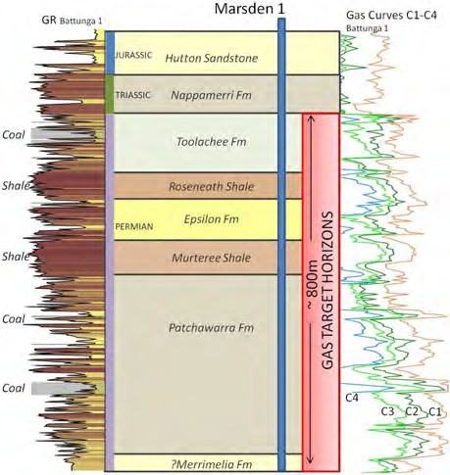

Figure 4.15 Gas target zone for Marsden 1 (based on
nearby Battunga 1 well).

of the Murteree Shale in PEL 95 (Figures
4.15, 4.16 and 4.17). Marsden 1 intersected a thick coal interval and gas readings
were elevated throughout the Permian section. Early core analysis results indicate high gas contents. The well was cased and suspended for further evaluation.

Davenport 1 (2012) was drilled in the deepest part of the Milpera Trough to evaluate the unconventional gas potential of Permian coals and shales in PEL 94 (Figure 4.18). The well was cased and suspended for future evaluation after intersecting 110m of net
coal including one seam in the Patchawarra with over 45m of coal. Coal cores are currently being analysed for gas content and other physical parameters.

Unconventional Hydrocarbon Resource
Targeted
• Shale Gas (continuous gas accumulation)

• Deep Coal Seam Gas (continuous gas accumulation)
Target Formations 4
• Toolachee Formation (deep CSG), PEL 95

• Murteree Shale (shale), PEL 95

• Patchawarra Formation (deep CSG), PELs 94 and 95

Target Depths
• PEL 94, Patchawarra Formation:
1990-2175 m

• PEL 95, Toolachee Formation:
1870-1980 m

• PEL 95, Patchawarra Formation:
2450-2550 m

• PEL 95, Murteree Shale: 2160-2225 m

Target Thickness
• PEL 94, Patchawarra Formation: 5-25 m

• PEL 95, Toolachee Formation: 15-25 m

• PEL 95, Patchawarra Formation: 15-25 m

• PEL 95, Murteree Shale: 65 m

Target Formations
• Toolachee Formation (deep CSG), PEL 95

• Murteree Shale (shale), PEL 95

• Patchawarra Formation (deep CSG), PELs 94 and 95

Target Depths
• PEL 94, Patchawarra Formation:
1990-2175 m

• PEL 95, Toolachee Formation:
1870-1980 m

• PEL 95, Patchawarra Formation:
2450-2550 m

• PEL 95, Murteree Shale: 2160-2225 m

Target Thickness
• PEL 94, Patchawarra Formation: 5-25 m

• PEL 95, Toolachee Formation: 15-25 m

• PEL 95, Patchawarra Formation: 15-25 m

• PEL 95, Murteree Shale: 65 m

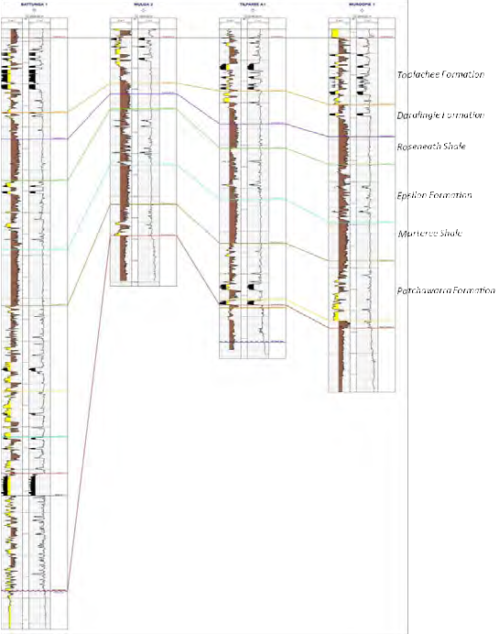Exploration Results To End July 2012
See Project Summary

Resource Potential
No resource estimation available at this stage.

Figure 4.16 Log correlation showing rapid thinning of the Patchawarra Formation on the margins of the Battunga Trough, Cooper Basin, South Australia. The target Permian coal seams are best developed in the Battunga Trough. In contrast the REM shales are a relatively consistent thickness.
Environment and Land Access Grant of a petroleum licence does not enable (approve) regulated activities within those tenements. Approval for an activity (e.g. geophysical surveys or drilling) is
a separate process that is subject to a separate, rigorous assessment and consultation process, so
that operations are planned and regulated to be sound, safe and meet community expectations for outcomes. An Environmental Impact Report (EIR) must be prepared, in consultation with stakeholders and relevant government agencies, addressing potential threats and

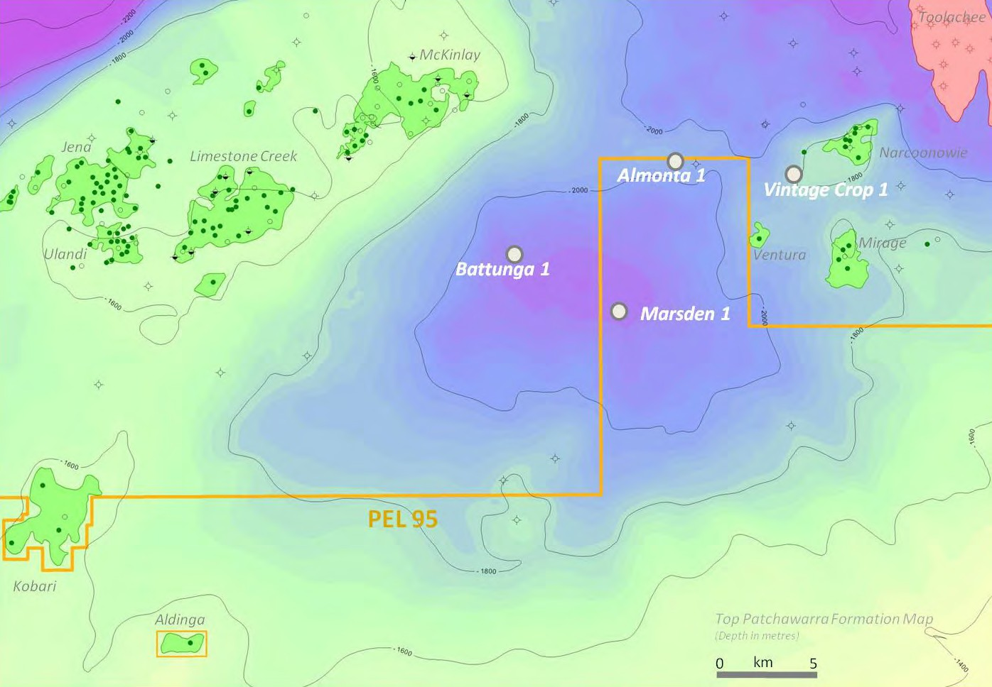

Figure 4.17 Map showing depth to the top of the Patchawarra Formation and the location of Marsden 1 in the deepest
part of the Battunga Trough.

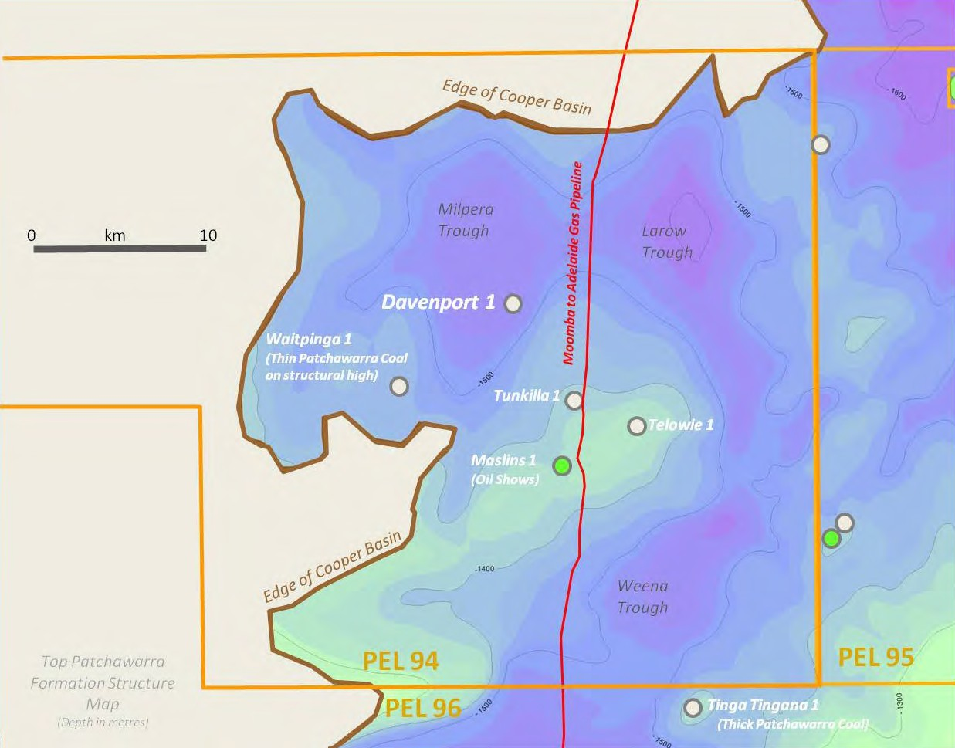4

Figure 4.18 Map showing depth to the top of the Patchawarra Formation and the location of Davenport1 in the deepest
part of the Milpera Trough.

risks to the environment, and the extent to which these threats are likely and manageable. A Statement of Environmental Objectives (SEO), developed through an open, consultative process and based
on information in the EIR, must then be approved for compliance before a regulated activity can proceed. Please see Chapter 5 for further details of the approval process.

Copies of EIRs and SEOs prepared by licensees for regulated activities, and Environmental Significance Assessments prepared by the Energy Resources Division can be downloaded via the following link: www.pir.sa.gov.au/petroleum/environment/ register/seo,_eir_and_esa_reports

Land access agreements for PELs 94 and
95, pursuant to section 31 of the Native Title
Act 1993 (Cth), can be downloaded via the following link: www.petroleum.dmitre.sa.gov. au/environment/native_title,_aboriginal_ lands,_iluas/current_native_title_agreements

Forward Plan
A decision regarding the forward plan will be made when core analyses are completed.

Contact Details
Name: Mike Dodd – Exploration and
Development Manager
Phone: +61 8 8338 2833
Website: www.beachenergy.com.au

4.1.5 Southern Cooper Coal Seam
Gas Project
Licence
PEL 96

Licence Holders
Strike Energy Limited (66.67% and Operator) AGL (33.33%)

Location
Cooper Basin, South Australia (Figure 4.19)

Project Summary
PEL 96 was granted to Strike Oil Limited (now
Strike Energy) and AGL in 2009 (Figure. 4.19).

Forge-1, drilled in 2010, was the first exploration well drilled to test the coal seam gas potential of the Permian coals in PEL 96 (Figures. 4.20 and 4.21). Drilling achieved
a partial test of the proposed drill target. The full 224 m section of Permian coal measures was not drilled due to suspension of drilling for operational reasons. The target Permian coal measures were penetrated immediately beneath the base Eromanga Basin unconformity and were consequently oxidised. Biogenic gas contents in the order of 1.1 m3/t (40 scf/ton) were recorded in
the coal cores submitted for gas desorption
analysis.

Follow up drilling in PEL 96 is not planned until
2014 (Figure 4.22).

Unconventional Hydrocarbon Resource
Targeted
• Shale Gas (continuous gas accumulation)

• Coal Seam Gas (continuous gas accumulation)

Target Formations
• Toolachee Formation (CSG)

• Roseneath Shale (shale)

• Epsilon Formation (shale, CSG)

• Murteree Shale (shale)

• Patchawarra Formation (CSG)

Target Depths
1000-2500 m
Target Thickness
• Coal Seam Gas: 5–75 m net coal thickness

• Shale Gas: 30–60 m net shale thickness

Exploration Results To End 2011
The Forge 1 well penetrated an aggregate thickness of 21 m of coal from 1,281m in the upper part of the Permian section. The full sequence, including the primary coal target in the Patchawarra Formation, was not drilled due to operational reasons. Biogenic gas contents in the order of 1.1 m3/t (40 scf/ton) were recorded.

Resource Potential
• CSG: Prospective Resource Estimate 3.7
– 9.3 tcf (Gross)

• Shale Gas: Prospective Resource
Estimate 0.36 – 0.95 tcf (Gross)

Environment And Land Access
Grant of a petroleum licence does not enable (approve) regulated activities within those tenements. Approval for an activity (e.g. geophysical surveys or
drilling) is a separate process that is subject to a separate, rigorous assessment and consultation process, so that operations
are planned and regulated to be sound, safe and meet community expectations for outcomes. An Environmental Impact Report (EIR) must be prepared, in consultation with stakeholders and relevant government agencies, addressing potential threats
and risks to the environment, and the extent to which these threats are likely and manageable. A Statement of Environmental Objectives (SEO), developed through an open, consultative process and based
on information in the EIR, must then be approved for compliance before a regulated activity can proceed. Please see Chapter 5 for further details of the approval process.

139°30'E
26°0'S

QUEENSLAND
4
141°0'E
26°0'S

Wangkangurru/Yarluyandi Petroleum Conjunctive Indigenous Land Use Agreement (SI2011/023)

SC97/3
The Wangkangurru/Yarluyandi
Native Title Claim

SC98/1
Yandruwandha/Yawarrawarrka
Native Title Claim

PL20

Cooper Basin
27°0'S
27°0'S
Permian Edge

Coongie Lakes (NP)

Cooper
Innamincka (RR)

PL5
PL18

Moomba "
28°0'S
28°0'S
PL17

PL15

SC97/4
Dieri Native Title Claim

PL9

Strzelecki (RR)
Basin

Yandruwandha/Yawarrawarrka Petroleum Conjunctive Indigenous Land Use Agreement (SI2006/008)
29°0'S

PLs7,8

PEL 96
29°0'S
NEW SOUTH WALES

SC99/1
Adnyamathanha No.1
SC08/2
Dieri No 2 Native Title Claim
139°30'E

PL2

PL1
0 10 20 30 40 km

MGA Zone 54
Strzelecki (RR)
141°0'E
REG 204218-011

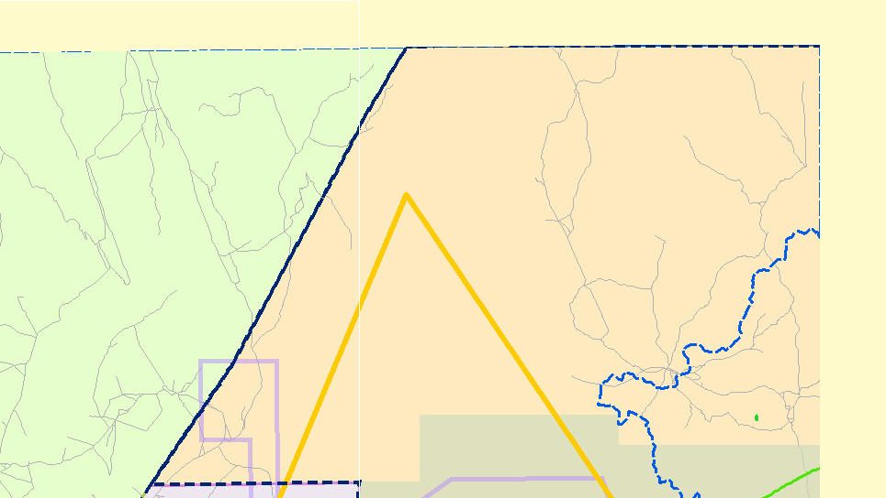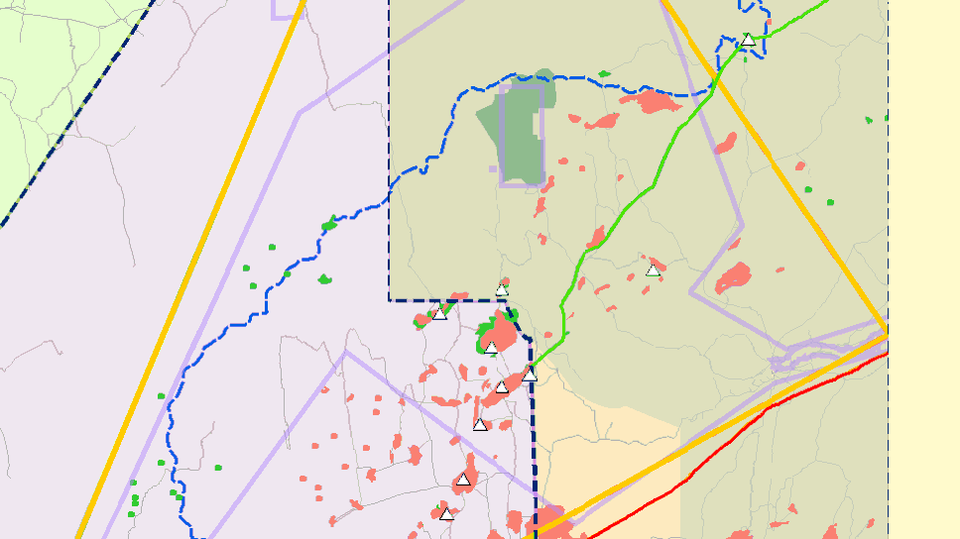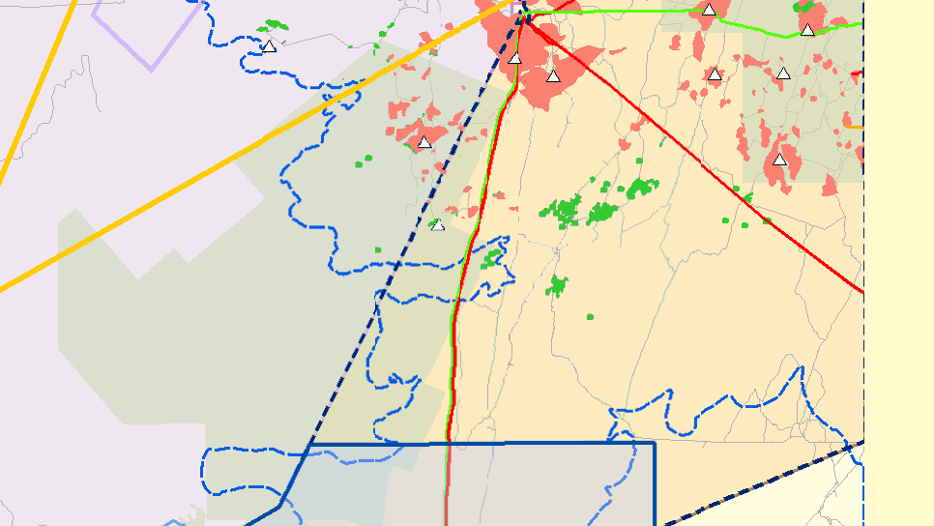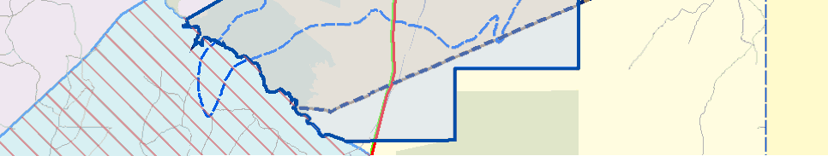Selected Petroleum tenements
Petroleum Exploration
Indigenous Land Use
Agreement (ILUA)
* Satellite station
" Processing plant

Licence 96
Restricted areas
Coongie Ramsar site
National Estate area
Parks with no petroleum exploration access
Native Title Claims and Determinations
SC97/3:
The Wangkangurru/Yarluyandi
Native Title Claim
SC97/4:
Dieri Native Title Claim
SC98/1:
Gas field
Oil field
Pipeline Licence (PL)
Gas
Gas and liquids

Parks with petroleum exploration access
Yandruwandha/Yawarrawarrka
Native Title Claim
Liquids

SC99/1:
Adnyamathanha No.1
SC08/2:
Dieri No 2 Native Title Claim
Roads

Figure 4.19 PEL 96 location, land access and Native Title, Cooper Basin.

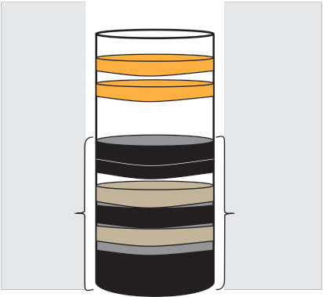Basin
Conventional
Unconventional
Depth

Eromanga
Oil 800-1500 m

Cooper

Natural Gas
Oil
Toolachee Coal
Daralingie Fm

Roseneath Shale Epsilon Coal Murteree Shale

Patchawarra Coal

CSG
Shale Gas
Tight Gas

1000-2500 m

Figure 4.20 Gas target zone for PEL 96.

Copies of EIRs and SEOs prepared by licensees for regulated activities, and Environmental Significance Assessments prepared by the Energy Resources Division can be downloaded via the following link: www.pir.sa.gov.au/petroleum/environment/ register/seo,_eir_and_esa_reports

The Land Access Agreement for PEL 96, pursuant to section 31 of the Native Title Act
1993 (Cth), can be downloaded via the following link: www.petroleum.dmitre.sa.gov. au/environment/native_title,_aboriginal_ lands,_iluas/current_native_title_agreements

Forward Plan
• 2012: Evaluation of target prospectivity.

• 2013: Seismic survey.

• 2014: Drilling of 1 – 2 deep wells.

Contact Details
Name: Don Poynton – Managing of
Exploration and Environment
Phone: +61 8 6103 0999
Website: www.strikeenergy.com.au

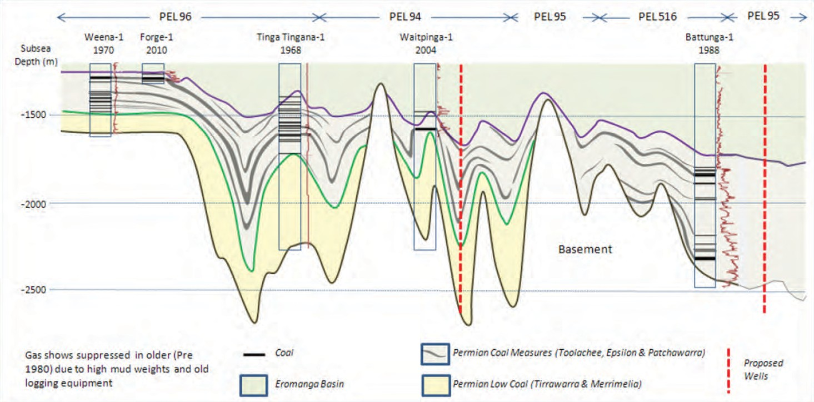4

Figure 4.21 Log correlation across the southern Cooper Basin, South Australia. The target Permian coal seams and REM
shales are generally shallower than 2000 m in PEL 96.

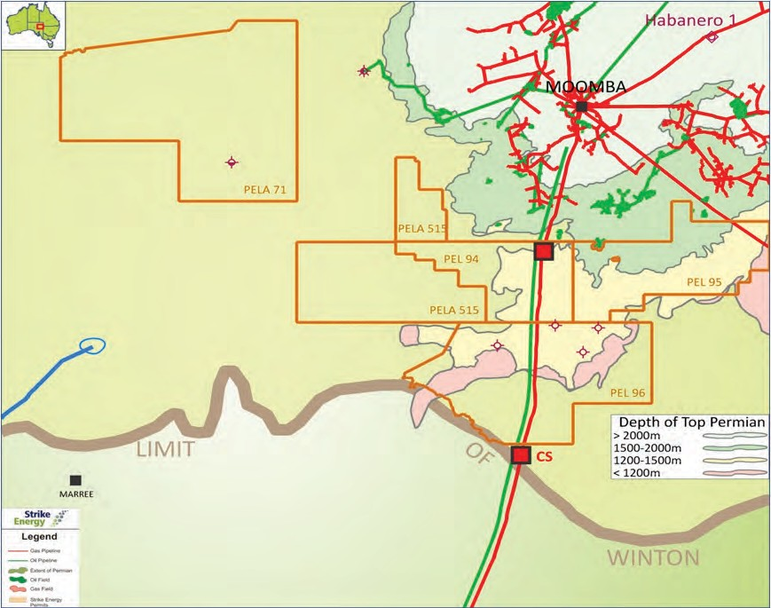

Figure 4.22 Map showing depth to the top of the Permian succession in licences in which Strike Energy has an interest. The
top of the Permian succession in PEL 96 is less than 1500 m over the entire licence. No exploration wells are planned for PEL
96 in 2012.

4.1.6 Otway Basin Gas Project
Licences and Licence Holders
PEL 186
Beach Energy (66.67%) Cooper Energy (33.33%)*

PEL 255
Beach Energy (100%)*

PEL 494
Beach Energy (100%)*

PEL 495
Cooper Energy (60%)* Beach Energy (35%)
*Denotes operator

Location
Otway Basin, South Australia (Figure 4.23)

Project Summary
Within the South Australian portion of the Otway Basin, the Casterton Formation is considered to have highest prospectivity for unconventional oil and gas plays (Figure 4.24).

The Casterton Formation contains shales
that are the source rocks of the commercial gas accumulations in the Penola Trough
and has also generated oil, as evidenced
by the widespread oil flows/recoveries
and shows, particularly on the flanks of the basin. The formation is widespread but has only been penetrated in about ten wells on the northern and eastern flanks of the
Basin, where the Casterton is not sufficiently thermally mature to present a viable shale gas play.

The existing well control indicates an average prospective shale sequence in
the Casterton of about 85 m. However, the formation is interpreted to reach thicknesses in excess of 300 m in the undrilled troughs, where it is thermally mature to overmature and may be overpressured (the deepest Casterton penetration to date is at approximately 2,500 m).

On a regional basis, the Casterton Formation is generally a moderately rich, gas prone
source rock, with total organic carbon (TOC) averaging approximately 2.5%. However the source richness of the formation can vary widely over relatively short distances and in some portions of the basin it has excellent
oil source capacity, with TOCs of up to 20% observed in western Victoria. Although these intervals are thin and not widespread, where they are present and thermally mature
they are capable of generating significant
volumes of oil.

The Casterton Formation was deposited in a cold climate, lacustrine environment and contains predominately siliceous shales containing minor amounts of siderite. As such they have similar mineralogy to the REM shales in the Nappamerri Trough of the Cooper Basin and some producing shales in North America.

Shales and low permeability sands within the lower Pretty Hill Formation may also present viable unconventional plays, where they
are thermally mature and the Casterton Formation may be too deep to present an economic target.

Unconventional Hydrocarbon Resource
Targeted
• Shale Gas

• Basin-centred Gas

Target Formations
Casterton Formation and lower Pretty Hill
Formation

Target Depths
2,600 – 4,000 m

Target Thickness
Up to 300 m

Exploration Results To End July 2012
Most of the Casterton well penetrations to date have been in western Victoria where
it is present at relatively shallow depths. The only definitive Casterton penetration in South Australia to date is at Sawpit 1, which was drilled on the northern flank of the Penola Trough and penetrated 61 m of Casterton Formation at a depth of about 2,500 m.

140°0'E

Kingston

Padthaway
Talapar (CP) PRESWA

Grass Tree (CP)
141°0'E 4

Rosetown, Grave Reserve
Kingston "
Butcher Gap (CP)
Mount Scott (CP) Fairview (CP)

Mullinger
Swamp (CP)

Vivigani Ardune (CP) "
37°0'S

Naracoorte "
37°0'S

Kungari (CP)
PEL 186
Lucindale

Naracoorte
Caves (NP)

PL13

Guichen Bay (CP)
Robe
Woakwine (CP)

Big Heath (CP)
Hacks Lagoon (CP)

Robe Trough "

Lake Hawdon

Mary Seymour (CP)
Bool Lagoon
(GR)
!

Lake Robe (GR)
Little Dip (CP)

Lake St Clair (CP)
South (CP)

186
St Clair
Penola
Reedy Creek (CP) Trough
PEL 255
Penola (CP)
Glen Roy (CP)

PEL 495

Penola

PL16

Trough
Furner (CP)
Calectasia "
(CP)
VICTORIA

Beachport (CP)
Beachport "
Penguin Island (CP)

Belt
Hill (CP)
PEL 494

PL3
PL19

Lake Frome (CP)
"

Millicent
PL4

Otway

Canunda (NP)

Tantanoola
Caves (CP)

Telford Scrub (CP) Gower (CP)

Basin

Canunda (NP)
Mount Gambier "
Lower Limestone
Bucks Lake (GR) Coast PRESWA

0 10 20 30 40 km
38°0'S

MGA Zone 54
Carpenter Rocks (CP) Nene Valley (CP)
Douglas Point (CP)

Penambol (CP)
38°0'S
Lower Glenelg River (CP)
Ewens Ponds (CP)

140°0'E
Dingley Dell (CP)
Piccaninnie Ponds (CP)
141°0'E

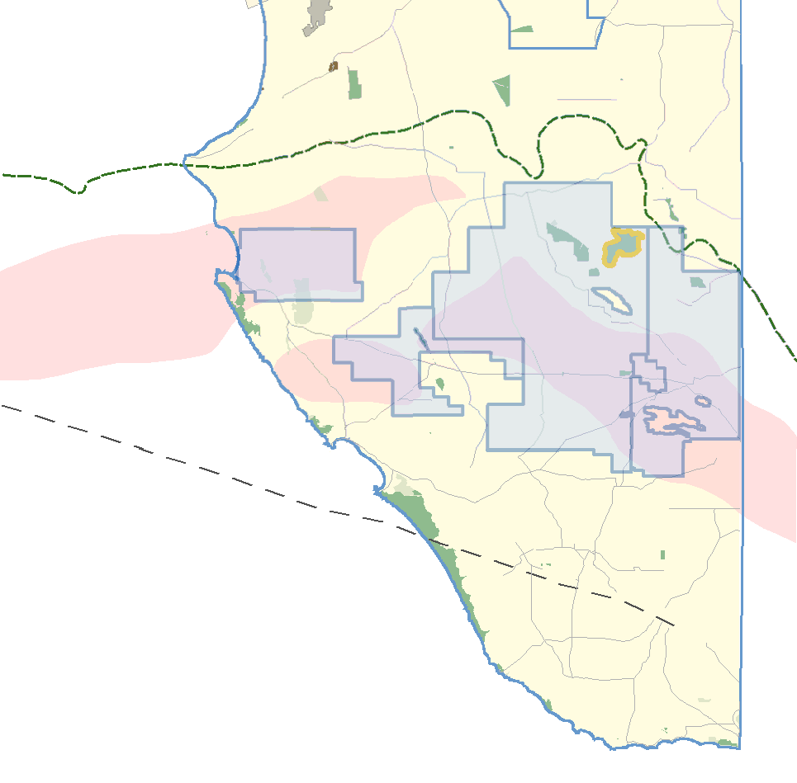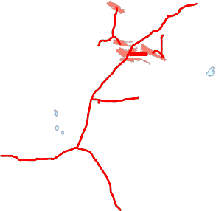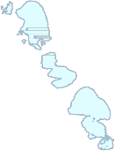REG 204218-038

Selected petroleum tenements
Petroleum Exploration
Licences 186, 255, 494, and 495

Restricted areas
Aboriginal Lands

Prescribed Wells Areas (PRESWA) Bool and Hacks Lagoons Ramsar site
Parks with petroleum exploration access

Parks with no petroleum exploration access
Gas pipeline Gas field Coalfield
Oil field
Structural elements
Hinge
Casterton Formation
Play Fairway
Highway
Roads
Railway

Figure 4.23 PELs 186, 255, 494 and 495, land access and Native Title, Otway Basin.

Stratigraphic Column, Otway Basin
approved for compliance before a

Chronostratigraphy
Teritiary |  | Heytesbury Group
 |  | Nirranda Group
 |  | Nirranda Group
Cretaceous | Early Late | Sherbrook Group
 |  | Otway Supergroup
Jurassic
Palaeozoic |  | Kanmantoo Group

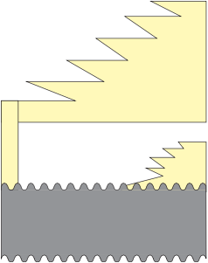Age

Alb
Otway Supergroup

Apt

Bar

Hau

Val

Ber

Tith

Kim

Rock Unit

Eumeralla
Formation

Windermere/Katnook Sandstone

Lair Formation

Pretty Hill
Crayfish Group
Pretty Hill Fmn
Sandstone

Upper Sandpit Shale Mbr
Sandpit Sandstone Mbr
Lower Sandpit Shale Mbr

Upper Sandpit Shale Mbr

v v v v v v v v v v v v v v
regulated activity can proceed. Please see Chapter 5 for further details of the approval process.

Copies of EIRs and SEOs prepared by licensees for regulated activities, and Environmental Significance Assessments prepared by the Energy Resources Division can be downloaded via the following link: www.pir.sa.gov.au/petroleum/environment/ register/seo,_eir_and_esa_reports

Forward Plan
The Sawpit-2 exploration well (PEL 495) is
expected to commence drilling in Q4 2012.

Figure 4.24 Stratigraphic Column, Otway Basin.

Seismic interpretation indicates that the Casterton thickens considerably into the troughs where it is interpreted reaches thicknesses in excess of 300 m and depths in excess of 4,000 m.

Resource Potential
The potential Gas In Place in the Casterton play is assessed to be in the range 17 - 58 tcf. Approximately 75% of the play lies within the South Australian portion of the basin.

Environment And Land Access
Grant of a petroleum licence does not enable (approve) regulated activities within those tenements. Approval for an activity (e.g. geophysical surveys or
drilling) is a separate process that is subject to a separate, rigorous assessment and consultation process, so that operations
are planned and regulated to be sound, safe and meet community expectations for outcomes. An Environmental Impact Report (EIR) must be prepared, in consultation with stakeholders and relevant government agencies, addressing potential threats
and risks to the environment, and the extent to which these threats are likely and manageable. A Statement of Environmental Objectives (SEO), developed through an open, consultative process and based
on information in the EIR, must then be
The well will test a conventional oil target and will be deepened to the Casterton Formation to acquire core to obtain further information in relation to its capacity to host unconventional resources.

3D seismic was acquired in April 2012 in PEL
186 (Robe Trough) with the aim of maturing a location for drilling in 2013.

Contact Details
Name: Michael Dodd
(Beach Energy Limited) Phone: +618 8338 2833
Website: www.beachenergy.com.au

Name: Steve Twartz
(Cooper Energy Limited) Phone: +618 9489 3777
Website: www.cooperenergy.com.au

4.2 COAL GASIFICATION PROJECTS, SOUTH AUSTRALIA 4

Marla
)"

EL
4513
!(

") Oodnadatta

(!

(! EL 4512

Moomba ")

EL 4511
Arckaringa !(
!(

Coober Pedy
")")

!( CAIRN HILL
(!
Snafell (!
!(

CHALLENGER !(
PROMINENT HILL
(!
Hawks Nest

!( OLYMPIC DAM
((

Four Mile !(!(! BEVERLEY
(

AMBROSIA A!tacama
!((
(!(!( Sonoran

")
Tarcoola
Reliance !(!! LEIGH CREEK BELTANA

JACINTH
Typoon

!( Tripitaka

Tunkillia !(

Ceduna

!(
Carrapateena

Portia
!(
Junction
Kalkaroo !( !Dam
( (
HONEYMOON

)" Crocker Well !(
White Dam North

Ê
Thevenard

Port
WHITE DAM !(!(!(
!(

Paris !(
Menninnie Dam
!(
)" Augusta
Mutooroo
!(

!(
Poochera
WILLCHERRY HILL !(

hyalla
Mutooroo

W (! Ê ÊPort Bonython
!( Razorback

Warramboo !(
IRON CHIEFTAIN!(
HEP
!(
Port Pirie
Port Pirie
Ê")

Current as at 11 September 2012

Bramfield !(
!(
MIDDLEBACK RANGES Samphire
!( Bungalow
!(

Mining projects
!( Operating mine
!( Mineral development project
WILGERUP

!( Fusion
PEL 120

Port Lincoln
Hillside !(
Port

Exploration tenements
Mineral Exploration Licence (EL)
Gum Flat !!( Ê)" Port Lincoln
Uley
(
Adelaide
Ê
ADELAIDE ")

!( Bird in Hand

!(
MINDARIE

Petroleum Exploration Licence (PEL)

Coalfield

Infrastructure ") Locality Ê Port
Highway
Major road
Railway – standard gauge Railway – non standard gauge Gas pipeline
Liquids pipeline
132 000 volt powerline
KANMANTOO !(
!(
ANGAS

PEL 127

EL 4576

0 100 200 300 Kilometres

Datum GDA 94 – Projection South Australia Lambert

")

275 000 volt powerline
Mount Gambier

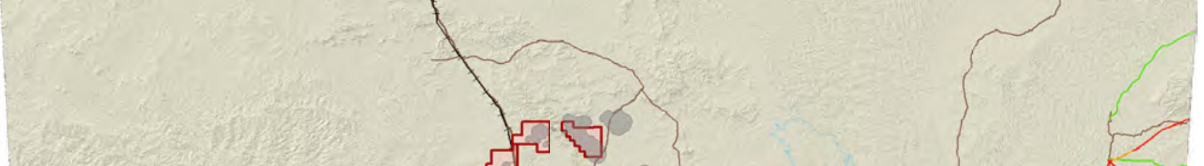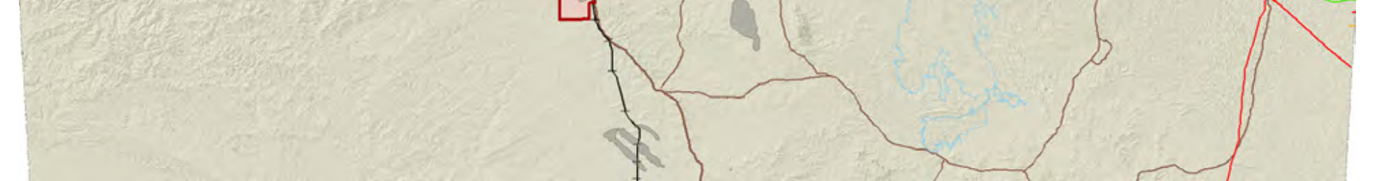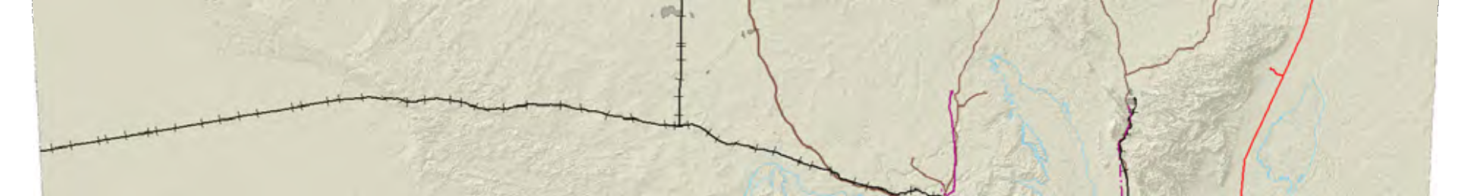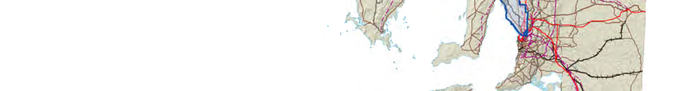Figure 4.25 Map of South Australia showing oil and gas infrastructure, powerlines, mining projects and the location of coal
gasification projects.

4.2.1 Arckaringa CTL and Power
Project
Licences and Licence Holders
ELs 4511, 4512, 4513
CNOOC New Energy International (Australia) Pty Ltd.*(51%)
Arckaringa Energy Pty. Ltd. - fully owned
subsidiary of Altona Energy Plc (49%)
*Denotes operator

Location
Arckaringa Basin, South Australia (Figure 4.26)

Project Summary
The Arckaringa Coalfield, comprising four deposits of sub-bituminous coal in the northern Arckaringa Basin (Figure 4.26), was discovered in 1980 by Meekatharra Minerals.

Systematic exploration of the licences was carried out in the early 1980s at which time
a resource of 7,850 Mt was declared. Altona
Energy Plc (Altona) acquired the coal
assets in 2005 and undertook a series of pre- feasibility studies between 2006 and 2008. These studies included a drilling program with associated testing and analyses, pre- feasibility work on CTL and Power Plant options, optimisation work on mine costs, fuel and electricity market studies, and construction of a Project Economic Model.

Completion of the field exploration program in 2008 resulted in a JORC Resource Estimate of 1.287 billion tonnes for part of the Wintinna deposit which is covered by EL 4512 (Figures
4.26, 4.27 and 4.28). The outcome of the pre- feasibility studies was the establishment of a base case scenario comprising a 10 mtpa mine supplying coal to a CTL plant with an output of 10 mmbbls per annum liquid fuels (mainly ultra clean diesel) as well as a co- generation power plant delivering 560 MW per annum to the national power grid.

Altona has since forged a Joint Venture with CNOOC New Energy Investment Co., Ltd. (CNOOC-NEI), a subsidiary of the China National Offshore Oil Corporation (CNOOC), to complete the Project Bankable Feasibility Study (BFS) and expedite the project’s development. CNOOC-NEI owns 51% of the
Arckaringa Unincorporated Evaluation Joint Venture (AUEJV) and Altona 49%. Under the terms of the AUEJV, the Australian subsidiary of CNOOC-NEI (CNOOC New Energy International (Australia) Pty Ltd or CNOOC- NEIA) will fund the BFS for the Arckaringa Project and will act as the operator, not
only to carry out the staged evaluation work under the BFS, but also to take responsibility for assessing the full potential of the coal resource and bring projects to development.

Permits and approvals are now in place for a drilling programme that will proceed when drilling contractors and other service providers have been selected. The key objectives of the programme are:
• to extract bulk samples of coal to test
and extend the coal quality profile

• to complete in-fill coal and coal geotechnical boreholes to facilitate open cut mine design (especially in an area covering the potential initial box cut)

• to complete hydro-geological test wells to enable the refinement of the existing hydro-geological model and underpin a groundwater management plan.

Attaining these objectives is essential to the progress of the Bankable Feasibility Study (BFS) for the Arckaringa CTL and Power Project.

Unconventional Hydrocarbon Resource
Targeted
Mined coal to liquids (Figure 4.29)

Coal Deposits
Westfield - EL 4511 (England Hill Area) Wintinna - EL 4512 (Arckaringa Area) Murloocoppie - EL 4513 (Copper Hill Area)
Target Formation
Upper Mount Toondina Formation (Wintinna
Deposit)

133°30'E
26°0'S

NORTHERN TERRITORY

135°0'E
SC05/1
4
136°30'E
26°0'S
SC97/3

SC10/5
Tjayiwara
Unmuru
Irrwanyere Mt Dare
Witjira (NP)

SC96/3
Eringa Part A
The Wangkangurru/ Yarluyandi

SP11/1

SC94/2
SC96/3
Proceeding Simpson Desert (RR)
Wangkangurru

De Rose Hill De Rose Hill
Eringa

SC96/3
Eringa No. 2
and
/Yarluyandi Petroleum Conjunctive ILUA (SI2011/023)

Anangu Pitjantjatjara
27°0'S
Yankunytjatjara Lands
Mintabie " "

Marla
27°0'S

SC97/9
Yankunytjatjara Antakirinja

EL 4513
Wangkangurru/Yarluyandi

" Oodnadatta
Oodnadatta

Far North
28°0'S
28°0'S
PRESWA

EL 4511 EL 4512

"
Emu
29°0'S

Maralinga
Tjarutja Lands

Arckaringa Basin
Tallaringa (CP)

Coober Pedy
" Coober Pedy
Lake Eyre (NP)
SC98/2
Arabana People
29°0'S

Wabma Kadarbu Mound Springs (CP)

Anangu Pitjantjatjara
Yankunytjatjara Lands

Woomera Prohibited Area

ga
30°0'S
30°0'S

SC95/7
Olympic Dam
Andamooka

Antakirinja Matu-Yankunytjatjara
SC96/4 "
Barngarla "

Yellabinna (RR)
31°0'S
SC12/2
Naley
Yalata

Yellabinna (WA)

"
Tarcoola
Roxby Downs

" Glendambo
31°0'S

"
Woomera

Aboriginal Reserve

Boondina (CP)
SC06/1
Yumbarra (CP) Far West Coast
Yumbarra (CP)
Koonibba Aboriginal Community
Lake Gairdner (NP)

SC97/7
Gawler Ranges
SC09/1
Kokatha
Uwankara

132°0'E
Chadinga (CP)
133°30'E
Pureba (CP)
135°0'E
136°30'E

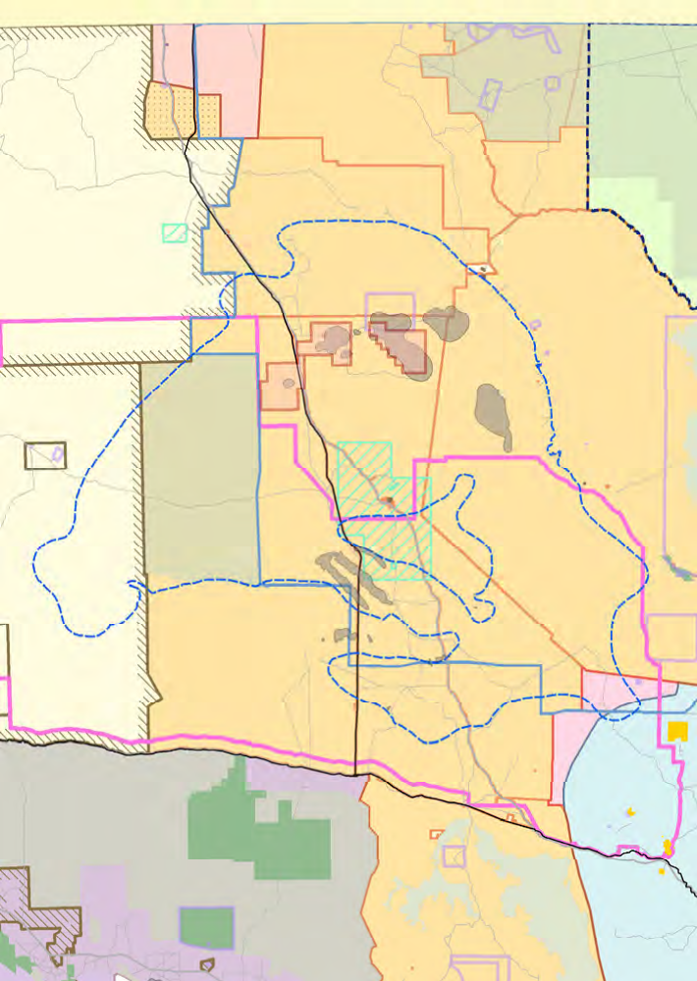0 50 100 150 km
REG 204218-014

Mineral exploration tenement
Mineral Exploration Licence (EL)

Restricted areas

MGA Zone 53

Indigenous Land Use
Agreement (ILUA)

Determinations of Native Title

Coalfield

Highway

Iron Knob

Port Augusta

Aboriginal Lands

Commonwealth land

Prescribed Wells Areas (PRESWA) Woomera Prohibited Area
National Estate area

Precious stones field

Parks with petroleum exploration access

Parks with no petroleum exploration access
Native Title Claims
SC96/4,
Barngarla Native Title Claim
SC97/3,
The Wangkangurru/Yarluyandi
Native Title Claim
SC06/1,
Far West Coast
SC09/1,
Kokatha Uwankara
Native Title Claim
SC10/5,
Tjayiwara Unmuru
Native Title Claim
SC12/2,
Naley Native Title Claim

! ! ! ! ! ! ! !
SP11/1,
! ! ! ! ! ! ! !
Roads
Railway

! ! ! ! ! ! ! !
De Rose Hill

! ! ! ! ! ! ! !

Figure 4.26 ELs 4511, 4512 and 4513, land access and Native Title.

Seam Name
QUATERNARY
Alluvium

Figure 4.28 Wintinna deposit cross - section.
CRETACEOUS
Bulldog Shale
204210-105

Coal Type
Cadna-Owie Formation
Sub-bituminous

Seam Description
Wintinna Open Cut Mine Target Area: 8 main seams (Figures 4.27 and 4.28) with combined 20-30 m thickness within 40-50 m vertical interval. Seams are un-weathered and generally flat lying with no structural complexities.
JURASSIC
Algebuckina
Sandstone

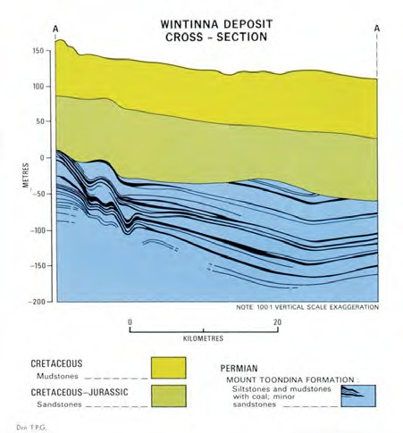

Unconformity
Isolation

Perentie Upper Perentie Goorikiana Upper
EARLY PERMIAN
Upper Mt Tooddina Formation
Goorikiana
Mirackina Upper

Mirackina

Arckaringa

Mt Barry Nilkinina Waddikee

0 20 metres
Figure 4.27 Typical Stratigraphy, Wintinna coal deposit.
Overburden Thickness
145-210 m

Coal Quality Data
Wintinna Deposit Typical Raw Coal Quality
(average all seams)

Total Moisture (as received) 36.6% Inherent Moisture (air dried basis) 13.2% Ash (air dried basis) 10.5% Volatile Matter (air dried basis) 32.5% Total Sulphur (air dried basis) 1.64% Chlorine (dry, ash free basis) 0.05% Specific Energy (air dried basis) 23.6 Mj/kg Relative Density 1.25 (g/cc)

Sources: Statement of Coal Resources Wintinna July 2008, McElroy Bryan Geological Services (MBGS) Wintinna Resource Coal Quality Review, July 2008, A and B Mylec (for MBGS)

4

Combined
Cycle
Power Plant

Syngas
CO+2H
LP Steam
Tail Gas

2

Coal
Diesel

Clean
0
Gasification
2 Up

Sulphur

Fischer-Tropsch
Synthesis

Naphtha
Refining

Other fuels

Insert Slag CO
2
By Product

Figure 4.29 CTL conversion process.

Coal Resource

Deposit | Million Tonnes (non JORC)
Measured1 Indicated1 Inferred1 Total
Wintinna 1,150 750 2,000 3,900
Westfield 100 200 500 800
Murloocoppie 250 300 2,600 3,150
7,850
Million Tonnes (JORC compliant)
Million Tonnes (JORC compliant) 187 650 450 1,287
1 Based on SA Dept. for Minerals and Energy standards in the 1980s.

The Wintinna Deposit coal resource statement prepared by McElroy Bryan Geological Services in 2008 incorporates the results of Altona’s 2007/08 drilling programme. The report shows a JORC compliant resource estimate of 1,287 Mt, of which 837 Mt is in the Measured and
Indicated categories. The resource estimate covers only about 25% of the known area of the Wintinna deposit.

One tonne of Wintinna coal yields one barrel of liquids plus power and industrial products. The JORC compliant coal resource is therefore equivalent to approximately 1.2 billion barrels of liquid hydrocarbons.

Conversion Process
The Coal-to-Liquids (CTL) process consists of
three main steps (Figure 4.29) in which run of mine solid coal feedstock is converted
to higher value product using Gasification and Fischer-Tropsch (FT) processes. These are:
• Synthesis Gas Generation

• Liquid Synthesis using FT process

• Products Upgrade

Large parts of the gasification and FT processes are exothermic. The Arckaringa Project will capture this heat to generate electricity and export it to the national grid. The nearest point of the SA electricity grid is some 350 km to the south at Roxby Downs/ Olympic Dam.

The Arckaringa Project is best summarized as a conventional open cut coal mine followed by processing and an oil refinery/petro- chemicals plant with efficient integrated combined cycle electricity generation which captures and uses waste heat.

Input
Coal feedstock: 10 Million Tonnes pa

Products
Fischer Tropsch Liquids:
• 10 Million Barrels pa (approx 80 % FT
diesel, 20% Naptha)

Power (Steam and Gas Turbines in Combined
Cycle Gas Turbine configuration):
• 1,140 MW (Gross)

• 562 MW (Net Export)

Environment And Land Access

Mining Act 1971 - Exploration
Amendments to the Mining Act that came into force on 1 July 2011 require the holder of an exploration licence (EL) to have
an approved program for environment protection and rehabilitation (PEPR) in place prior to the commencement of any exploration activities on an EL (Mining Act
1971 Part 10A, and Mining Regulation 114) (http://minerals.pir.sa.gov.au/licensing_and_ regulation/mining_operations).

A PEPR should identify all relevant environmental, social and economic impact events that may result from the proposed exploration activities and how each of
the identified impacts will be managed or
avoided.

DMITRE has developed a generic program
for environment protection and rehabilitation for low impact mineral exploration in South Australia which must be adhered to unless
an alternative low impact exploration PEPR has been developed and approved by the Minister. For all other activities (not within
the scope of the generic PEPR) a PEPR in accordance with Part 10A of the Act is required. Under Regulation 114 (Transitionary Provisions) an exploration work approval (EWA) for drilling/use of declared equipment, or a declaration of environmental factors (DEF) for exploration in sensitive areas (in accordance with EL conditions) are deemed to be a PEPR until 1 July 2014 unless otherwise required by the Minister.
It is intended that over the next 3 years a PEPR as required under the Act will eventually replace the current EWA and DEF formats. Guidelines and determinations for the development of this PEPR are currently being developed by DMITRE.

Exploration Compliance Reports (ECRs) are required as a condition of PEPR approval.

The Water Affecting Activity (WAA) permit
- required to cover the hydro-geological test and other drill holes currently planned, pursuant to the terms of the PEPR - was recently granted by the South Australian Arid Lands Natural Resources Management Board under the newly expanded and strengthened regulations governing water affecting activities in the Arid Lands regions of South Australia.

Following discussions with the Native Title claimant group Antakarinji Matu- Yankunytjatjara Aboriginal Corporation (AMYAC) and its representatives, the Work Area Clearance (WAC) process has also been formally completed. The discussions have been ongoing since October 2011
and led to a formal acceptance by AMYAC on 12 July 2012 that the drilling programme design and drill hole locations meet the terms of the WAC (as required under the PEPR granted by DMITRE). As a result, all drill hole locations are now cleared for drilling.

The WAC process involved the relocation and/or redesign of six of the proposed maximum 31 drill holes to protect aboriginal heritage concerns during, and as a result
of, the drill programme . During discussions, AMYAC and the Arckaringa JV partners have agreed to work together to achieve and implement a framework or Memorandum
of Understanding (MOU) that can lead to a Native Title Agreement to cover respective rights, responsibilities and economic opportunities during any future mining and development project at Wintinna.

Mining Act 1971 - Mining
There is a two-stage authorisation process for mining in South Australia. (http://minerals.pir. sa.gov.au/licensing_and_regulation/mining_ operations)

Applications for a Mining Lease (Mineral (ML) or Extractive Mineral Lease (EML)), Retention Lease (RL) or Miscellaneous Purposes Licence (MPL) must be supported by a ‘Mining Lease Proposal’.

Once a tenement is granted, a Program for Environment Protection and Rehabilitation (PEPR) is required to be approved before mining may commence.

Appropriate documentation is required to be prepared and submitted to DMITRE for approval. The purpose of the documentation is to provide a comprehensive and detailed description of environmental, social and economic risks and benefits of the proposed operation so that stakeholders and DMITRE can make an informed, risk-based and balanced judgment about the proposed operation.

The Mining Regulation and Rehabilitation
Branch of DMITRE regulates all operating
mine and quarry sites. Each mining operation has a DMITRE Mining Compliance officer who is responsible for ensuring the site is operated in compliance with Lease conditions and
it’s Program for Environment Protection and Rehabilitation (PEPR). The provision
for a PEPR under the amended Mining Act commenced on 1 July 2011. This replaced the regulation under the Mining Act relating to the requirement for a Mining and Rehabilitation Program (MARP).

Publically available documents relating to all mines in South Australia are available from the South Australian Resources Information Geoserver (SARIG). Go to the top left widget, select Databases, then Publications and Reports from the drop down list.

Environmental Protection, Biodiversity and
Conservation Act 1999
Potential impacts on water resources from coal mining are a focus of the Commonwealth Government’s Independent Expert Scientific Committee and the
National Partnership for Coal Seam Gas and Large Coal Mines agreed between
the South Australian State Government and
the Commonwealth Government in 2012. 4
Pursuant to this partnership plans are already in place for:
• regional studies of aquifers of the Arckaringa Basin and overlying younger basins; and

• the South Australian State Government
to be accredited as a one-stop-shop
for the State and Federal governments’
environmental assessments pursuant to the Commonwealth Government’s Environmental Protection, Biodiversity and Conservation Act 1999; and

• referring the environmental assessment of coal mining in the Arckaringa Basin to the Commonwealth Government’s Independent Expert Scientific Committee, to underpin informed regulation.

Forward Plan (Indicative Only)
2012 - Bankable Feasibility Study
2013 - Bankable Feasibility Study
2014 - Approvals and Financing
2015 – 2018 - Construction

Contact Details
Name: Chris Schrape - Managing Director, Altona Energy Plc (Director, Arckaringa Energy Pty. Ltd)
Phone: +61 8 8110 2500
Website: www.altonaenergy.com.au

4.2.2 Walloway UCG Project
Licence and Licence Holder
PEL 120
SAPEX Ltd* (100%)
Wholly owned subsidiary of Linc Energy
*Denotes operator

Location
Walloway Basin, South Australia (Figure 4.30).

Project Summary
Linc Energy, as operator of PEL 120 in the
Walloway Basin located approximately
90 km south east of Port Augusta, completed a 15 well drilling program near Orroroo
(Figure 4.31) between August 2009 and March 2010 to assess the underground Coal Gasification (UCG) of Tertiary lignites (Figure 4.32).

The first 5 wells intersected coal at depths of between 200 and 293 m with coal seam thicknesses of up to 23 m. On completion of these wells Linc Energy commissioned Xenith Consulting Pty Ltd who determined
that, in accordance with the JORC Code, a
significant coal mineralisation target of 1.0 to
1.3 billion metric tonnes is indicated.

Unconventional Hydrocarbon Resource
Targeted
• Underground Coal Gasification
(Figure 4.33)

Target Formations
• Walloway Rider coal seam (UCG)

• Walloway coal seam (UCG)

Target Depths
• Walloway Rider coal seam: ~240 m

• Walloway coal seam: 200-293 m

Target Thickness
• Walloway Rider coal seam: ~3 m

• Walloway coal seam: 8-23 m

Exploration Results To End 2011
• Completed 15 wells in the Orroroo area
(Orroroo 1 to 15 wells)
Environment and Land Access
Grant of a petroleum licence does not enable (approve) regulated activities within those tenements. Approval for an activity (e.g. geophysical surveys or
drilling) is a separate process that is subject to a separate, rigorous assessment and consultation process, so that operations
are planned and regulated to be sound, safe and meet community expectations for outcomes. An Environmental Impact Report (EIR) must be prepared, in consultation with stakeholders and relevant government agencies, addressing potential threats
and risks to the environment, and the extent to which these threats are likely and manageable. A Statement of Environmental Objectives (SEO), developed through an open, consultative process and based
on information in the EIR, must then be approved for compliance before a regulated activity can proceed. Please see Chapter 5 for further details of the approval process.

Copies of EIRs and SEOs prepared by licensees for regulated activities, and Environmental Significance Assessments prepared by the Energy Resources Division can be downloaded via the following
link: http://www.pir.sa.gov.au/petroleum/ environment/register/seo,_eir_and_esa_ reports

Forward Plan
2012 - 2013: To be supplied

Contact Details
Name: Ryan Koch
Phone: 08 8405 8708
Website: www.lincenergy.com

The Dutchmans
Stern (CP)

138°0'E

"

SEE Figure 4.30

SC11/1

139°0'E

SC99/1
Adnyamathanha No.1
140°0'E 4

Quorn Adnyamathanha #4
SC10/2

Davenport
Port Augusta "
Native Title Claim
Ngadjuri Nation

PL2
Winninowie (CP)
Mount Brown (CP)

Mount

"
Orroroo
Yalpara (CP) Black Rock (CP)
"
Yunta

SC12/1
Wilyakali

Remarkable (NP)
"
Melrose
Walloway Basin

Whyalla
(CP)
33°0'S

"

Whyalla

"
Port

Baroota
Telowie Gorge (CP)

"
Peterborough

Pualco
33°0'S
Range (CP)

SC96/4
Barngarla
Native Title
Claim

Munyaroo (CP)
Germein

"
Port Pirie
SC96/5
Nukunu Native
Title Claim

" Jamestown
PL1
Pandappa (CP)

Caroona Creek (CP)

Clements
Gap (CP)

Mokota (CP)

SC11/2

PEL
120

Clare
"

Burra
"
Ngadjuri Nation #2
Red Banks (CP) Hopkins
Creek (CP)

" Wallaroo
" Kadina
34°0'S

" Lochiel

Spring Gully (CP)
White Dam (CP)

Morgan "
34°0'S

" Moonta
Moonta

Port
Clinton (CP) " Wakefield

PL1

Kapunda

Roonka (CP)
Morgan (CP)

Wills Creek (CP)
" Maitland
"

Nuriootpa
SN94/1
Brookfield (CP)

PL6

) Point Pearce

SC00/1
Kaurna Peoples

Gawler
" " Penrice

Kaiserstuhl
Swan
Reach

Bakara
(CP)

Native Title Claim
Northern Adelaide
Plains PRESWA
" Gulf
" (CP) Hale (CP)
Para Wirra (RP)

PL13
Central

PL6
Swan Reach (CP)
Ridley (CP)

Mallee
PRESWA

Minlaton
St Vincent
SC10/3
Ramindjeri
Adelaide
Port Gawler (CP)
"

Minlacowie (CP)
138°0'E
ADELAIDE "
PRESW139A°0'E
Mannum
Lowan (CP)

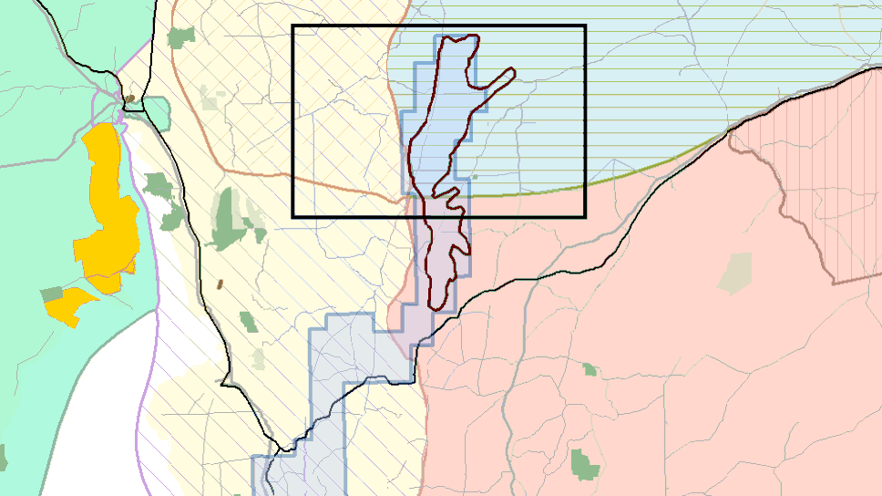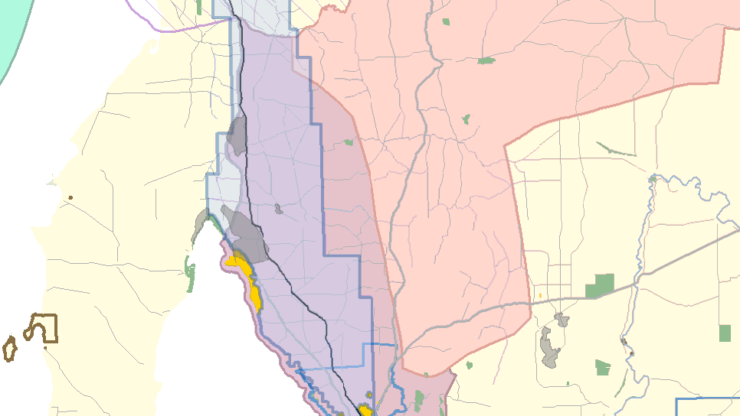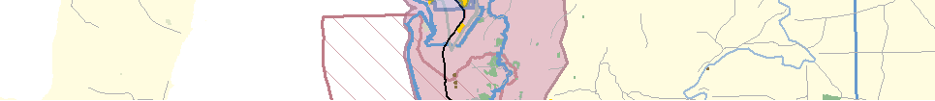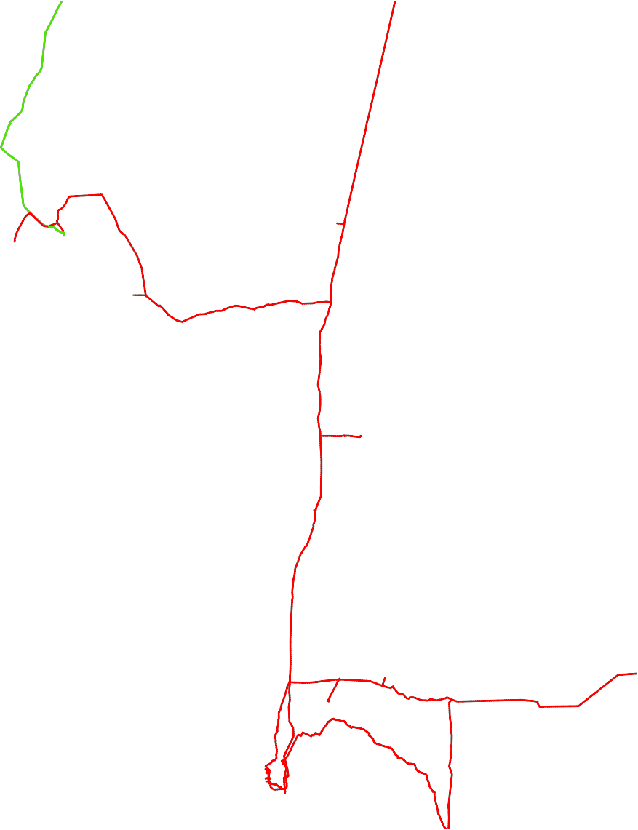REG 204218-039

0 20 40 60 80 km

MGA Zone 54

CSG exploration wells

Selected exploration tenement
Petroleum Exploration Licence (PEL)

Native Title Claims
SC96/4, Barngarla Native Title Claim SC96/5, Nukunu Native Title Claim SC99/1, Adnyamathanha No.1
SC00/1, Kaurna Peoples Native Title Claim
SC10/2, Ngadjuri Nation
SC10/3, Ramindjeri
SC11/1, Adnyamathanha #4 Native Title Claim
SC11/2, Ngadjuri Nation #2
SC12/1, Wilyakali
SN94/1, R J Howard Investments

Restricted areas
Aboriginal Lands
Commonwealth land

Prescribed Wells Areas (PRESWA) Parks with petroleum exploration access Parks with no petroleum exploration access
Pipeline Licence (PL)
Gas
Liquids

Highway
Roads
Railway

Figure 4.30 PEL 120, land access and Native Title.

138°20'E
32°20'S
138°30'E
138°40'E
138°50'E
139°0'E

SC11/1
Adnyamathanha #
Native Title Claim

PEL
120
Walloway
Basin
32°20'S

Yalpara (CP)
32°30'S
SC99/1
Adnyamathanha No.1
32°30'S

SC96/5
Nukunu Native
Title Claim
2
6 7 8
1 3 10
9
5

SC10/2
Ngadjuri Nation
32°40'S

11 4 12
32°40'S
13 14
15

Black Rock (CP)

138°20'E

138°30'E
"
Orroroo

138°40'E

138°50'E

SC11/2
Ngadjuri Nation #2
139°0'E

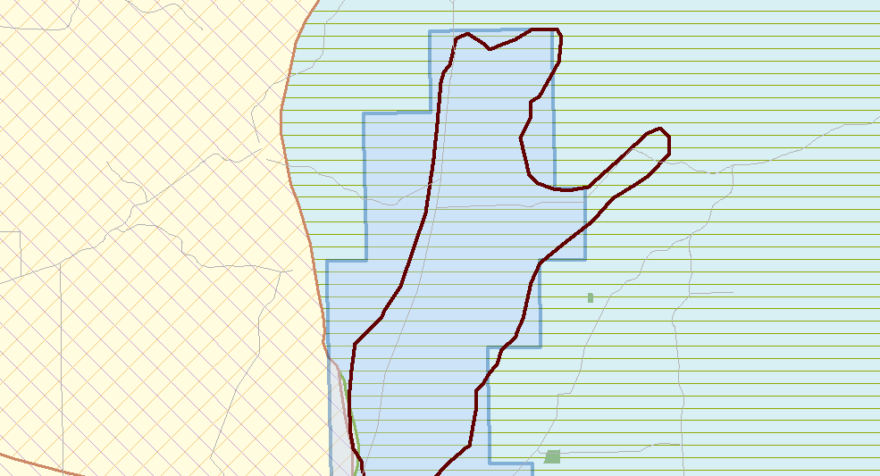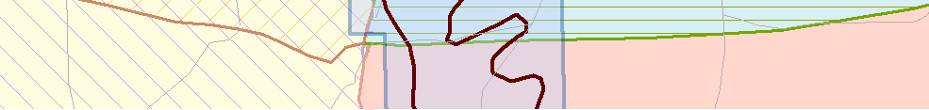REG 204218-040

0 20 km

MGA Zone 54

CSG exploration wells

Selected exploration tenement
Petroleum Exploration Licence (PEL)

Restricted areas
Parks with no petroleum exploration access
Native Title Claims
SC96/5, Nukunu Native Title Claim
SC99/1, Adnyamathanha No.1
SC10/2, Ngadjuri Nation
SC11/1, Adnyamathanha #4 Native Title Claim
SC11/2, Ngadjuri Nation #2

Figure 4.31 Location of drillholes, PEL 120 Walloway Basin.

4
WELL ORROROO 2 |  |  | WALLOWAY BASIN |  |  |  |  | PEL 120
EASTING | 279787 | NORTHING |  | 6390380 | ELEVATION | 362m | COMPILED BY S KWITKO
DATE SPUD | 03/09/09 | TD DRILLED |  | 289.3m GL | TD LOGGED | 285.4m GL | DATE SEPT 2009

Depth
0

1
GRA

API
LSDG

g/cc

200
0

3
DTP

μs/ft
RLLD

LITH
200

WELL

CONSTRUCTION

Description

m GL
CALI

0 75
mm 200 1
OHMM
1000

CLAY - red brown, soft

CLAY (70%) - red brown, soft GRAVEL (30%) - sub-angular to angular, poorly sorted, with pebbly lithics

CLAY - red brown, soft

CLAY (50%) - red brown, soft GRAVEL (50%) - angular, poorly sorted, with pebbly lithics

50

CLAY - light yellow to khaki, stiff, puggy, mottled

100

CLAY - grey to red-brown, soft, very sticky

CLAY - grey, soft, very sticky

150
CLAY, SILT, SAND - light grey soft clay and silt interbedded with pale grey, very fine grained sand

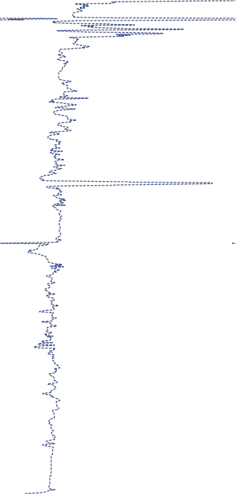

CLAY - medium grey to brown, soft

CLAY, SAND - light grey, soft clay interbedded with pale grey, very fine grained, subrounded, well sorted sand

200

CLAY - grey, soft, becoming carbonaceous towards base

COAL - lignite, dark brown

CLAY - medium grey, soft, carbonaceous fragments

250
CLAY, SILTSTONE - medium grey clay interbedded with bluish grey siltstone

SILTSTONE - bluish grey hard siltstone interbedded with minor dark shale bands

300

Figure 4.32 Stratigraphic section, Orroroo 2, Walloway Basin.

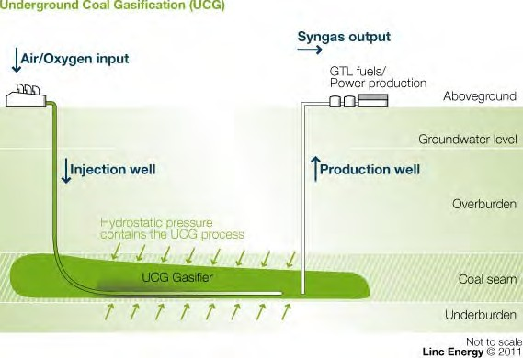
Figure 4.33 UCG process

4.2.3 Kingston Project Licences And Licence Holders PEL 127, EL 4576
Hybrid Energy Australia Pty. Ltd. - fully owned
subsidiary of Strike Energy Limited* (100%)
*Denotes operator

Location
Otway Basin South Australia (Figure 4.34).

Project Summary
In 1979, Western Mining Corporation Holdings Limited (WMC) discovered lignite in the Tertiary Dilwyn Formation on the northern margin of the Otway Basin (Figures 4.35
and 4.36). An extensive drilling programme comprising 950 holes (92 cored) followed over the next seven years, and a 985 million tonne deposit was delineated. The Kingston lignite was considered a feedstock for a proposed State power generation plant and comprehensive geological, geotechnical, hydrological, environmental and mining feasibility studies were undertaken. Pilot
combustion tests were conducted on bulk samples of the lignite extracted by 1 m diameter coring.

Strike Energy acquired the Kingston
lignite asset in 2005, and commenced an investigation of the resource for combustion and gasification potential.

The WMC drilling was sufficient for a JORC compliant resource estimate of 578 Mt (measured and indicated), determined
in 2007. Preliminary mining scope and groundwater studies followed in 2008/2009, with combustion and gasification test work
on the coals completed in 2011. The intensive gasification test work undertaken by the University of Adelaide confirmed that the Kingston lignite can be successfully gasified using fluid bed gasification technology to deliver good quality syngas that is high in hydrogen (Figure 4.37). Bench scale testing was undertaken to determine the optimal bed material and temperature operating

window, and semi-industrial scale testing was undertaken to prove that a continuous operation can be maintained and also demonstrate the range of gas compositions produced.

The project work completed by Strike Energy has confirmed that the Kingston Lignite Deposit can be mined, combusted, and gasified to produce syngas with the potential to manufacture high value products such as liquid fuel, urea, ammonia and methanol. Strike is currently seeking a partner for the advancement of the project.
Unconventional Hydrocarbon Resource 4
Targeted
Mined coal to synthesis gas (Figure 4.38)

Coal Deposits
Kingston Lignite Deposit

Target Formation
Dilwyn Formation

Coal Type
Lignite

140°0'E

Mallee PRESWA
141°0'E

Mount Boothby (CP)
Ngarkat (CP)

Coorong (NP)
36°0'S
SC98/4
Ngarrindjeri and Others
Native Title Claim

Messent
(CP)

Martin
Washpool (CP)

Gum Lagoon (CP)

Tintinara-Coonalpyn
36°0'S
PRESWA
Kelvin Powrie (CP)

" Keith
Tatiara PRESWA

Coorong and Lakes
Alexandrina and Albert
PEL 127

Tilley
Swamp (CP)

Gum Lagoon (CP)
Mount
Monster (CP)
Poocher Swamp (GR)

Aberdour (CP)

Bordertown
"

EL 4576
PL13
Wolseley Common (CP)
Custon (CP)

Jip Jip (CP)
Desert Camp (CP)

Pine Hill Soak (CP)
VICTORIA

Hanson Scrub (CP)
Padthaway "

Padthaway (CP) Bangham (CP)

0 10 20 30 km

MGA Zone 54
Padthaway
PRESWA
Talapar (CP)

Geegeela (CP)

Kingston
Grass Tree (CP)

Rosetown, Grave Reserve
Kingston "

Butcher Gap (CP)
Mount Scott (CP) Fairview (CP)

Mullinger
Swamp (CP)

Vivigani Ardune (CP) "
37°0'S

Naracoorte "
37°0'S
Naracoorte

Otway Basin
Kungari (CP)
Lucindale
Caves (NP)
Bool and Hacks

Guichen Bay (CP)
Lower Limestone Coast PRESWA
Lagoons

Hacks Lagoon (CP)

Robe
"
Woakwine (CP)
140°0'E
Big Heath (CP) Mary Seymour (CP)

Bool Lagoon
(GR)

141°0'E

Selected exploration tenements
Petroleum Exploration Licence (PEL) Mineral Exploration Licence (EL)

Gas pipeline

Coalfield

Native Title Claims
SC98/4,
Ngarrindjeri and Others
Native Title Claim

Restricted areas
Aboriginal Lands
Prescribed Wells Areas (PRESWA) Ramsar site
Parks with petroleum exploration access

Parks with no petroleum exploration access
REG 204218-019

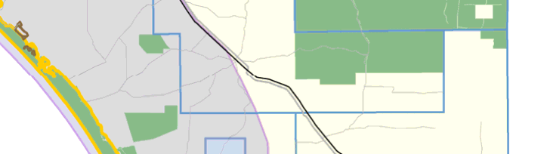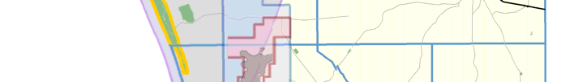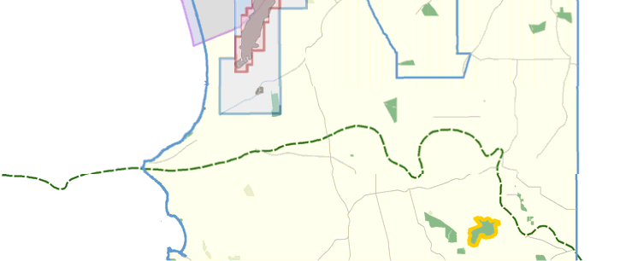 Highway
Roads
Railway

Figure 4.34 PEL 127 and EL 4576, land access and Native Title.

0 m Seam Description
The lignite deposit occurs in a NE trending elongate depression 27 km long and up to
RECENT
Moulineaux
Sand
5 km wide. The lignite lies predominantly in one horizon, occurring as a single seam in
Padthaway
FM
10 the south of the deposit and with partings
in the north (Figure 4.36). Maximum seam thickness is 9 m. In the north of the deposit a thickness of 12 m is attained where the main seam coalesces with an overlying less well
QUATERNARY

PLEISTOCENE
Bridgewater
FM
20
developed lignite horizon.
Coomandook
Formation

Overburden Thickness
20-80 m

30 Coal Quality Data
OLIGACENE
Gambier
Limestone
Kingston Lignite Deposit typical raw coal quality:
• Moisture (as received): 53.3%

40 • Ash (dry basis): 14.9%
Narrawaturk
Marl

• Volatile Matter (dry basis): 46.9%

• Sulphur (dry basis): 2.9%

• Sodium (dry basis): 0.85%
50
• Chlorine (dry basis): 0.15%
TERITIARY
Mepunga

• Specific Energy (dry basis): 22.7 MJ/kg

• Relative Density: 1.2

60 Coal Resource

70 MDOA Seam
Kingston Deposit Strip Ratio | Million Tonnes  (JORC compliant)  Measured Indicated Total
< 5:1 217.1 4.5 221.5
5 to 10:1 229.9 20.8 250.7
>10:1 76.5 29.5 106.0
Total 523.5 54.8 578.3

EOCENE
Dilwyn Formatin (Fm)

80
ORDOVICIAN CAMBRIAN
Kanmantoo Group

NB. Thickness of formations diagrammatic only

Figure 4.35 Lignite seams in the Tertiary Dilwyn
Formation, Kingston deposit.
MDOB Seam

Input
Lignite from conventional open cut mining

Processing
Fluid bed gasification technology.

Product
Hydrogen rich synthesis gas, suitable for the manufacture of a range of products such as urea, ammonia, methanol or liquid fuel.

Environment And Land Access
Petroleum and Geothermal Act 2000

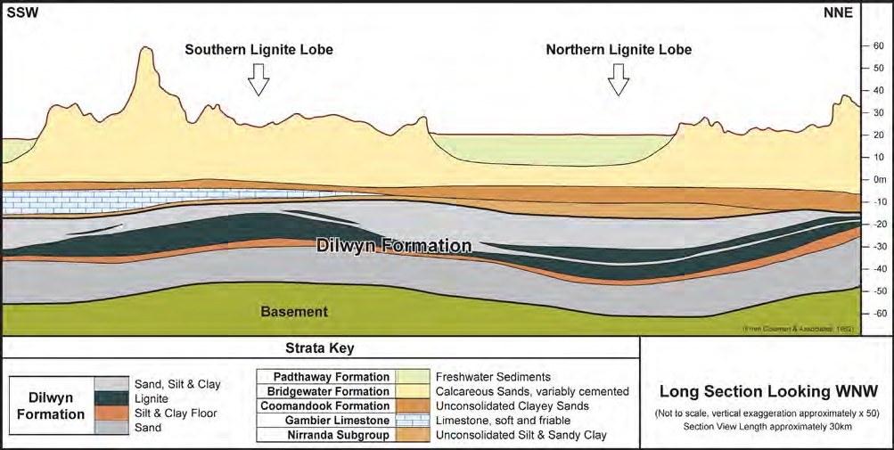Figure 4.36 Cross section showing the lignite lobes of the Kingston deposit.

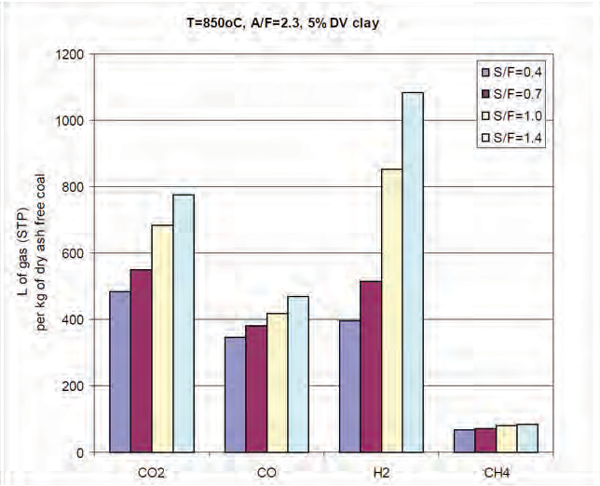

Figure 4.37 Effect of steam/fuel ratio on gas yield (L/kg) determined from semi-industrial scale gasifier (air/fuel = 2.3, bed T = 850ºC, 5% clay addition).

Grant of a petroleum licence does not enable (approve) regulated activities within those tenements. Approval for an activity (e.g. geophysical surveys or
drilling) is a separate process that is subject to a separate, rigorous assessment and consultation process, so that operations
are planned and regulated to be sound,
safe and meet community expectations for outcomes. An Environmental Impact Report (EIR) must be prepared, in consultation with stakeholders and relevant government agencies, addressing potential threats
and risks to the environment, and the extent to which these threats are likely and manageable. A Statement of Environmental Objectives (SEO), developed through an open, consultative process and based
on information in the EIR, must then be approved for compliance before a regulated activity can proceed. Please see Chapter 5 for further details of the approval process.

Copies of EIRs and SEOs prepared by licensees for regulated activities, and Environmental Significance Assessments prepared by the Energy Resources Division can be downloaded via the following link: www.pir.sa.gov.au/petroleum/environment/ register/seo,_eir_and_esa_reports

Mining Act 1971 - Exploration
Amendments to the Mining Act that came into force on 1 July 2011 require the holder of an exploration licence (EL) to have
an approved program for environment

CO
Combined Cycle Power Generation

2

n

n o
Carbon Dioxide Capture a Compressi
d
on

Lignite  Preparati and Size Reductio | n
 | n

Syngas Cleaning a Conditioni |  | nd
 |  | ng

Gasifier

Lignite Mi and Wate Manageme | e r
 | nt

Sulfer
Recovery

CO to
2
Geosequestration

Processing
Electricity

Naphtha
Product Recovery and Refining

Diesel

Sulfer

Mining Preparation Gasification Cleaning Synthesis Conversion
Final
Products

Figure 4.38 Coal Gasification – Process and Products.

protection and rehabilitation (PEPR) in place prior to the commencement of any exploration activities on an EL (Mining Act
1971 Part 10A, and Mining Regulation 114) (http://minerals.pir.sa.gov.au/licensing_and_ regulation/exploration#pepr).

A PEPR should identify all relevant environmental, social and economic impact events that may result from the proposed exploration activities and how each of
the identified impacts will be managed or
avoided.

DMITRE has developed a generic program
for environment protection and rehabilitation for low impact mineral exploration in South Australia which must be adhered to unless
an alternative low impact exploration PEPR has been developed and approved by the Minister. For all other activities (not within
the scope of the generic PEPR) a PEPR in accordance with Part 10A of the Act is required. Under Regulation 114 (Transitionary Provisions) an exploration work approval (EWA) for drilling/use of declared equipment, or a declaration of environmental factors (DEF) for exploration in sensitive areas (in accordance with EL conditions) are deemed to be a PEPR until 1 July 2014 unless otherwise required by the Minister.
It is intended that over the next 3 years a PEPR as required under the Act will eventually replace the current EWA and DEF formats. Guidelines and determinations for the development of this PEPR are currently being developed by DMITRE.

Exploration Compliance Reports (ECRs) are required as a condition of PEPR approval.

Mining Act 1971 - Mining
There is a two-stage authorisation process for mining in South Australia. (http://minerals.pir. sa.gov.au/licensing_and_regulation/mining_ operations)

Applications for a Mining Lease (Mineral (ML) or Extractive Mineral Lease (EML)), Retention Lease (RL) or Miscellaneous Purposes Licence (MPL) must be supported by a ‘Mining Lease Proposal’.

Once a tenement is granted, a Program for Environment Protection and Rehabilitation (PEPR) is required to be approved before mining may commence.

Appropriate documentation is required to be prepared and submitted to DMITRE for approval. The purpose of the documentation is to provide a comprehensive and detailed

economic risks and benefits of the proposed operation so that stakeholders and DMITRE can make an informed, risk-based and balanced judgment about the proposed operation.

The Mining Regulation and Rehabilitation
Branch of DMITRE regulates all operating
mine and quarry sites. Each mining operation has a DMITRE Mining Compliance officer who is responsible for ensuring the site is operated in compliance with Lease conditions and
it’s Program for Environment Protection and Rehabilitation (PEPR). The provision
for a PEPR under the amended Mining Act commenced on 1 July 2011. This replaced the regulation under the Mining Act relating to the requirement for a Mining and Rehabilitation Program (MARP).

Publically available documents relating to all mines in South Australia are available from the South Australian Resources Information Geoserver (SARIG). Go to the top left widget, select Databases, then Publications and Reports from the drop down list.

The original Western Mining Corporation Kingston lignite project environmental assessment reports include:
• Assessments Branch, 1984. Kingston Lignite Project. Assessment report, South Australian Department of Environment and Planning. South Australia. ISBN
0724387447

• Kinhill Stearns, 1983a, Kingston Lignite Project: draft environmental impact statement. Prepared for Western Mining Corporation Limited by Kinhill Stearns. ISBN 0959267816

• Kinhill Stearns, 1983b. Kingston Lignite Project: supplement to the draft environmental impact statement. Prepared for Western Mining Corporation Limited by Kinhill Stearns. ISBN 0949397032.

Twenty six public and eight government submissions were received in response to the Draft EIS (1983a). Issues raised in each
proponent or included in full as appendices in the Supplement (1983b). Hard copies of the reports and submissions held in various libraries across the country can be located through the National Library of Australia – go to http://trove.nla.gov.au/

Contact Details
Name: Mr Andrew Hooper-Nguyen – Chief Financial Officer and Chief Commercial Officer
Phone: +61 2 8261 1000
Website: www.strikeenergy.com.au

