OT2025 RSEL-C ACREAGE RELEASE
To:
Executive Director, Regulation and Compliance Division, Department for Energy and Mining (as authorised delegate of the Minister for Energy and Mining).

Full name(s) Participating interest (%)
Business address
Telephone
Email

Full name(s) Participating interest (%)
Business address
Telephone
Email

Full name(s) Participating interest (%)
Business address
Telephone
Email

Full name(s) Participating interest (%)
Business address
Telephone
Email

Name of participant who may be contacted about the application

We hereby make application for the grant of a regulated substances exploration licence in respect of the area described hereunder and as shown on the attached map.

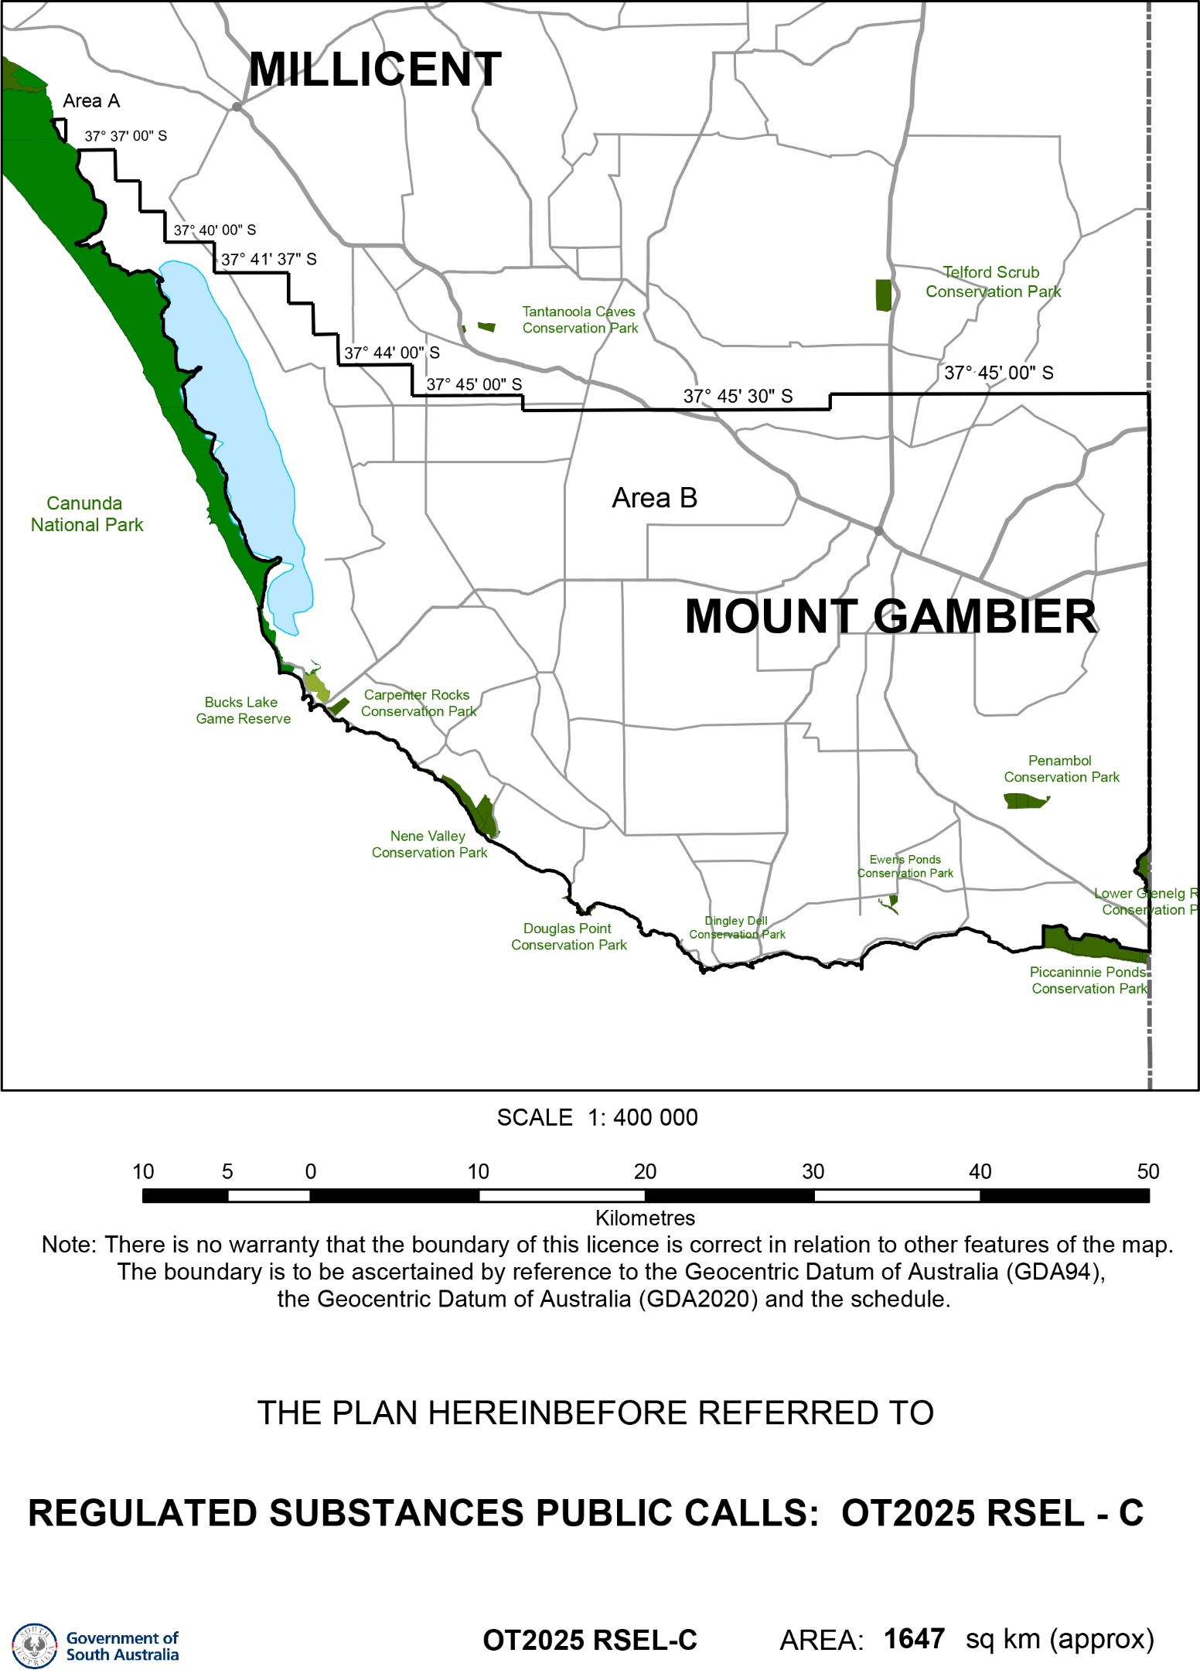

In the case of an incorporated body applicant only – A copy of our most recent audited annual financial statement and our expected financial position over the anticipated term of the licence is attached. (Include statements for each participant.)
In the case of personal applicants only – A statement demonstrating my/our expected financial position over the anticipated term of the licence is attached. (Include statements for each participant.)
The proposed work program for each of the five years of the initial term of the licence, which includes specific reference to the ‘OT2025 Bid Assessment Policy’, and a technical report that assesses the prospectivity of the area and how the proposed work program relates to this prospectivity is attached.
The application fee/remittance advice for electronic funds transfer is enclosed. Please refer to the following web page from 1 July 2025 to determine the applicable application fee for FY 2025/26, and for DEM banking details for payments made by electronic funds transfer:
https://www.energymining.sa.gov.au/industry/energy-resources/licensing-and-land-access/onshore-licensing/regulated-fees
Alternatively, please email: DEM.EnergyResourcesAcreageRelease@sa.gov.au

Signature of applicant(s):
Dated this Day of 2025

SEND APPLICATION MARKED ‘Confidential — contains RSEL application’ to:
Executive Director, Regulation and Compliance Division
Department for Energy and Mining
Email DEM.EnergyResourcesAcreageRelease@sa.gov.au

Closing date for OT2025 RSEL-C applications –
5:00 pm Australian Central Daylight Time
31 October 2025

OT2025 RSEL-C YEAR 1 WORK PROGRAM
Note: All work in Year 1 is guaranteed (Energy Resources Act 2000)

Regulated substance to be explored
Petroleum | Hydrogen | Other

Exploration wells Year 1
 | Well 1 | Well 2 | Well 3 | Well 4 | Well 5
Cost (A$’000)
Number of Play target/s

Further information on play target/s to be addressed

Attach documents if required.

Seismic Year 1
 | km/km²  length/area must be specified | Cost (A$’000)
2D Seismic
3D Seismic
Seismic reprocessing

Other studies Year 1
 | Cost (A$’000) | Description
Gravity surveys
Aeromagnetic surveys
Other (e.g. geochemical surveys

Comments/any other information

Attach documents if required.

OT2025 RSEL-C YEAR 2 WORK PROGRAM
Note: All work in Year 2 is guaranteed (Energy Resources Act 2000)

Regulated substance to be explored
Petroleum | Hydrogen | Other

Exploration wells Year 2
 | Well 1 | Well 2 | Well 3 | Well 4 | Well 5
Cost (A$’000)
Number of Play target/s

Further information on play target/s to be addressed

Attach documents if required.

Seismic Year 2
 | km/km²  length/area must be specified | Cost (A$’000)
2D Seismic
3D Seismic
Seismic reprocessing

Other studies Year 2
 | Cost (A$’000) | Description
Gravity surveys
Aeromagnetic surveys
Other (e.g. geochemical surveys)

Comments/any other information

Attach documents if required.

OT2025 RSEL-C YEAR 3 WORK PROGRAM
Note: All work in Year 3 is guaranteed (Energy Resources Act 2000)

Regulated substance to be explored
Petroleum | Hydrogen | Other

Exploration wells Year 3
 | Well 1 | Well 2 | Well 3 | Well 4 | Well 5
Cost (A$’000)
Number of Play target/s

Further information on play target/s to be addressed

Attach documents if required.

Seismic Year 3
 | km/km²  length/area must be specified | Cost (A$’000)
2D Seismic
3D Seismic
Seismic reprocessing

Other studies Year 3
 | Cost (A$’000) | Description
Gravity surveys
Aeromagnetic surveys
Other (e.g. geochemical surveys)

Comments/any other information

Attach documents if required.

OT2025 RSEL-C YEAR 4 WORK PROGRAM
Note: All work in Year 4 is guaranteed (Energy Resources Act 2000)

Regulated substance to be explored
Petroleum | Hydrogen | Other

Exploration wells Year 4
 | Well 1 | Well 2 | Well 3 | Well 4 | Well 5
Cost (A$’000)
Number of Play target/s

Further information on play target/s to be addressed

Attach documents if required.

Seismic Year 4
 | km/km²  length/area must be specified | Cost (A$’000)
2D Seismic
3D Seismic
Seismic reprocessing

Other studies Year 4
 | Cost (A$’000) | Description
Gravity surveys
Aeromagnetic surveys
Other (e.g. geochemical surveys)

Comments/any other information

Attach documents if required.

OT2025 RSEL-C YEAR 5 WORK PROGRAM
Note: All work in Year 5 is guaranteed (Energy Resources Act 2000)

Regulated substance to be explored
Petroleum | Hydrogen | Other

Exploration wells Year 5
 | Well 1 | Well 2 | Well 3 | Well 4 | Well 5
Cost (A$’000)
Number of Play target/s

Further information on play target/s to be addressed

Attach documents if required.

Seismic Year 5
 | km/km²  length/area must be specified | Cost (A$’000)
2D Seismic
3D Seismic
Seismic reprocessing

Other studies Year 5
 | Cost (A$’000) | Description
Gravity surveys
Aeromagnetic surveys
Other (e.g. geochemical surveys)

Comments/any other information

Attach documents if required.

