chapter
6

Unconventional Gas Supply-Chains (Information, Materials, Equipment,
Services, Infrastructure and People)

6.1 Introduction

Upstream petroleum producers, contractors to those producers, and petroleum users have a common interest in efficient, high quality and competitive supply chains. The difference in the cost of exploration and development for gas to markets between scenarios with efficient, high quality supply chains that leverage on economies of
scale and scenarios with uncompetitive supply chains is easily AUD 1 per GJ. A competitive gas price that is, for example,
$6 per GJ rather than $7 per GJ is more than double the value of royalties to South Australians through lower energy bills, and
the associated flow-on affect of competitive energy prices. Such a difference in ex- wellhead cost per GJ can result from both well costs and well productivity profiles.
One example of innovation to attain cost reduction is to take a ‘factory’ approach to drilling several wells from a single pad,
minimising mobilisation / demobilisation and flow-line costs, as well as enabling specialist crews to focus in incremental improvements for efficiency (Williamson, S., 20121)

With that as context, the primary objectives of this chapter are to:
• Provide information to justify risk-taking by people and enterprises to prepare to compete for supply-chain opportunities

1 Williamson, S, 2012, Australia to become a major gas player: A need to change the rules of the game, Presentation at APPEA’s CSG Conference, Brisbane, 8-10 October 2012
associated with unconventional gas development in South Australia;

• Characterise materials, equipment, services, infrastructure and people in supply chains that are essential for the economic development, processing and transport of unconventional gas to markets; and

• Reveal the magnitude of opportunities, and in doing so, boost competition for local, national and international content in those supply chains associated with the development of significant shale and tight gas in the South Australian Cooper Basin.

This chapter will also outline a model to maximise the opportunities for growing the sector, focussed on the identification of opportunities and the creation of clusters and centres of excellence. This chapter will focus on shale and tight gas resources in the South Australian Cooper Basin.

6.2 Why Expect Significant Unconventional Gas Projects in South Australia?

Success in the development of shale gas, shale oil, tight gas, and Coal Seam Gas (CSG) in North America is stimulating
investment to unlock enormous potential to develop unconventional gas resources in many countries – including Australia. Indeed, it is realistic for Australia to aspire to increase

CSG production and for South Australia to be (at least) a successful fast follower of the USA in developing shale and tight gas resource plays.

Multiple-use land access for environmentally sustainable upstream petroleum operations will be a key lead factor in South Australian’s rewards from unconventional gas development, and success by a number
of companies in multiple unconventional gas plays will drive supply-side competition. Supply-side competition in Australian
gas markets can enable decades of simultaneous growth in both LNG exports; and domestic use of competitively priced gas for heating, power generation and feedstock for manufacturing.

Underpinning such aspirations is the level of interest in unconventional gas plays in
South Australia. At the time of writing this report, 24 Joint Ventures (JVs) are exploring
9 unconventional gas plays in South Australia, and each has potential for the development of significant gas projects as listed and located in Figure 6.1. The chance at least one unconventional gas play will
be developed is very high, as illustrated with Figure 6.2. Furthermore, the development of oil and gas in the Cooper Basin demonstrates that the challenge of distance from markets has, and can be, overcome for economic gas development.

The balance of this chapter is focused on shale and tight gas resources in the South Australian Cooper Basin. Chapter 2 provides descriptions of all recognised unconventional gas plays; and Chapter 4 provides summaries of leading unconventional gas projects in South Australia. Also, for the gasification of

EROMANGA BASIN
! ! ! !
! ! ! !
! ! ! !
! ! ! !
UNCONVENTIONAL PLAYS
! ! ! ! !
! ! ! ! ! !
! ! ! ! ! !

LAKE EYRE BASIN
! ! ! ! !
! ! ! ! !
! ! ! ! !
! ! ! ! !
in SOUTH AUSTRALIA

S.A.

Murloocoppie

East Wintinna
! ! ! ! ! ! ! !
! ! ! ! ! ! ! ! ! !
! ! ! ! ! ! ! ! ! ! !
! ! ! ! ! ! ! ! ! ! ! !
! ! ! ! ! ! ! ! ! ! ! !
! ! ! ! ! ! ! ! ! ! ! ! ! !
! ! ! ! ! ! ! ! ! ! ! ! ! ! !
COOPER
! ! ! ! ! ! ! ! ! ! ! ! ! ! !
BASIN

Prospective plays in the mix:

Westfield

Wintinna

Weedinna
! ! ! ! ! ! ! ! ! ! ! ! ! ! !
! ! ! ! ! ! ! ! ! ! ! ! ! !
! ! ! ! ! ! ! ! ! ! ! ! ! !
! ! ! ! ! ! ! ! ! ! ! ! !
! ! ! ! ! ! ! ! ! ! ! !
T
! ! ! ! ! ! ! ! ! ! ! !
! ! ! ! ! ! ! ! ! ! ! !
! ! ! ! ! ! ! ! ! ! ! !
! ! ! ! ! ! ! !
! ! ! ! ! ! ! ! ! ! !
1. Shale gas in the Cooper
(>3 JVs)

Fractured shales also
Coober Pedy ")
Ingomar
Phillipson
! ! ! ! ! ! ! ! ! ! !
! ! ! ! ! ! ! ! ! ! !
! ! ! ! ! ! ! ! ! ! !
! ! ! ! ! ! !
! ! ! ! ! !
!
2. Shale gas in the Otway
(>2 JVs)
3. Shale gas in the Officer

yield ethane, LPG,
condensate and sometimes oil

Market options:
ARCKARINGA BASIN
124

) Leigh Creek
Telford, Copley Basin
TORRENS BASIN
(2 JVs)
4. Gas in low permeability reservoirs (tight gas) –

Electricity generation, heating and cooling, LNG, CNG, CTL, gas storage, bio-fuel blinding,
petrochemicals including fertilizers, car battery supply chains

POLDA BASIN

WILLOCHRA BASIN

WALLOWAY BASIN

NORTHERN St VINCENT BASIN
Cooper Basin (>3 JVs)
5. Fracture stimulation of coals, Cooper Basin (>3 JVs)
6. Coal Seam Gas in the
Eromanga (>3 JVs)

0 100 200 300 km

GDA94 - Equidistant Conic
Lock
Lochiel
PIRIE BASIN
7. Underground coal

! ! ! ! ! Basin under exploration for shale gas
! ! ! ! ! !
Bowmans
Anna
Sedan
gasification – Walloway,

! ! ! ! ! !
T

Tight gas plays

BASIN

") ADELAIDE
Moorlands
Arckaringa, Pedirka and
other basins (2 JVs)

Major coal-bearing sedimentary basins
Tertiary
Permian
St VINCENT

MURRAY BASIN
8. Coal mining – Arckaringa
& Tertiary basins for power

Mesozoic
Kingston

!
! ! ! !
generation, syngas and
synfuel (>4 JVs)

Coal deposit
Petroleum tenements targetting coal plays
Petroleum exploration licence (PEL)
Petroleum exploration licence application (PELA)
! ! ! ! ! ! !
! ! ! ! ! ! ! ! !
! ! ! ! ! ! ! ! ! !
! ! ! ! ! ! ! ! !
! ! ! ! ! ! ! ! !
OTWAY
! ! ! ! ! ! !
! ! ! ! ! ! !
BASIN
! ! ! ! ! !
! ! ! ! ! !
! ! ! ! !
! ! ! !
9. Other Coal–Sourced Gas in Jurassic and Tertiary basins (>2 JVs)

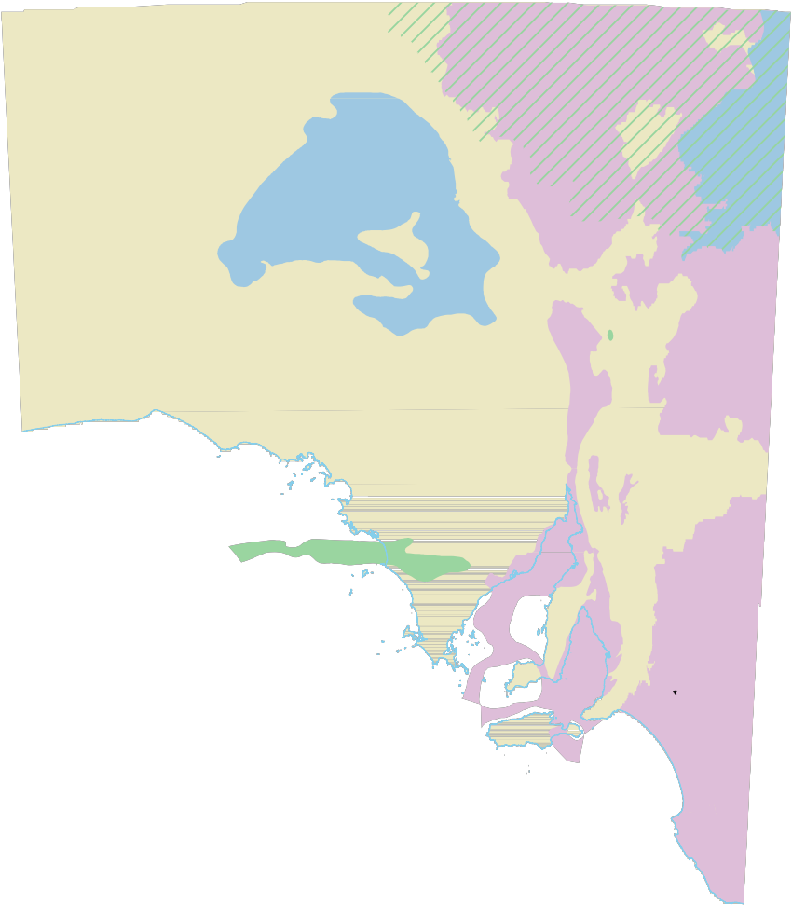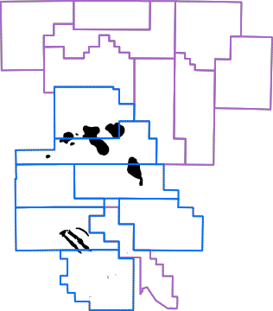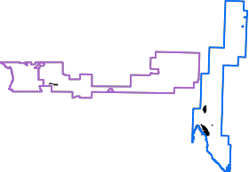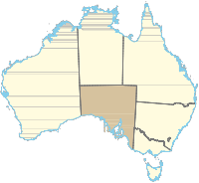Figure 6.1 Unconventional gas plays in South Australia

100%

Chance portfolio of independent pay-trends will yield at least one commercial project

> coin toss chance
for at least ONE 99%

99%
is to provide easy access to geologic 6
and engineering data and information
to influence perceptions of prospectivity.
The South Australian government (through

80%

60%
50%

40%

20%

0%
commercial success
from a portfolio of
20+ play-trends

64%

18%
88%

20 plays
15 plays
10 plays
5 plays
the Department for Manufacturing, Innovation, Trade, Resources and Energy, DMITRE) provides easy access to accurate archived data in useful formats. Available data includes geological, geophysical, engineering, production and administrative (e.g. tenement) data. Ready access to
data reduces critical uncertainties, enabling
investment decision making that forms the

0% 5% 10% 15% 20% 25%
Individual independent play-trend chance for commercial success
204226-008

Figure 6.2 Probability of at least one commercial project from portfolios of 5, 10, 15 and 20 independent, unconventional gas play trends in a portfolio of unconventional gas resources.

mined and underground coal as feedstock for synthesis gas, power generation and the manufacture of synthetic liquid fuel, also refer to publicly available information for
Altona Energy’s mined coal-to-liquids project in the Arckaringa Basin2 and Linc Energy’s generalised description of underground coal gasification3.

6.3 Investment Life-cycle for
Unconventional Gas

The generalised lifecycle for the delivery of petroleum (including unconventional gas) to domestic and international markets is summarised in Table 6.1.

6.3.1 Information, Data and
Knowledge
Relevant data, information and knowledge are the foundation for efficient investment. The most common government policy to attract investment in petroleum (including unconventional gas) exploration investment
basis for efficient and effective exploration.

Regulatory requirements for petroleum exploration and production companies
to submit data and reports generated by licence activities to government (DMITRE) is a key part of the supply-chain for data,
information and knowledge. Submitted data are verified, catalogued and archived, in standard digital formats. Basic petroleum exploration and development data are made publicly available after a 2 year confidentiality period. Production data is
made publicly available after 6 months. Data value-adds include consolidated datasets and maps and application in prospectivity research projects.

South Australia offers petroleum explorers and producers an extensive range of petroleum data via the free PEPS Database, including oil and gas production data, cores and cuttings, well completion reports, well logs and seismic datasets. Key datasets
are available for free download, while larger datasets for cost of transfer. For more information on DMITRE data products and services refer to the DMITRE website4.

2 Altona currently has the most advance coal-
to-liquids project in South Australia. For details, see: www.altonaenergy.com/pdfs/Altona%20AGM%20 presentation%2008%20Dec%202011.pdf

3 Linc Energy provides a generalised description of

its project at www.lincenergy.com/underground_coal_
gasification.php
4 Available at: http://www.pir.sa.gov.au/petroleum/
access_to_data

Table 6.1 Generalised lifecycle for the delivery of unconventional gas to domestic and international markets

Skilled people with competencies including but not limited to: In-house or contracted services including but not limited to:
• Leadership • Seismic operations (acquisition processing and interpretation)
• Administration • Fracture stimulation

• Science & Math - especially geology, geophysics ,environmental science and numerical modelling
• Engineering - especially drilling, pipeline, chemical, mechanical, electrical;
construction, and process engineers
• Specialists and managers in the fields of: finance, law, information technology, occupational health, safety, environmental management (OHS&E), human resource management, marketing, government relations, stakeholder engagement, and communication.
• Flowline/pipeline/compression construction& operations
• Plant construction and operations

Stakeholder engagement, site clearance and activity approvals.

Acquisition, processing and interpretation
of geophysical, geological, engineering and economic data to high-grade and
apply for exploration licences.

Additional acquisition, processing and interpretation
of geophysical, geological, engineering and economic data to high-grade
exploration drilling locations.

Drilling, production testing and reserve estimates.

Identifying and negotiating with prospective customers to enter into commercial contracts.

Securing capital from cash flow, equity finance and/or debt finance.

Stakeholder engagement, site clearance and activity approvals.

Acquisition, processing and interpretation
of additional geophysical
, geological, engineering and economic data to support Front end Engineering and design (FEED) and FID.

Convert reserves from undeveloped to developed with at least sufficient production wells to
meet sales contracts.

Construction of facilities for processing, transport and delivery of products to markets.

Stakeholder engagement, site clearance and activity approvals.

Conduct safe and environmentally sustainable operations Acquire, process and interpret additional geophysical, geological, engineering
and economic information to optimise production Identifying and negotiating with prospective customers to enter into commercial contracts.

Secure capital from cash flow, equity finance and/or debt finance.

Restore lands as required and to meet community expectations.

Exploration and discovery in local new plays and/or other locations | Appraisal, reserves  booking and pilot development | Marketing & sales contracts to underpin finance and  Final Investment  Decisions (FID) | Development for deliverability and well-  timed pipeline, processing plant and export facility construction) | Production, maintenance, incremental development | Production, maintenance, incremental development
Exploration & discovery to use facility headroom and expand/extend project life (reap economies of scale and
increase profits and return on investment)

6.4 Supply Chain Scenarios for Tight and Shale Gas Development

Success in exploration and appraisal of unconventional gas resources can be expected to open opportunities for local, national and international content in
all supply chains for the development, production, processing, transport and use of natural gas flowing from unconventional gas resources in (at the least) the Cooper Basin.

The development of one export capacity unconventional gas program in South Australia is expected to create substantial challenges in the supply of
materials, equipment, services and skilled personnel. Obviously, the development
of unconventional gas in South Australia will create substantial opportunities for local enterprises to compete to become
reliable suppliers in these areas. Supply-side competition is in the interest of developers and South Australian based enterprises capable of winning local contracts stand
a chance to also supply inter-state and
international gas development projects.

Section 6.4.1 provides a generalised description of the prospective magnitude of supply chains for successful unconventional gas development, with success defined
as an incremental 6 tcf of sales gas being booked in the coming decade.

6.4.1 Geophysical Survey Acquisition Up to three seismic crews in the Cooper Basin may be required to meet demand for geophysical information to optimally locate
exploration, appraisal and development
wells within the next 3 to 5 years. This is an incremental increase in demand, and is not expected to be a limiting factor for development of unconventional gas in
South Australia. Irrespective of the number of seismic crews in the Cooper Basin, perfectly timed accessibility to seismic survey areas have in the past, and may in the future be locally challenged with seasonal flooding. If land access windows are narrow, petroleum
licence operators may not be able to 6
optimally schedule a minimum number of seismic crews. That will be the source of some inefficiency in mobilising-demobilising seismic crews between contracted surveys.

With that as one driver, changes to the
Petroleum and Geothermal Energy Act
2000 are now a matter of consultation with the upstream petroleum industry to enable greater sharing of seismic contractors.
If enacted, these changes will give an incentive for seismic contractors to offer licences to access multi-client seismic data to upstream petroleum companies at lower cost than if the surveys were recorded on a single-user (proprietary) basis.

The incentive will be in the form of an increase (from 8 years to “up to 15 years”) in the term of time for multi-client seismic surveys to remain outside public records
(but still available to any company on more favourable commercial terms than would be a proprietary geophysical survey. Petroleum licence holders will be able chose between recording proprietary seismic data and contracting to purchase multi-client data. Lodgement requirements for seismic survey information will remain unchanged as will entitlements for DMITRE to use multi-client data (in advance of that data entering public records) in publicly available studies.

6.4.2 Exploration – Appraisal Drilling Ahead of Final Investment Decision for Development
Based on the spud dates of Encounter 1 and Holdfast 15 and Beach Energy’s plans for resource appraisal and pilot development (refer to Table 6.2 which represents exploration and early stage appraisal),
the cycle- time from exploration drilling through to a final investment decision for unconventional gas development drilling in the Cooper Basin can be expected to span at least 3 years.

5 Spud dates in Beach Energy’s PEL 218: Encounter 1 (3 October 2010) and Holdfast 1 (21 January 2011).

Table 6.2 Beach Energy’s post discovery steps to appraise and undertake pilot development of unconventional; gas in Petroleum Exploration Licence 218 in the South Australian Cooper Basin. Slide 30, Beach Energy presentations at Citi and Goldman Sachs Conferences, downloaded from: http://bpt2.live.irmau.com/IRM/Company/ShowPage.aspx/PDFs/2337-
36623505/BeachEnergyLimitedPresentations

Q1 2012 Q1/Q2 2012 2012 Q3/Q4 2012 2013 2013/2014
Fracture Stimulate Encounter-1 | Independent certification of reserves  and resource bookings | At least  five vertical exploration wells | Three horizontal pilot production wells | Extended flow testing of new wells | Six horizontal pilot production wells around Encounter-1 and Holdfast-1 | Development and production program

$200 million estimated capex

6.4.3 Development Drilling for
Deliverability
Based on Luo et al (20116) – accounting for the acceleration of production that could be drained from other wells, the estimated ultimate recovery (EUR) for tight gas vertical
infill wells is roughly an average 3 billion cubic feet (bcf) per well. Gas liquids richness will reduce minimum economic gas recovery volumes from wells. A recovery of between
1 and 2 bcf sales gas per vertical infill well is expected to be an economic result within most producing gas fields in the Cooper Basin7. The EUR from long reach multi-stage fracture stimulated wells draining a greater extent of permeability-height tight gas reservoirs will presumably be proportionately greater.

Assuming 6 trillion cubic feet (tcf) of sales gas is roughly equivalent to the minimum reserves that need be booked to underpin an FID to start-up a new LNG export facility reserves, 3 bcf raw gas recovery per well and a sales to raw gas ratio of 0.8, then the magnitude of AFE requirements for a model
greenfield LNG project supplied with Cooper Basin gas can multiple the quantities by a factor of up to 2,500. A higher, 5bcf raw gas

6 Shu Luo, Baurzhan Kassenov, and Mohan Kelkar (University of Tulsa), 19April 2011, Infill well potential in tight gas reservoirs, proceedings of the Research Partnership to Secure Energy for America (RPSEA)
Meeting – downloaded from http://www.rpsea.org/ attachments/contentmanagers/3458/07122-43- UGC2011-Optimizing_Wamsutter_Well_Locations_UTXA_ Luo-4-19-20.pdf.

7 Personal communication with Santos executives in
2012.
recovery per well (with a sales to raw gas ratio of 0.8) corresponds to a factor of 1,500. An LNG plant using over 1 bcf per day for 15 years will require around 6 tcf. If each well
is assumed to access between 3 bcf (raw) and 5bcf (raw) per well, (with a 0.8 sales to raw gas ratio), then between 1,500 to 2,500 wells would be required. Field fuel demand, the loss of some development wells for operations reasons, well recoveries in excess forecast average, and lower or higher raw to sales gas ratios can each drive the number
of wells to a lower or larger number..

Appendices 2a and 2b respectively specify materials, equipment and services expected to be part of Authority for Expenditures (AFEs) for vertical (Appendix 2a) and long reach (Appendix 2b) production wells required
for unconventional shale and tight gas development in the South Australian Cooper Basin.

Appendix 2a lists requirements for vertical, multi-stage fracture stimulated infill wells that are:
• typically drilled and cased to an average of 3,000 m true vertical depth (covering a range of wells to 2500 –
3500 m) with a 1250 to 1500 Horse Power rig; and,

• fracture stimulated with approximately
6-8 treatments, each extending potentially 250 metres from the well, prior to completion.

Assuming campaign operations through which each development well is drilled, cased, and temporarily suspended every

20 days (including average rig moves that are minimised multiple wells drilled from single drill pads), one rig would drill 15 to
20 wells per year at 90 percent availability. Additional equipment would be mobilised to perforate, undertake pre-fracture stimulation pressure tests, fracture stimulate, and complete wells for connection to flowlines.
At these generalised rates to drill, case, test, stimulate, complete and connect each well,
2,500 wells for gas deliverability of between
2.4 bcf to 4 bcf per well over 15 years would require:
• 8-11drilling rigs;

• 2 to 3 work-over rigs (1 for every 5 drilling
rigs); and

• 3 to 4+ fracture stimulation spreads (1 for every 2 to 3 drilling rigs)

Appendix 2b lists requirements for long reach, multi-stage fracture stimulated wells that are:
• typically drilled and cased to an average of 3,500 m measured depth (covering a range of long reach wells to
4000 – 5000 m true vertical depth) with a
1250 to1500 HP rig; and

• fracture stimulated with approximately
15 treatments, each extending potentially 250 metres from the well, prior to completion.

Assuming campaign operations through which each development well is drilled, cased, and temporarily suspended every
30-40 days (including average rig moves that are minimised multiple wells drilled from single drill pads), one rig would drill 11 wells per year at 90 percent availability. Additional equipment would be mobilised to perforate, undertake pre-fracture stimulation pressure tests, fracture stimulate, and complete wells for connection to flowlines at a rate of 7-20
days per well. At these generalised rates
• 3 to 4+ fracture stimulation spreads (1 for 6
every 2 to 3 drilling rigs)

Table 6.1 provides an indicative schedule for rigs and units required to ramp up
to the steady development of 6 tcf of unconventional gas in the Cooper Basin, assuming 50 percent would come from vertical infill production wells and 50 percent will come from long-reach production wells

Table 6.3 Indicative schedule for rigs and units required for a 6 tcf development of unconventional gas in the Cooper Basin

2014 2015 2016 2017-2028
Drilling rigs 3 5 9 15
Workover rigs 1 1 2 3
Frac. Stim. crews 1 2 3 5

6.4.4 Regional Logistics, Supply Centres and Petroleum Processing Plants
Moomba is a “fly in – fly out” oil and gas processing and operations supply centre owned by the SA Cooper Basin Producers8 and operated by Santos Limited. The processing plant at Moomba has a capacity to process up to 430 PJ per day9 sales gas (methane) and also separates ethane, liquefied petroleum gas (propane and butane), condensate and oil. The plant
can be upgraded or expanded to process greater volumes of sales gas to markets.

Santos Limited describes this essential infrastructure as follows10:
The Moomba facility accepts production
from 115 gas fields and 28 oil fields containing
536 producing gas wells and 177 producing oil wells through approximately 5,600 kilometres of pipelines and flowlines via 24 oil and gas satellite facilities, many of which

to drill, case, test, stimulate, complete and

connect each well, 1,500 to 2,500 wells for
8 Santos Ltd (operator): 66.6%; Beach Energy Ltd:
20.2% and Origin Energy Ltd: 13.2%

gas deliverability of between 3 bcf to 5 bcf

per well over 15 years would require:
• 9-15 drilling rigs;

• 3 work-over rigs (1 for every 5 drilling
rigs); and
9 See: www.aemo.com.au/en/Electricity/Planning/
Gas-Statement-of-Opportunities/~/media/Files/Other/
planning/Gas%20Facilities%20Accompanying%20
Data%20xlsx.ashx

10 From: www.santos.com/exploration-acreage/
production-processing/moomba.aspx

incorporate field boost compression. The Moomba facility also incorporates substantial underground storage for processed sales gas and ethane.

Natural gas liquids are recovered via a refrigeration process in the Moomba plant and sent together with stabilised crude oil and condensate through a 659 kilometre pipeline to Port Bonython near Whyalla, South Australia.

Sales gas is sent from Moomba to Adelaide via a 790 kilometre pipeline, to Sydney via an 1160 kilometre pipeline. Ethane is sent to Qenos in Sydney via a dedicated pipeline.

The central processing plant in Moomba comprises:
• Oil processing: crude stabilisation and crude/condensate storage; and

• Gas processing: inlet slugcatchers, seven Benfield CO2 removal trains, gas dehydration via molecular sieves, a natural gas liquids recovery plant, an ethane treatment plant including amine absorption, and pipeline compression.

Water is provided by bores and a reverse
osmosis treatment plant and electricity is supplied via 20MW of on-site power generation capacity. The plant is serviced by a jet-capable sealed airstrip.

Additional to the above-quoted description,
the South West Queensland Pipeline is a
937 kilometre pipeline from Moomba to Wallumbilla in South East Queensland and includes the 180 kilometre Queensland
to South Australia/New South Wales Link running from Ballera to Moomba. The Moomba to Wallumbilla pipeline enables gas from Queensland to reach South East
Australian markets, and will enable Moomba gas to reach eastern Queensland markets (including LNG export terminals at Gladstone following installation of compression in the Moomba plant.

Third party petroleum (mostly oil) is processed by the SA Cooper Basin Producers on commercial terms.
There is some chance one or more (other than Santos) petroleum producers could construct a stand-alone logistics and petroleum processing facility if there is insufficient spare capacity in the existing Moomba plant.

The existing roads and airstrips may need to be upgraded for the transport of materials and equipment from ports and manufacturing locations. The decision to
develop large unconventional gas resources along with further success in oil exploration is expected to justify the:

• sealing of roads to: (1) Moomba from Lyndhurst (to the south); (2) Moomba from the Queensland border (to the east); and (3) in critical locations within the Cooper Basin to improve accessibility during floods; and

• expansion of existing, and/or the construction of an additional airstrip.

A determination of public versus private purpose (and hence funding for such transport infrastructure) will inevitably be the subject of consultation between government and industry in coming years.

The final version of this Roadmap will include a list of materials, equipment and services required for the construction, operations
and maintenance of petroleum processing facilities to yield sales gas, ethane, LPG, condensate and oil.

6.4.5 Gas Pipelines
The timely construction and commissioning of the South East Australia Gas (SEAGas) and the Queensland-South Australia-
New South Wales (QSN) pipelines without overt government subsidies is evidence
of an effectively competitive gas pipeline industry servicing eastern Australia. On this basis, timely planning and contracting
for gas transport facilities construction
and commissioning is expected to deliver sufficient petroleum pipeline infrastructure to meet gas sales schedules.

6.4.6 Liquefied Natural Gas (LNG)
Plants11
Considerable competition is arising in international LNG markets. At present there are proposals for 14 new LNG plants in Australia from 2011-2016 (including four
plants in Gladstone depending on eastern
Australian unconventional gas as feedstock)
– more than any other country in this term
(Offshore Technology, 201112). Multiple
LNG facilities being constructed in northern Queensland depend on the timely delivery of unconventional gas supplies at a time when seven North American LNG projects are seeking long-term deals with buyers in Asia (McAllister, Edward, 201113) and where prices are three to four times higher than gas prices in domestic markets in Australia and the United States. This supply-side competition has impacts such as Trinidad and Tobago losing some of its LNG export market to the USA (Mahdi, 201114).

On 25 October 2010, Santos agreed to supply 750 PJ of gas to the Gladstone Liquefied Natural Gas (GLNG) project. The gas will be delivered from Santos’ eastern Australian gas portfolio, with existing uncontracted Cooper Basin 2P reserves being the primary supply source. The oil- linked pricing formula in this agreement is a
driver for investment in the Cooper Basin. The gas will be supplied over a period of 15 years commencing in 2015.

11 The final version of this Roadmap will include a list of materials, equipment and services required for the construction, operation and maintenance of petroleum pipeline facilities.

12 Offshore Technology, 2011, Snapshot: Planned LNG
terminals to 2016, article published on 3 November
2011. Download from www.offshore-technology. com/features/featuresnapshot-planned-lng- terminals-to-2016/.

13 McAllister, Edward, 2011, Update 2 - Cheniere signs second US LNG export deal, Thomson Reuters article published 21 November 2011, downloaded from: http://af.reuters.com/article/energyOilNews/ idAFN1E7AK1U620111121.

14 Mahdi, W., 2011, Trinidad’s LNG Exports to U.S. Plunge on Increased Shale Gas Production, article published
by Bloomberg on 13 November 2011. Downloaded from www.bloomberg.com/news/2011-11-13/trinidad-lng- exports-to-u-s-plunge-on-shale-gas-supply-rise-1-.html.
On 25 November 2010, Beach Energy 6
announced a Memorandum of Understanding with Itochu to plan for a mid- scale LNG facility, possibly located on the Spencer Gulf (South Australia). The facility would have a 1 million tonnes per annum capacity and need 60 PJ of gas per annum with a capital expenditure of about AUD 1 billion.

Additional options for the marketing of South Australia’s unconventional gas resources includes potential for a new-build LNG
export facility at Port Bonython or, given new pipelines from Moomba to the north, export via LNG facilities in Darwin.

6.4.7 Roads
Based on comments with companies operating in the Cooper Basin, the two most advantageous improvements that could
be undertaken to road infrastructure are as follow. An initial response to these issues is also provided.
• Reduce red tape in relation to transport, and in particular, enable practical relaxation of limits on axle width, road weight, the use of triple road trains,
the towing of heavy earthmoving equipment and also, practical changes to requirements for certain permits such as for road closures;

— Initial response: A working group
of key users of these roads and the State Government will be convened in 4Q12 through 1Q/13. Guidelines for road closures (to describe flexibility) and a map showing existing gazettals for the use by
B-Doubles and 35.0m B-Triples on both unpaved and paved roads will be made available from web-pages for this Roadmap.

• Set plans to pave roads from Leigh
Creek to Moomba, from Moomba
to Innamincka, from Moomba to the Queensland Border (Dillon’s Highway, and from Moomba to Tirrawarra,

— Initial response: A working group of key users of these roads and the State Government will be convened in 4Q12 through
1Q/13. As background, the State Government’s Transport Division currently allocates 20% of its annual road maintenance budget on unsealed outback roads. The obvious value of paving these
roads to all users will need to be considered in the context of long- term, full-cycle costs on roads
with (current) relatively low traffic volumes. The State Government routinely assists in the development of business-case scenarios to
define and justify funding models. A whole-of-industry approach could provide shared economies of scale. In this regard, firm industry plans to increase traffic volumes would be
a key consideration in shifting the Government’s budget priorities for the paving of outback roads. At this point in time, the cost of sealing the roads in question would range to $1 million per km. In summary, the South Australian government will work with industry to identify road sections where minimum cost improvements could address targeted improvements. The discussions to
be undertaken in 4Q12 – 1Q/13 will inevitably conclude funding options for both upgrading and ongoing maintenance.
6.4.8 Rail Facilities
Railroad facilities connect Whyalla to Leigh Creek and Adelaide to Perth, Darwin. And the eastern states (Victoria, ACT, NSW
and Queensland). No railroads connect to Moomba. Pipelines and trucking are the current the most efficient means to
connect Moomba to markets and its supply chains. Rail facilities run north of the proven productive onshore Otway petroleum fields in southeast South Australia.
6.5 Model to Maximise Immediate and Long Term Opportunities for the Growing Unconventional Gas Sector

The role of government in relation to industry is to correct market failure. The rapid expansion of the oil and gas industry in South Australia has created a situation where it is possible that this economic opportunity may fail to bring any long-term benefit to the state. The lack of a mature support industry
in the state encourages the large oil and gas companies to rely on existing supply chains rather than developing local industry.

Outlined below is a two stage model that could be used to maximise the immediate and long term opportunities for growing the unconventional gas sector. This model focuses on a couple of key and related areas: Capability development and the
identification of opportunities; and creating
clusters and centres of excellence.

This approach aims to maximise the leverage gained by South Australian industry from
the expansion of the oil and gas sector in South Australia, especially with regard to high-value activities. At present, capacity to do so is limited by the disparate nature and limited size of the industry in Australia, a lack of investment in research and development in oil and gas and related technologies, reluctance of smaller firms to cooperate to meet Tier 1 contractor requirements and
the reluctance of prime contractors to do business with smaller organisations.

Through the use of the model discussed below, it is hoped that in a partnership between industry, government and academia, we can:
• Develop local industry and prepare local firms to a level whereby they would meet major project proponent’s prequalification requirements; and/or encourage joint ventures with overseas firms who can provide additional skills and resources;

• Identify opportunities for centres

of excellence to develop globally competitive firms and exploit niche opportunities; and

• Support the development of industry clusters to create economies of scale and promote technology transfer.

The approach that Government could choose to partner with industry to implement this model has not been chosen.

This approach complements the South Australian Government’s broader activity to ensure that local industry has a chance to compete for work opportunities on a level playing field. To that end, the Government introduced a new South Australian Industry Participation Policy, in July 2012, to ensure that local business was given full, fair and reasonable opportunity to compete for work. This policy is consistent with the Australian Industry Participation National Framework, to which all States and Territories are signatories.

6.5.1 Principles for Prioritising Work
Packages
The identification of priority work packages is vital to any effort to maximise the impact and returns from existing and potential industry capacity and capability. This identification is also an important part of addressing capability gaps in the sector, as there is little value in addressing these gaps if there is little market opportunity to capitalise on this.

Maximising the immediate and long term economic impact of the oil and gas sector requires an approach that prioritises and focuses on the activities and major project work packages that will deliver the highest impact and value to South Australia. The principles which underpin this prioritisation are:

1. Contestability: Priority work packages should be contestable as follows:

— Both Australian industry and foreign industry have existing capability;

— Australian industry has the
potential to develop the 6
capability to supply the requirements of that work package; or

— Capability does not exist in Australia but could be attracted through inward investment to the country.

Pursuing work packages that already have a very high likelihood of being provided
by Australian firms or that definitely cannot be produced in Australia should not be prioritised.
2. Value: Priority work packages
should have a high financial value. Some packages will also deliver broader value (such as boosting employment or stimulating investment in advanced, high value-add manufacturing).

3. Industry Development: Priority work packages should contribute to
the ongoing development of the manufacturing and resource sectors. This could be through focussing on
skill and knowledge intensive activity, by assisting the transition of existing manufacturers into the resource sector or by leveraging demand for new services and manufacturing capabilities.

6.5.2 Process for Prioritising Work
Packages
The prioritisation process is an iterative
approach which has five stages:
1. Remove projects with low supply, installation and maintenance returns;

2. Determine the degree of work package contestability;

3. Evaluate the likelihood of Australian supply;

4. Undertake value analysis; and

5. Rank and determine priority packages

A diagram illustrating this process is provided in figure 6.5 and a description of each stage follows.

Identify potential suppliers and local capability

Project proponent supply list of work packages
Work with Project proponent to ensure work packages are released in a way that maximises local participation

Low contestability- Australia can not supply

Global Supply Chain but low chance to develop local capability
Stage One
Remove low financial-value
work packages

<$5 million

Stage Two Assess work package contestablity

Contestable or Global
Supply Chain

Stage Three

<$5 million

Low contestability
‘Naturally
Protected’

Good existing capability

Evaluate likelihood of
Australian supply (existing and potential

Assess as

Good investment attraction
Contestable items or Global Supply Chain with potential to develop local capability

Stage Four

Regional assesment,

investment attraction opportunity
opportunity

Work package value analysis and rating
Not priority

watching brief and/or
information flow

Low/No opportunity

Watching brief

Definite investment attraction

Stage Five Identify and rank priority work package

Apparent local industry opportunity

Local enterprise/industry capability analysis

Good regional opportunity

Regional intervention

Work with Project proponent to ensure work packages are released in a way that maximises local participation

Low local
capability or potential capability

Capable and
prequalified
Potential local
capability but not prequalified

Investment attraction
Enterprise specific information or assistance

Capability development
program (see figure 2)

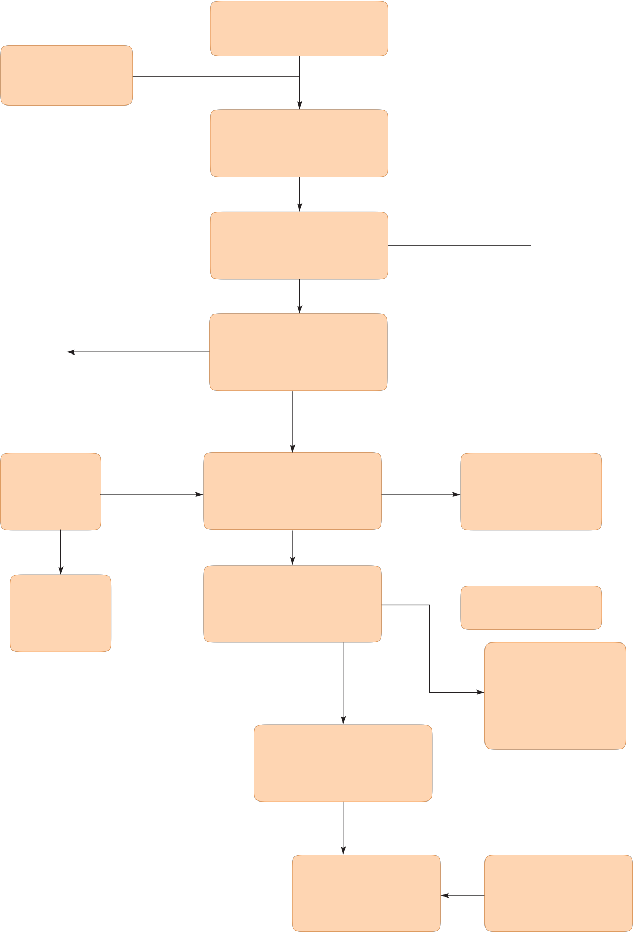

Figure 6.5 Work Package Prioritisation Process

Stage 1: Remove projects with low supply, installation and maintenance costs.
Stage one identifies work packages with low supply, installation and maintenance returns. These packages are precluded because the prioritisation process aims to identify high- value, high-impact work packages. These packages are unlikely to provide a significant financial benefit for the state as a whole and are of a scale that makes them unlikely to produce a high impact.

Stage 2: Determine degree of work package contestability.
Stage two provides a high level classification of work packages, based on their degree of contestability, into the following categories:
• ‘Naturally protected’ and likely to be sourced from within Australia

• Definitely contestable items

• Items that may be contestable but are likely to be wrapped up in global supply chains
• Clearly non-contestable items that are things we know we cannot produce or where the work package specifies a non-local sole acceptable supplier.
factors, to remaining work packages. 6
Financial value is simply the sum of supply and installation costs. Non-financial factors take into account the outcomes that are sought by the South Australian and Australian Governments.

These factors can be placed into an assessment table to identify those work packages Australian firms are likely to compete for and be of high value for the Australian economy.

Stage 5: Determine and rank priority packages.
The work packages that are identified from this process could then be ranked in terms of contract value (i.e. private benefit) or value to Australia (i.e. public benefit). An
assessment matrix, such as illustrated in figure
6.6, could be used to rate the priority work packages.

Figure 6.6 illustrates the matrix for dividing packages into four priority categories based on their relative value and contestability (priorities 1, 2a, 2b or 3).

Stage 3: Evaluate likelihood of Australian supply.
Stage three examines the degree of competitiveness Australian firms have relative to overseas suppliers. This stage will identify those work packages where
Australian industry is likely to have an existing competitive edge because of:
• Existing supply relationships (where known);

• Australian industry capacity and

Higher Relative Valve

Lower Relative Valve

Priority 2a work packages

Priority 3 work packages

Lower
Relative

Priority 1 work packages

Priority 2b work packages

Higher
Relative

potential to scale up to meet work
Contestablilty
Contestablilty

package volume requirements;

• Nature of work package; and

• High level identification of potential
interstate and overseas suppliers.

Stage 4: Value analysis.
Stage four assigns a value rating,
encompassing financial and non-financial

Figure 6.6. Assessment matrix to rate the priority work packages.

The definitions of these priorities are:
Priority 1: Work packages with a high value to Australia and a high contract value.

Priority 2a: Work packages with a high value to Australia but a relatively lower contract value.

Priority 2b: Work packages with a relatively lower value to Australia but a high contract value.

Priority 3: Work packages with a relatively lower value to Australia and a relatively lower contract value.

6.5.3 Creating Clusters and Centres of
Excellence
Building on the approach set out above to identify priorities for work packages within major projects, it is important that the industry has the capability and capacity to maximise the outcomes for local businesses and the State more broadly.

The formation of regional industry clusters to bring together skills and experience
and assist Australian firms to overcome the limitations that currently prevent them from competing for large contracts in the oil and gas industry will be vital.

In parallel, the creation of centres-of- excellence which bring together industry and academia to promote research and development activities will be important to bring increases in productivity by advances in technology and practice.

Flowing from the formation of clusters and centres of excellence the opportunity exists to encourage and facilitate the formation of consortia to create the economies of scale necessary to compete for major contracts in the unconventional gas sector which would otherwise have been awarded to overseas concerns.
Government can assist to encourage industry to develop clusters and championing centres-of-excellence. The
former will encourage cooperation, promote technology transfer and facilitate the development of joint ventures; the latter
will foster collective R&D efforts. Taken together, these practices will maximise the advantages to be gained by the expansion of the oil and gas sector in the state.

Key Roles
The success of establishing industry clusters and centres of excellence is entirely dependent on ensuring a coordinated approach across industry.

A close relationship will need to be established between academia, industry bodies and government to coordinate activities towards the formation of centres- of-excellence and clusters in the oil and gas sector. It will also be valuable to leverage
off the knowledge and skills of key national figures such as the Commonwealth Supplier Advocates, the Resources Supplier Envoy, and the ICN National Sector Managers for Mining and Oil & Gas.

Several SA Government organisations could play a beneficial role in assisting industry achieve this closer partnership. The Industry Capability Network SA (ICN SA) works to promote local businesses through import replacement and opportunities for participation in major projects. ICN performs a technical role providing purchasers with a free vendor identification service to identify Australian suppliers capable of supplying those items that would otherwise be imported. The ICN SA has positive and long working relationships with the oil and gas industry in SA both with individual firms and through industry associations.

This process could be facilitated in a range of ways and the State Government is still considering mechanisms to work with industry to drive these outcomes.

Centres of Excellence
There are already well established and regarded centres of excellence, such as the Ian Wark Research Institute based at the University of South Australia and the Geotechnical and Mining Research Group at the University of Adelaide with which a stronger and more coordinated industry partnership could be established.

Opportunities exist to not only leverage off of these existing capabilities but also consider the development of new SA-based centres- of-excellence.

The centres-of-excellence will bring together academia, industry and government in order to maximise research and development activities and technology transfer opportunities. These will be funded by public/ private cooperative efforts and will also train professionals and skilled workers specifically for the oil and gas industry.

Given the geographic spread of the industry, it may be valuable to encourage the creation of regional industry clusters to eliminate some of the disadvantages of a non-mature industry.

These clusters will encourage the creation of consortia to create synergies, promote cooperation and create economies of scale. These clusters will also encourage investment in the industry and cultivate
technology transfer opportunities. The scope of opportunities for the clusters should be ascertained through the use of a process (such as that set out above) which is designed to identify those projects which
are contestable and not currently readily supplied by existing South Australian industry.

Creation of Clusters
The cluster concept is not new. Successful industry clusters have been created in many locations. It is our intent to capitalise upon the work of others by adapting two best- practice examples to local conditions.

The approaches used by the Norwegian and Ontarian governments to develop industry clusters around resource endowments (including oil and gas) have been
highlighted as models of development that 6
could be replicated in South Australia.

The details of each regional model differ reflecting their cultural characteristics, institutional frameworks and stages of industry development. Despite this, most
models share similar attributes. Namely, they:
• Develop clusters around existing industrial expertise

• Actively involve industry, academia and governments

• Make extensive use of working group and cluster

The development of an approach for South Australia raises the following implications. Addressing the following questions will point to focus areas that can be further explored and identify knowledge gaps.
• What is the specific industry development problem that a cluster approach is intended to overcome?

• Who are the industry leaders who can drive a cluster’s development and how are they engaged?

• What specific globally competitive industrial expertise does South Australia have that can form the core of the cluster?

• What are the unique local geology and production factors that provide specific opportunities for local suppliers?

• What requirements or problems do lead
customers have that are significant in South Australia but less important elsewhere?

• How strong are intra-industry linkages and is competition between firms done on the basis of innovation or price?

• What opportunities exist for import replacement?

• To what extent are participants in the cluster already globally focused?

• Given the pipeline of gas and resource projects, what is the capacity of local industry to pursue opportunities outside this state?

• What are the main barriers, including capability gaps, for the cluster to attain global competitiveness?
Figure 6.7 is adapted from the Harvard Business School and depicts the interaction between the actors in the oil and gas cluster
in Norway. The cluster is a holistic approach incorporating financial markets, upstream and downstream and research and education institutions. It provides a valuable picture of the holistic approach that would be necessary to establish a successful unconventional gas cluster in SA.

Norwegian Oil and Gas cluster map

Government and Regulatory
Ministry of Fisheries and Coastal Affairs
Ministry for Petroleum
and Energy Ministry of Labour

Ministry of
Finance
Government
Pension Fund
Ministry of the
Environment Gasco* Petoro
=
Petroleum
Directorate
Storting
(Parliament)

Petroleum Tax
Office
State’s direct
financial interest

Suppliers

Advanced materials
Oil and gas industry suppliers

Upstream
Specialised services

Law firms

Steel
Subsea
Oil and gas
exploration
Drill and
well
Field
development
Production

Accounting
firms

IT/Communication equipment

Machine tools

Concrete
Topside

Geology, seismic, reservoir

Drilling and well technology
Midstream
Downstream

Regulatory consultants

Banks

Operations support

Related clusters

Transport and logistics
Education/Research institutions

University of Stavanger/ Oslo/Bergen
Institutions for collaboration

Norwegian Oil and Gas
Partners INTSOK

Business services

Institute for Energy
Tech

Kon-Kraft

Heavy machinery

SINTEF

OG21

Marine equipment

IRIS Rogaland
Research

OLF Industry
Association

Chemical products

Production technology

Norwegian
Geotechnical

Research Council

Norwegian Oil Offshore Drilling Engineers (NODE)

Figure 6.7. Assessment. Adapted from Norway Oil and Gas Cluster, Harvard Business School, May 2012. www.isc.hbs.edu/pdf/Student_Projects/2012%20MOC%20Norway%20final.pdf
*National Pipeline Company; =National manager for the State’s Direct Financial Interests in petroleum licences

