Department for Transport Energy and Infrastructure (DTEI)

Results from household survey on the use of energy appliances and products in the home.

Consultancy and Training Services
South Australia

©Australian Bureau of Statistics

Contents
Key Findings 3
Lighting 3
Shower Heads 3
Water Heaters 4
Standby Power Controllers 4
Demographics 5
Postcode Deciles 5
Where to get more detailed information 5
Methodology 6
Questionnaire 6
Design 6
Testing 6
Sample Design 6
Weighting 6
Distribution Checking 7
Data Quality 9
Relative Standard Errors (RSEs) 9
Logical Errors 9
Lighting and “don’t know”s 9
References 10

Key Findings

Lighting

Technical Potential
The survey suggests that approximately 47% of non-Priority Group households have 4 or more traditional globes not connected to a dimmer, compared to 43% of Priority Group households. The group of people with the greatest potential for four or more traditional globes was the group that are home owners, for both Priority Group and non-Priority Group households. The discrepancy between Priority Group and non-Priority Group households’ technical potential for halogen globes was more marked, with 46% and 23% of households having 4 or more halogen globes respectively. Home owners displayed the great potential for changeover again. If we look at the percentage of households that have four or more globes that could be changed (either traditional that are not connected to a dimmer or halogen), then for non-Priority Group we can expect 72% of households to have at least 4 globes that can be changed, compared with 58% of Priority Group households.

Market Potential
For traditional globes, the percentage of households with 4 or more globes that were interested in changing them to Compact Fluorescent globes was 31%, or 69% of households with the technical potential. For halogen globes, 23% of households had at least 4 changeable halogen globes and were interested in changing these over for more energy efficient globes. This corresponds to 64% of households that had four or more halogen globes being interested in changing them. 38% of households were interested in changing their globes for more energy efficient ones, and had at least 4 globes that could be changed. This corresponds to 57% of people who could change 4 or more globes, being interested in doing so.

Shower Heads

Technical Potential
The survey results suggest that 46% of households in the area surveyed have at least one inefficient showerhead. This percentage was consistent in the Priority Group and non-Priority Group households, with the respective percentages being 46% and 47%. However, results varied for tenure type, with Private rental properties having the highest percentage of households, 51%, with at least one inefficient shower head.

Market Potential
The market potential was substantially different, with only 18% of households in the area surveyed having at least one inefficient shower head, and being interested in replacing it with a water saving showerhead. In other words 39% of the households with technical potential were interested or very interested in installing water saving showerheads. Again, this was quite similar between Priority Group and non-Priority Group households, and more varied for the different tenure types. However, at this fine level of gradation, the results at the cross-classification level are of questionable reliability.

The survey estimates that approximately 246,000 households in the area surveyed could still participate in the shower head activity in REES, with approximately 97,000 interested in doing so.

Water Heaters

Technical Potential
The survey suggests that 10% of households in the area surveyed have a conventional electric water heater that is either located inside the dwelling (in the roof space or elsewhere inside) or outside and greater than 3 metres from the neighbouring dwelling. The vast majority of these houses were owned rather than rented or otherwise.

Market Potential
Estimates from the survey suggest that only 4.7% of households in the area surveyed have an electric water heater that is either inside the dwelling or greater than 3 metres from their neighbour’s house and are either interested or very interested in changing to a more efficient system. This is equivalent to 47% of households that could change, being interested in changing.

Possible to change
It is interesting to note that approximately 5.6% of households had a conventional electric water heater that was either inside or outside and greater than three metres from their neighbour’s house and thought that it was possible to change it for a more energy efficient water heater. In other words, of around 52,000 households with these water heaters, 29,500 considered theirs to be changeable.

Standby Power Controllers

Nests of Electronic Equipment
The survey results show that 80% of households in the area surveyed have 1-3 nests of equipment for Audio Visual usage (AV nest), 9% don’t have any AV nests, and 2% didn’t know how many they had. This corresponds to 89% of households having at least 1 nest of equipment for AV usage.

In comparison, the survey suggests that 47% of households do not have any nests of equipment for IT usage (IT nest). Since 1.7% of households did not know how many nests of IT related equipment they had, the total percentage of households that have at least 1 nest of IT equipment, is 51%.

Overall, the survey estimated that 90% of households in the area had at least 1 nest of equipment where a SPC could be implemented. Also, the survey suggests that this percentage varies significantly between the Priority Group and the non-Priority Group, with approximately 85% of households in the Priority Group having at least one nest of equipment, and almost 95% of households not in the Priority Group having at least one nest.

Market Potential
The survey suggested that 51% of households were interested in implementing standby power controllers, which is equivalent to approximately 57% of households with at least one nest being interested in implementing a standby power controller. This varied greatly for Priority Group and non-Priority Group, with 60% of non-Priority Group households being interested or very interested in installing standby power controllers, and only 39% of Priority Group households being interested in installing standby power controllers.

Already Installed
The survey estimates that only 6% of households already have a standby power controller installed.

Demographics
The survey suggested that:
- 42.5% of households in the area surveyed were in the Priority Group.
- 84.7% of households were home owners, 6% rented privately, and 6.5% rented public housing.
- 8% of households in the area sampled were in non-metro areas, and 92% were in metro areas.
- households in the area had income distributions as seen in Figures 1 and 2 above.
- 88% of households in the area sampled had houses that are 10 or more years old, and less than 1% of dwellings were built in the last year.
- the most common family type in the area was a couple family with no children, at 32.4% of households, followed by single occupants and then couple families with dependent children. The least common family type was group households with an estimate of less than 1% of households falling into this category.
- 39.5% of households had 2 occupants, and 23.5% of households had only one occupant, with only 2.2% of households estimated to have had 6 or more occupants.
- 85.5% of households lived in separate detached dwellings, and 6%-6.5% of households lived in each of the single storey unit and semi-detached dwelling type categories.
Please note that some of these proportions do not correspond exactly with ABS figures. This is likely due to the size of the survey and the bias induced by differences in collection methodology, questionnaire design, survey vehicle, scope and coverage.

Postcode Deciles
DTEI were interested in finding out which postcodes have the most potential for implementation of REES initiatives. The postcodes were ranked for certain characteristics and then listed with their decile alongside them. There are three sets of deciles calculated from the lighting questions. These correspond to the estimated number of households with four or more traditional, halogen or either of these globes that could be changed for more energy efficient alternatives. The deciles are calculated so that each of the 10 deciles have 10% of households with 4 or more changeable globes, with decile 10 including the suburbs with the highest number of households with 4 or more changeable globes.

This process was repeated for showerheads, and calculated for the postcodes with the most inefficient shower heads being in decile 10, and also for the postcodes with the greatest number of households with at least one inefficient shower head.

Where to get more detailed information

Table 1: List of excel workbooks that have more detailed information
REES Initiative | Excel Book
- Lighting | Lighting.xls
- Showerheads | Shower Heads.xls
- Water Heaters | Water Heaters.xls
- Standby Power Controllers | SPC.xls
- Demographics | Can be found in all of the other excel workbooks by doing the correct filtering
- Postcode Deciles | Can be found on certain tabs of the other workbooks

Methodology

Questionnaire

Design
The ABS undertook the design of the questionnaire, which was designed to meet the information needs of DTEI in regard to measuring technical and market potential for the Residential Energy Efficiency Scheme (REES). This questionnaire was for telephone interviewing and took approximately 15 minutes of the respondent’s time. It was a survey of households, and was focussed on collecting information about energy efficient lighting, hot water services, water efficient shower heads and standby power controllers. There were a variety of questions regarding the physical fittings of the house, and the attitudes of the household towards improving their energy efficiency.

Testing
The ABS undertook cognitive interviews of 10 volunteer respondents from varied backgrounds to ensure that the questionnaire was capturing the information required, and was meeting the accuracy desired. We made several revisions based on the intelligence gained from this process and also due to in depth consultation with DTEI.

Sample Design
The sample design was a stratified simple random sample without replacement (SRSWOR). The strata were designed to produce reliable estimates at low income levels. To do this, an indicator of low household equivalised income (HIED) was taken with reference to the Socio-Economic Index For Areas (SEIFA) to be HIED<=$20,799 per year. Using the data from the 2006 Census of Population and Housing, postcodes were then ranked by their relative proportions of these low income households, and assigned to three strata. Then 1950 households were selected from each of the strata, defined by a list of postcodes, at random from the Electronic White Pages (EWP) by Harrison Research. 1950 was chosen to account for sample loss, an estimated level of non-response and cost constraints.

Weighting
The number of households within each of the strata was initially estimated using the 2006 Census of Population and Housing figures. However, since this information is almost 5 years old, the number of households has increased in these areas. The ABS produces household benchmarks which are used to extrapolate sample estimates to population totals in our household surveys. This information is produced at ABS specific geography levels. Since this survey was specified by ESCOSA postcode groupings we couldn’t use the ABS household benchmarks directly. Instead, we applied a growth factor calculated from the household benchmarks to the 2006 figures to calculate a survey specific benchmark for the number of households in the area surveyed in 2011.

Table 2: Number of households in each of the income strata in 2006 and the number projected to be in the strata in 2011
Stratum | # households in 2006 | #households in 2011
1
  149194
  161250
2
  195996
  211834
3
  145939
  157732

We then used the 2011 figures to weight the data, simply allocating a weight to each respondent so that the sum of the stratum weights equalled the number of households in the stratum.

Table 3: Number of households responding, the number of households projected and the corresponding weight assigned to each of the units in each of the strata.
Stratum | # households that responded | #households in 2011 | Weight
1 | 813 |  | 198.34
  161250
2 | 807 |  | 263.50
  211834
3 | 898 |  | 175.65
  157732

This ensures that all estimates add up to 530,816, our best estimate of the total number of households in the area surveyed in 2011.

Distribution Checking
DTEI were interested in what kind of coverage was achieved by the survey in regards to often collected household characteristics such as income and tenure. The following graphs are a comparison of levels as measured by the 2006 census for the Adelaide Statistical Division and this survey (which was conducted in a similar geographical area).
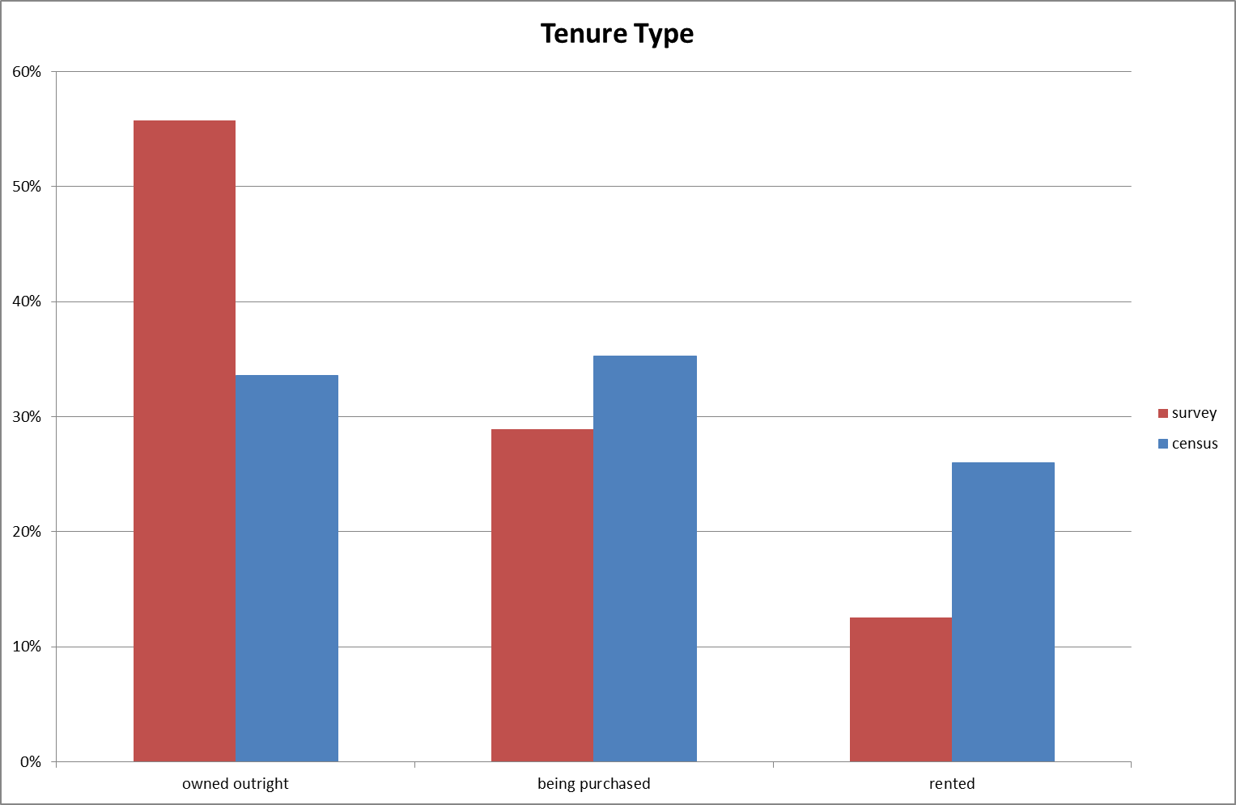

Figure 1: Distribution of tenure type for the DTEI survey compared with the 2006 census of population and housing.

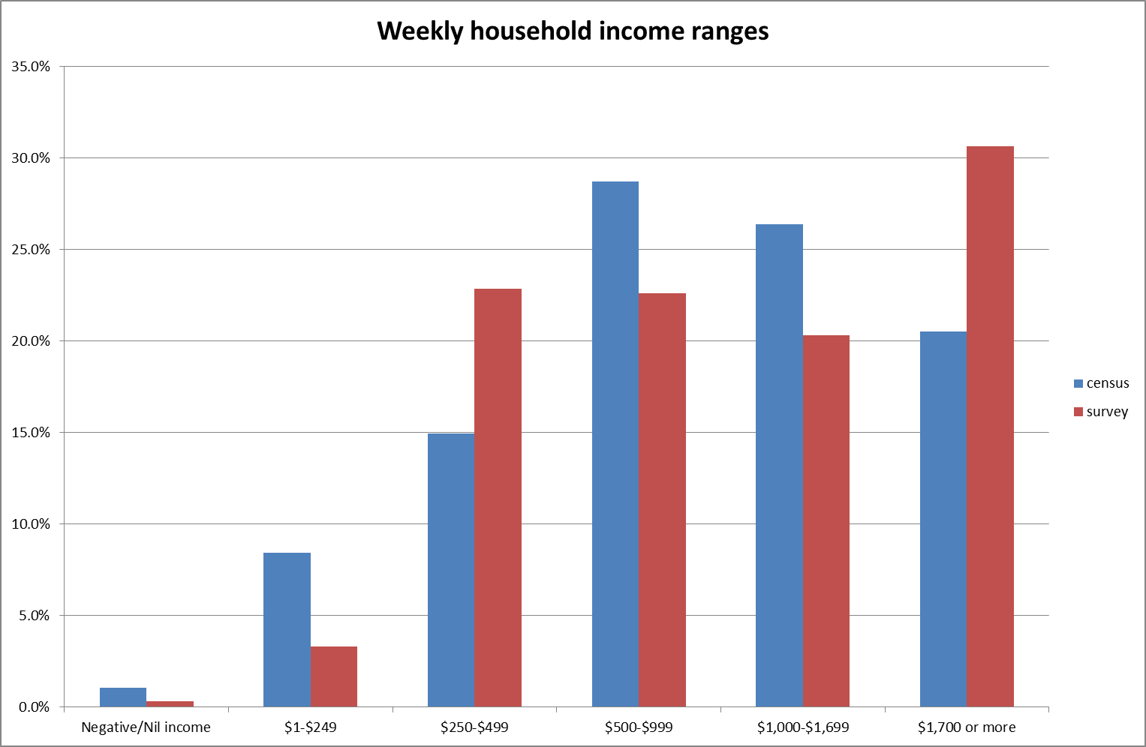

Figure 2: Distribution of weekly household income for the DTEI survey compared with the 2006 census of population and housing.

These two graphs show that there are some differences in these distributions. However, these must be considered in the context of the differences between this survey and the Census of Population and Housing.
- The method of collection differed for the two data sources; the survey was a telephone interview and the census is a drop off and return self-enumerated form.
- The selection methodology was also not the same, since all households are enumerated in the census of population and housing, and only approximately 0.45% of households reported for the DTEI survey.
- The DTEI survey didn’t use standard ABS geography to define its region of interest, and hence there cannot be a direct comparison for these distributions, however care was taken to get the most comparable data.
- The other aspect that may explain some of the differences is the public’s perception of the data collector. Many more people refused to answer or didn’t complete the question regarding income on the survey (7.99%), while much fewer households didn’t answer the corresponding question in the census of population and housing (2.6%).

In light of all of these considerations it was determined that no adjustments to account for distribution differences were required, and the weights stated above were used in the calculation of most estimates (see Data Quality below).

Data Quality

Relative Standard Errors (RSEs)
All of our estimates are produced with an associated measure of reliability, called a relative standard error. This can be thought of as the variability associated with taking a sample rather than getting responses from all people in the population of interest. When considering the tables, if the figure is in red then caution should be used when using the figure. This is when the standard error of the estimate is greater than 25% of the actual estimate. In general, the smaller the RSE, the greater the reliability of the estimate. It is our belief that if the RSE is greater than 50%, the estimate is too unreliable to be of use.

Logical Errors
There were some concerns regarding some of the responses provided by Harrisons for the lighting questions as they did not make logical sense. For example, there was a respondent who reported having 1 incandescent light, and 5 of these connected to a dimmer. Since there was obviously a misunderstanding of the question, the 19 respondents that showed logical errors were excluded from the calculations for the lighting questions, and the weights of the remaining 2499 respondents were adjusted slightly to account for this.

Lighting and “don’t know”s
Please be aware that if a respondent said that they had a certain type of light, but didn’t know how many of that light they had, they were given the value of 1. Also, if the respondent stated that they had some of their lights connected to a dimmer, but they didn’t know how many, it was assumed that 1 of them was attached to a dimmer. The figures provided are best estimates based on these assumptions.

References

http://www.abs.gov.au/websitedbs/D3310114.nsf/home/Census+data

